Informatics Institute of Technology

In Collaboration With

The University of Westminster, UK



*The University of Westminster, Coat of Arms*

GenSum

**Adaptive Generalized Text Summarization System using Optimized**

**Transformers**

A dissertation by

Mr. Nazhim Kalam

W1761265 | 2019281

Supervised by

Mr. Torin Wirasingha

April 2023

Submitted in partial fulfilment of the requirements for the

BSc (Hons) Computer Science degree at the University of Westminster.

# **DECLARATION**

I declare that all aspects of this thesis, including its subordinate parts, are the outcome of my personal original research efforts. Moreover, I verify that I have not previously submitted or presented any part or entirety of this material in any other degree or certification program at any other institution or university. Any factual information obtained from reputable external sources has been duly acknowledged through appropriate citation.

**Student Name**: Nazhim Kalam

**Registration Number**: W1761265 - 2019281

**Signature: Date:** May 1, 2023



# **ABSTRACT**

Abstractive text summarization systems have been integrated with various application in the world to perform text summarization and its nothing new to the field. However, with the prior research it found that in the domain of movies the need for performance improvement is required using latest approaches than the current traditional ML & DL methods, movie review summarization plays a major role in helping users to make better decisions by matching their interest with the reviews of the movie, this saves a lot of time and also improves businesses in their sales.

In 2017 researches from Google Brain introduced NLP Transformers, which is a latest approach to solve NLP problems and its increasingly been known and used nowadays over traditional ML & DL approaches like using basic LSTM, RNN approaches. The author explored ways in which to get an optimal solution using Transformer for abstractive text summarization and yet making a generalized solution which can be adapted with respect to any domain (be it hotels, movies, restaurants) and increase its performance as the system gets used over with time.

The author was able to experiment with few of the top tier transformer architectures to filter out the optimal model and integrated an automated hyperparameter searching mechanism which will find the best set of hyperparameters to train & customize the model with respect to any domain. **ROUGE1 of 80.8, ROUGE2 of 79.42, ROUGEL of 80.8, ROUGELSUM of 80.8** was the optimal evaluation metric result achieved from the BART model giving the best result.

**Keywords:** Natural Language Processing (NLP), Machine Learning (ML), Deep Learning (DL), Recall-Oriented Understudy for Gisting Evaluation (ROUGE), Inductive logic programming (ILP)

**Subject Descriptors:**

* Computing methodologies 🡪 Artificial intelligence 🡪 Natural language processing 🡪 Natural language generation
* Theory of computation 🡪 Theory and algorithms for application domains 🡪 Machine learning theory 🡪 Semi-supervised learning.
* Information systems 🡪 Information systems applications 🡪 Management and querying of encrypted data.
* Security and privacy 🡪 Database and storage security 🡪 Data mining.

# **PUBLICATIONS**

1. **An Adaptive Approach for Generalized Text Summarization Using Optimized Transformers**

Conference: SmartNets 2023 – Big Data Analytics and Machine Learning

Status: Submitted, In-Review

Venue: Asia, Colombo

Date: April 25, 2023

1. **A Review on Creating a Performance Adaptive Generalized Abstractive Text Summarization Using Optimized Transformers**

Conference: SmartNets 2023 - Big Data Analytics and Machine Learning

Status: Submitted, In-Review

Venue: Asia, Colombo

Date: April 08, 2023

**APPENDIX L** shows the proof of research & review paper submission made at SmartNets 2023 conference.

# **ACKNOWLEDGEMENT**

I am grateful for the supportive individuals in my life who have empowered me to exceed my previous limitations and achieve my current level of success, including the completion-of this final year research project.

I would like to begin by thanking my supervisor, Mr. Torin Wirasingha, for his valuable contribution in refining my project idea and expanding its scope. His insights and guidance have been crucial in shaping my work. Additionally, I express my deepest gratitude to Mr. Guhanathan Poravi, my esteemed module leader, for consistently reviewing my reports and providing invaluable feedback. Thanks to his guidance, I now have the confidence to conduct research at any level. I extend my appreciation to the evaluators of this project, who took the time to thoroughly review my work and provide valuable advice for its enhancement. Furthermore, I would like to thank all the interviewees and survey respondents, including industry and academia experts, as well as my senior and junior peers at IIT, for their input in the requirement gathering process.

I would like to express my sincere gratitude to the esteemed professors at the Informatics Institute of Technology, as well as the supportive administration, for the opportunities, unwavering support, and guidance provided to myself during my undergraduate studies. Additionally, I want to acknowledge my peers from university, whose continual support and positive influence have been instrumental in my growth as a developer/researcher. Their encouragement and motivation have been a source of inspiration throughout my four-year journey. Lastly, I want to extend my deepest appreciation to my parents for their unwavering support and encouragement in pursuing my dreams, and to my dear family, friends, and significant other, whose encouragement has provided strength during challenging times.

**CONTENTS**

DECLARATION i

ABSTRACT ii

PUBLICATIONS iii

ACKNOWLEDGEMENT iv

LIST OF TABLES xii

LIST OF FIGURES xiii

CHAPTER 01. INTRODUCTION 1

1.1 Chapter overview 1

1.2 Problem domain 1

1.2.1 Movie user reviews 1

1.2.2 Text summarization 2

1.2.3 Transformers 2

1.3 Problem definition 3

1.3.1 Problem statement 3

1.4 Research motivation 3

1.5 Research questions 4

1.6 Research aim & objectives 4

1.6.1 Research aim 4

1.6.2 Research objectives 5

1.7 Novelty of the research 8

1.7.1 Problem novelty 8

1.7.2 Solution novelty 8

1.8 Research gap 8

1.9 Contribution to the body of knowledge 9

1.9.1 Research domain contribution 9

1.9.2 Problem domain contribution 10

1.10 Research challenge 10

1.11 Chapter summary 10

CHAPTER 02. LITERATURE REVIEW 11

2.1 Chapter overview 11

2.2 Concept map 11

2.3 Problem domain 11

2.3.1 User reviews 11

2.3.2 Corporate advantage 12

2.3.3 Text summarization 12

2.3.4 Abstractive and extractive techniques 12

2.3.5 NLP with deep learning 14

2.3.6 Transformers 14

2.3.7 Model customization & hyperparameter tuning 15

2.3.8 Generalization 15

2.3.9 Data expansion 16

2.4 Existing work 16

2.4.1 Text summarization systems 16

2.4.1.1 Abstractive approach 16

2.4.1.2 Extractive approach 17

2.4.2 Algorithmic approaches for text summarization 17

2.4.3 Usage of transformers 18

2.5 Technological review 19

2.5.1 Proposed architecture for the generalized text summarization system. 19

2.5.2 Machine learning text summarization techniques 20

2.5.3 Deep learning text summarization techniques 21

2.5.4 Available datasets for generalized text summarization 21

2.5.5 Preprocessing techniques used in text summarization 22

2.6 Evaluation techniques 22

2.6.1 Evaluation approaches 22

2.6.2 Benchmarking 24

2.7 Chapter summary 25

CHAPTER 03. METHODOLOGY 26

3.1 Chapter overview 26

3.2 Research methodology 26

3.3 Development methodology 27

3.3.1 Life cycle model 27

3.3.2 Requirement elicitation methodology 27

3.3.3 Design methodology 27

3.3.4 Software development methodology 27

3.4 Project management methodology 27

3.4.1 Schedule 27

3.4.1.1 Gantt chart 27

3.4.1.2 Deliverables 28

3.5 Resources 29

3.5.1 Software requirements 29

3.5.2 Hardware requirements 29

3.5.3 Technical skills 29

3.5.4 Data requirements 30

3.6 Risks & mitigation 30

3.7 Chapter summary 30

CHAPTER 04. SOFTWARE REQUIREMENTS SPECIFICATION 31

4.1 Chapter overview 31

4.2 Rich picture 31

4.3 Stakeholder analysis 32

4.3.1 Stakeholder onion model 32

4.3.2 Stakeholder viewpoints 33

4.4 Selection of requirement elicitation methodologies 34

4.5 Discussion of findings 35

4.5.1 Literature review 35

4.5.2 Brainstorming 36

4.5.3 Interviews 36

4.5.4 Survey 39

4.5.5 Self evaluation 43

4.5.6 Prototyping 43

4.5.6 Summary of findings 44

4.6 Context diagram 46

4.7 Use case diagram 46

4.8 Use case descriptions 47

4.9 Requirements 49

4.9.1 Functional requirements 49

4.9.2 Non-functional requirements 50

4.10 Chapter summary 51

CHAPTER 05. SOCIAL, LEGAL, ETHICAL & PROFESSIONAL ISSUES 52

5.1 Chapter overview 52

5.2 SLEP issues and mitigation 52

5.3 Chapter summary 52

CHAPTER 06. DESIGN 53

6.1 Chapter overview 53

6.2 Design goals 53

6.3 High level design 53

6.3.1 Architecture diagram 53

6.3.2 Discussion of tiers of the architecture 54

6.4 System design 55

6.4.1 Choice of design paradigm 55

6.5 Design diagrams 56

6.5.1 Data flow diagrams 56

6.5.1.1 Level 01 data flow diagram 56

6.5.1.2 Level 02 data flow diagram 57

6.5.2 UI design 57

6.5.3 System process activity diagram 58

6.6 Chapter summary 58

CHAPTER 07. IMPLEMENTATION 59

7.1 Chapter overview 59

7.2 Technology selection 59

7.2.1 Technology stack 59

7.2.2 Data selection 60

7.2.3 Programming language selection 60

7.2.4 Development framework selection 60

7.2.5 Libraries utilized 61

7.2.6 IDE’s utilized 62

7.2.7 Summary of technology selection 62

7.3 Implementation of core functionalities 63

7.3.1 Automated hyperparameter search & model customization 63

7.3.2 Model usage general & domain specific users 66

7.3.3 Model retraining 69

7.3.4 Data preprocessing 70

7.3.5 Generalized model training 70

7.4 User interface 70

7.5 Chapter summary 70

CHAPTER 08. TESTING 71

8.1 Chapter overview 71

8.2 Testing objectives & goals 71

8.3 Testing criteria 71

8.4 Model testing & evaluation 72

8.4.1 Model testing 72

8.4.2 Model evaluation 73

8.5 Benchmarking 75

8.6 Functional testing 75

8.7 Module & integration testing 75

8.8 Non-functional testing 77

8.9 Limitations of the testing process 77

8.10 Chapter summary 77

CHAPTER 09. EVALUATION 78

9.1 Chapter overview 78

9.2 Evaluation methodology & approach 78

9.3 Evaluation criteria 78

9.4 Self-evaluation 79

9.5 Selection of evaluators 80

9.6 Evaluation results & expert opinions 81

9.7 Limitations of evaluation 83

9.8 Evaluation of functional requirements 83

9.9 Evaluation of non-functional requirements 83

9.10 Chapter summary 83

CHAPTER 10. CONCLUSION 84

10.1 Chapter overview 84

10.2 Achievement of research aim & objectives 84

10.2.1 Achievement of aim 84

10.2.2 Achievement of objectives 84

10.3 Utilization of knowledge from the degree 84

10.4 Use of existing skills 85

10.5 Use of new skills 86

10.6 Achievement of learning outcomes 86

10.7 Problems and challenges faced 86

10.8 Deviations 87

10.9 Limitations of the research 87

10.10 Future enhancements 87

10.11 Achievement of the contribution to the body of knowledge 88

10.11.1 Domain contributions 88

10.11.2 Technical contribution 88

10.11.3 Additional contributions 88

10.12 Implementation code 88

10.13 Concluding remarks 89

REFERENCES I

APPENDIX A – INTRODUCTION VII

A.1. Prototype feature diagram VII

A.2. Project scope VII

APPENDIX B – LITERATURE REVIEW IX

B.1. Related work in abstractive text summarization IX

APPENDIX C – SRS I

C.1. Requirement elicitation methodologies I

C.2. Interview analysis I

C.3. Use case descriptions III

C.4. Functional requirements IX

APPENDIX D – DESIGN X

D.1. Design goals X

D.2. UI wireframes XI

APPENDIX E – IMPLEMENTATION XIV

E.1. Dataset resources XIV

E.2. Selection of programming language XVIII

E.3. Selection of deep learning (DL) framework XIX

E.4. Selection of User Interface (UI) framework XX

E.5. Selection of Application Programming Interface (API) framework XX

E.6. Data preprocessing XXI

E.7. Generalized model training XXV

E.8. User interface XXVIII

APPENDIX F – TESTING XXXII

F.1. Functional Testing XXXII

F.2. Non-functional testing XXXV

APPENDIX G – EVALUATION XXXIX

G.1. Expert evaluators XXXIX

G.2. Evaluation of functional requirements XXXIX

G.3. Evaluation of non-functional requirements XLI

APPENDIX H – CONCLUSION XLIII

H.1. Status of research objectives XLIII

H.2. Achievement of learning outcomes XLVI

H.3. Project plan XLVII

APPENDIX I – CONCEPT MAP XLIX

APPENDIX J – REVIEW PAPER L

APPENDIX K – RESEARCH PAPER LVIII

APPENDIX L – PROOF OF SUBMISSION LXIV

# **LIST OF TABLES**

Table 1: Research objectives 5

Table 2: Comparison of text summarization techniques 13

Table 3: Evaluation metrics for abstractive text summarization 23

Table 4: Comparison table for abstractive text summarization using transformers (Etemad, Abidi and Chhabra, 2021) 25

Table 5: Research methodology 26

Table 6: Deliverables & dates 28

Table 7: Risk management plan 30

Table 8: Stakeholder viewpoints & requirements 33

Table 9: Requirement elicitation methodologies 34

Table 10: Literature review findings 35

Table 11: Observations findings 36

Table 12: Interview analysis codes 37

Table 13: Interview results 37

Table 14: Survey analysis 39

Table 15: Survey thematic analysis codes 42

Table 16: Survey thematic analysis 42

Table 17: Competitor analysis 43

Table 18: Prototyping findings 43

Table 19: Summary of findings 44

Table 20: Use case description UC:07 47

Table 21: Use case description UC:03 48

Table 22: Functional requirements 49

Table 23: Non-functional requirements 50

Table 24: SLEP issues & mitigation 52

Table 25: Dataset sources 60

Table 26: Development framework utilized 61

Table 27: Libraries used with reasonings 61

Table 28: IDE’s used along with justifications 62

Table 29: Summary of technology selection 62

Table 30: Model evaluation results 73

Table 31: Benchmarking results 75

Table 32: Module & integration testing 76

Table 33: Performance testing results 77

Table 34: GUI testing results 77

Table 35: Evaluation criteria 78

Table 36: Self-evaluation of the author 79

Table 37: Categorization of selected evaluators 80

Table 38: Thematic analysis of expert feedback 81

Table 39: Utilization of knowledge gained from the course 84

Table 40: Mitigations to problems and challenges faced 86

Table 41: Related work in abstractive text summarization IX

Table 42: Stakeholder groups I

Table 43: Interview evidence I

Table 44: Interview participant details II

Table 45: Usecase mappings III

Table 46: Use case description UC:01 III

Table 47: Use case description UC:02 IV

Table 48: Use case description UC:10 IV

Table 49: Use case description UC:04 V

Table 50: Use case description UC:05 VI

Table 51: Use case description UC:06 VI

Table 52: Use case description UC:08 VII

Table 53: Use case description UC:09 VIII

Table 54: ‘MoSCoW’ technique of requirement prioritization IX

Table 55: Design goals of the proposed system X

Table 56: Selection of data science language XVIII

Table 57: Selection of DL framework XIX

Table 58: Selection of UI framework XX

Table 59: Selection of web framework XX

Table 60: Functional testing XXXII

Table 61: Non-functional requirement testing XXXVIII

Table 62: Details of the expert evaluator(s) selected. XXXIX

Table 63: Evaluation of the implementation of functional requirements XXXIX

Table 64: Evaluation of the implementation of non-functional requirements XLI

Table 65: Evaluation of the achievement of design goals XLII

Table 66: Status of research objectives XLIII

Table 67: Achievement of learning outcomes XLVI

# 

# **LIST OF FIGURES**

Figure 1: Transformer Architecture Downloads Rate (Wolf et al., 2020) 15

Figure 2: Proposed Generalized Abstractive Summarization System Process Flow (Self-Composed) – (*view high qual version*) 20

Figure 3: Rich Picture Diagram (Self-Composed) – *(view high qual version)* 31

Figure 4: Stakeholder Onion Model (Self-Composed) – *(view high qual version)* 32

Figure 5: Context Diagram (Self-Composed) 45

Figure 6: Use Case Diagram (Self-Composed) 46

Figure 7: Three-Tiered Architecture (Self-Composed) 52

Figure 8: Data Flow Diagram - Level 01 (Self-Composed) 55

Figure 9: Data Flow Diagram - Level 02 (Self-Composed) 56

Figure 10: System Process Flow Chart (Self-Composed) – *(view high qual version)* 57

Figure 11: Technology Stack (Self-Composed) 58

Figure 12: Model customization parameter initialization 62

Figure 13: Training hyper-parameter initialization 63

Figure 14: Model decoder customization 63

Figure 15: Model training hyperparameter tuning 64

Figure 16: Hyperparameter Results and Training Arguments (Self-Composed) 64

Figure 17: Model Training (Self-Composed) 65

Figure 18: General User Review Text Summarization (Self-Composed) 65

Figure 19: Assigning A Specific Model for The New Domain User (Self-Composed) 66

Figure 20: Domain Specific Text Review Summarization (Self-Composed) 67

Figure 21: Fetching Related Data for Model Retraining (Self-Composed) 68

Figure 22: Validation Accuracy by number of epochs – bart model (*Self-Composed*) 71

Figure 23: Validation Loss by number of epochs – bart model (*Self-Composed*) 71

Figure 24: Validation Accuracy by number of epochs – t5 model (*Self-Composed*) 71

Figure 25: Validation Loss by number of epochs – t5 model (*Self-Composed*) 71

Figure 26: Validation Accuracy by number of epochs – Pegasus model (*Self-Composed*) 72

Figure 27: Validation Loss by number of epochs – Pegasus model (*Self-Composed*) 72

Figure 28: Hotel Domain (Cinnamon Type) Evaluation 73

Figure 29: Movie Domain (Scope Cinema Type) Evaluation 73

Figure 30: Prototype Feature Diagram (Self-Composed) VII

Figure 31: Homepage Wireframe (Self-Composed) XI

Figure 32: Review History Page (Self-Composed) XII

Figure 33: User Profile Page (Self-Composed) XIII

Figure 34: CNN Dailymail Dataset (*view*) XIV

Figure 35: Gigaword Dataset (view) XV

Figure 36: Xsum Dataset (view) XVI

Figure 37: Amazon Movie Reviews Dataset (view) XVII

Figure 38: Hotel Reviews Dataset (view) XVIII

Figure 39: Preprocessing: Remove Markdown (Self-Composed) XXI

Figure 40: Preprocessing – Remove Hyperlinks (Self-Composed) XXI

Figure 41: Preprocessing: Remove Html Tags (Self-Composed) XXII

Figure 42: Preprocessing: Char Words Extension (Self-Composed) XXII

Figure 43: Preprocessing: Handling Common Contractions (Self-Composed) XXIII

Figure 44: Preprocessing: Removing Special Characters (Self-Composed) XXIV

Figure 45: Preprocessing: Resolving Spelling Mistakes (Self-Composed) XXIV

Figure 46: Preprocessing: Removing Duplicates (Self-Composed) XXV

Figure 47: Preprocessing: Restoring Missing Punctuations (Self-Composed) XXV

Figure 48: Preprocessing: Grammarly Correction (Self-Composed) XXV

Figure 49: GUI – Homepage (After Signup) (Self-Composed) XXVII

Figure 50: GUI – Review History Page (Self-Composed) XXX

Figure 51: GUI – User Profile (Self-Composed) XXXI

Figure 52: GUI – Model Retraining Modal (Self-Composed) XXXI

Figure 53: GUI – Homepage (Before Signup) (Self-Composed) XXXII

Figure 54: System Resource Manager Graph (Self-Composed) XXXVI

Figure 55: Lighthouse Landing Page XXXVII

Figure 56: Lighthouse Records Page XXXVII

Figure 57: Lighthouse User Profile Page XXXVII

Figure 58: CodeFactor - Gensum Repository XXXVIII

Figure 59: CodeQL - Gensum Repository XXXVIII

Figure 60: Gantt Chart: Initial Plan (Self-Composed) XLVIII

Figure 61: Gantt Chart: Final Plan (Self-Composed) XLIX

Figure 62: Research & Review Paper Submission LXV

**LIST OF ABBREVIATIONS**

|  |  |
| --- | --- |
| AI | Artificial Intelligence. |
| DL | Deep Learning |
| GUI | Graphical User Interface |
| ML | Machine Learning |
| NLP | Natural Language Processing |
| ROUGE | Recall-Oriented Understudy for Gisting Evaluation. |
| BLEU | BiLingual Evaluation Understudy. |
| T5 | Text to Transfer Transformer. |
| BART | Bidirectional Auto-Regressive Transformers. |
| BERT | Bidirectional Encoder Representations from Transformers. |
| PEGASUS | Pre-training with Extracted Gap-sentences for Abstractive Summarization Sequence-to-sequence |
| ILP | Inductive logic programming. |
| LSTM | Long Short-Term Memory. |
| RNN | Recurrent Neural Network. |
| CNN  SEQ2SEQ | Convolutional Neural Network.  Sequence to Sequence |
| RoBERTa | Robustly Optimized BERT Pre-training Approach |
| GPT-3  REST  GPU  API | Third Generation Generative Pre-Trained Transformer  Representational State Transfer  Graphical Processing Unit  Application Programming Interface |

# **CHAPTER 01. INTRODUCTION**

# **1.1 Chapter overview**

In this research project, the author experiments and optimizes a series of top-tier pretrained transformer designs by automating the process of model architecture customization and search hyperparameter optimization in an effort to improve the performance of abstractive text summarization for movie reviews while developing a generalized solution that can adapt and be used in other domains.

This chapter presents a clear definition of the problem, research gap, research challenge, and the research strategy that will guide the author's work over the upcoming months. In addition, the chapter provides an overview of the necessary evidence to substantiate the problem, as well as a review of relevant prior research.

# **1.2 Problem domain**

## **1.2.1 Movie user reviews**

In recent times, an increasing number of websites such as Amazon and the Internet Movie Database (IMDB), which is a platform dedicated to movie reviews, permit their users to share their feedback on subjects that intrigue them. This trend has been concurrent with the emergence of Web 2.0, a framework that prioritizes user engagement and participation (Khan, Gul, Zareei, et al., 2020).

According to Khan, Gul, Uddin, et al. (2020), online movie reviews are becoming an increasingly important source of information for users, particularly given the vast amount of data available on the web. Despite this, the sheer volume of movie reviews posted by online users on a daily basis can make it difficult for individuals to manually summarize reviews and assess their interest in a particular film. Consequently, one of the most challenging problems in natural language processing involves the mining and summarization of movie reviews.

Alsaqer and Sasi (2017) state that text summarization is a useful tool for assisting users and business decision-makers in compiling and analyzing a large number of online reviews. Nowadays, the vast majority of people read reviews of films before selecting or watching them on platforms such as Netflix or Amazon Prime.

However, users may encounter conflicting reviews that are either positive or negative, and reading all the reviews in detail can be time-consuming. As a result, summarizing reviews can make it faster and easier for users to make decisions. Additionally, this can help streaming services like Netflix to rapidly identify the viewing habits or preferences of their users, as noted by Dashtipour et al. (2021).

## **1.2.2 Text summarization**

Mahajan et al. (2021) suggest that in the present day, there is a vast amount of textual content accessible to us, such as news articles and reviews. Text summarization plays a critical role in facilitating the process of extracting crucial information from such pieces of text by minimizing the volume of text to be perused.

According to Etemad, Abidi, and Chhabra (2021), two main approaches exist for generating text summaries: extractive summarization and abstractive summarization. Extractive summarization entails the identification and extraction of the most significant sentences from the context or article without making any modifications to their original form. Conversely, abstractive summarization aims to generate its own sentences and create a summary; this approach is more effective than extractive summarization as it allows for the creation of more meaningful phrases within the context, rather than relying on selected sentences from the context without modification.

## **1.2.3 Transformers**

The Transformer architecture in Natural Language Processing (NLP) is a new and innovative model designed to handle sequence-to-sequence tasks and effectively deal with long-range dependencies. Its performance has exceeded that of other neural models, such as Convolutional Neural Nets (CNN) and Recurrent Neural Nets (RNN), and has emerged as the leading architecture in NLP. (Wolf et al., 2020).

Etemad, Abidi, and Chhabra (2021) state that Transformers utilize a self-attention mechanism to concentrate on particular sections of the input sequence, after which the encoder and decoder architecture is implemented.

# **1.3 Problem definition**

In the field of movie review summarization, current research has not explored optimizing the state-of-the-art deep learning methods, including ***transformers***, to address this issue. Previous studies have relied on conventional machine and deep learning algorithms like naïve Bayes and RNN. However, leveraging advanced deep learning approaches may improve the quality and accuracy of text summarization.

Deep learning models require more time for training, but they offer higher accuracy as they can automate both feature extraction and classification simultaneously. On the other hand, machine learning algorithms necessitate feature selection initially. Consequently, the implementation of deep learning techniques can help enhance the precision of text summarization and enable users to make informed decisions (Etemad, Abidi, & Chhabra, 2021).

## **1.3.1 Problem statement**

To date, there has been no investigation into optimizing and utilizing the state-of-the-art deep learning techniques, such as transformers, to generate abstractive summaries from movie reviews, which can enhance text summarization. (Khan, Gul, Zareei, et al., 2020).

# **1.4 Research motivation**

The problem of improving the quality of abstractive text summarization using advanced deep learning techniques is not limited to movie reviews alone but can also be applied to various other domains. Hence, a **generalized solution** was initially proposed to address this issue (Kouris, Alexandridis, & Stafylopatis, 2019).

In previous studies, scholars such as Etemad, Abidi and Chhabra (2021) have identified syntactic and semantic challenges as the main obstacles to effective text summarization. In their research, they explored several deep learning techniques and found that transformer-based models, particularly the T5 model, outperformed other models in various natural language processing tasks. This finding encourages further investigation into the optimization of transformer models to improve the quality of text summarization and overcome the challenges associated with summarizing movie reviews.

# **1.5 Research questions**

**R**Q1: What are the top tier transformer architectures widely used and know for NLP problems related to text summarization?

**R**Q2: How can a pretrained transformer architecture be fine-tuned to get the optimal hyper parameters and automate model customization?

**R**Q3: What kind of evaluations should be performed after fine-tuning to filter out the best transformer architecture?

**R**Q4: How can domain generalization be integrated for system?

# **1.6 Research aim & objectives**

## **1.6.1 Research aim**

***The aim of this research is to design, develop and evaluate an optimal adaptive generalized transformer architecture from a range of popularly used architectures by automating the process of model customization and hyperparameter tuning for optimization, therefore obtaining the recommended architecture's optimum performance***

The aim of this research project is to develop a functional system capable of conducting abstractive text summarization from user input in various domains, including movies, hotels, and ecommerce. The main emphasis will be placed on the quality of the text summary and performance optimization. The research will investigate various techniques, including data preparation, data analysis, hyperparameter tuning, model customization and model evaluation, to achieve the best results.

The objective of this research is to develop the fundamental elements, gather and assess pertinent data, and appraise the efficacy of the system. The system will be designed to be available for private or public utilization on both hosted servers and local web browsers. Additionally, the source code of the data science models will be made publicly accessible in a repository to facilitate additional research and practical implementation. A research paper will be produced as a result of this study.

## **1.6.2 Research objectives**

For the research to be considered successful, its goals must be fulfilled

Table 1: Research objectives

|  |  |  |  |
| --- | --- | --- | --- |
| **Objective** | **Description** | **LO** | **RQ** |
| Problem Identification | Comprehend and document the identified issue.  **RO1:** Perform research in a domain of interest and identify a sufficiently comprehensive problem that needs to be addressed.  **RO2**: Thoroughly explore and analyze potential solutions for addressing the problem.  **RO3**: Explore methods for developing an adaptive and generalized approach.  **RO4**: Create a schedule, determine associated deliverables, and develop a Gantt chart for the project. | LO1,  LO2 | RQ1,  RQ4 |
| Literature Review | Complete a thorough critical review of earlier related work.  **RO1:** Make a preliminary investigation on existing abstractive text summarization using deep learning approaches.  **RO2:** Make a preliminary investigation on why transformers architecture was the chosen deep learning choice for this research.  **RO3:** Analyze the top tier transformer architectures widely used.  **RO4:** Analyzing how the models can be fine-tuned via hyperparameter optimization & perform model customization.  **RO5:** Analyzing the different approaches used for model evaluation.  **RO6:** Analyze how the model can be generalized for every other domain. | LO1, LO4,  LO8 | RQ1, RQ2, RQ3, RQ4 |
| Methodology Selection and SLEP Framework | This defines the outline structure for the requirement analysis and the design process followed by the social legal ethical and professional issues.  **RO1**: Analyzing the Research Methodology approaches.  **RO2**: Analyzing the Development Methodology approaches.  **RO3**: Analyzing the Project Management Methodology approaches.  **RO4**: Analyzing the Solution Methodology approaches.  **RO5**: Analyzing the Social, Legal Ethical and Professional Issues which could develop during the phase of the project. | LO2,  LO6 | RQ4, RQ2, RQ1 |
| Requirement Elicitation | The process of defining the project's requirements involves the identification and application of appropriate methods and tools aimed at resolving anticipated research limitations and challenges, based on existing relevant research.  **RO1:** Gathering information related to the expected metadata required for the dataset to contain for the model training.  **RO2:** Gathering the requirements of transformer architectures for fine-tuning and understand the end to end user expectations.  **RO3:** Getting insights from domain experts to build a suitable system.  **RO4:** Gathering the requirements for handling generalization. | LO1, LO3, LO5 | RQ4, RQ2, RQ1 |
| Design | Considering the following when developing the suggested system:  **RO1:** Design a component to preprocess the dataset for the respective model inputs.  **RO2:** Design a component to store the top tier transformer models with their respective metadata, to use throughout.  **RO3:** Design a hyperparameter tuning component that can improve accuracy of the transformer model & customize model architecture.  **RO4**: Design high-level architecture for the system. | LO1, LO5 | RQ2 |
| Implementation | Setting up a mechanism capable of addressing the gaps that were intended to be covered.  **RO1**: To develop data preprocessing component.  **RO2**: To develop a component that handles and stores the top tier transformer architectures for fine-tuning.  **RO3**: To develop the automated model customization & hyperparameter search component that handles all the top tier architectures assigned.  **RO4**: To develop a component for the model evaluations for the measured hyperparameters | LO1, LO5, LO7 | RQ2, RQ3 |
| Evaluation | Testing and evaluating the developed system (including the data science models with the suitable metrices)  **RO1**: Performing unit test, integration and performance testing along with a test plan created.  **RO2**: Evaluating all the transformer architectures used for fine-tune experimentations, using recommended scores such as (ROUGE or BLEU SCORE). | LO1,  LO5 | RQ3 |
| Documentation | Keeping track of and documenting the study project's ongoing progress and any challenges encountered. | LO6, LO8 | - |
| Publication | Ensure that the documentation, reports, and papers are well-structured and include a critical analysis of the research.  **RO1**: To publish a review paper on the related work done.  **RO2**: To publish a research paper on the related work done.  **RO3**: To publish the code implementation repository as public to be access by future research investigations, along with the models and datasets | LO4,  LO8 | - |

# **1.7 Novelty of the research**

## **1.7.1 Problem novelty**

The novelty of the problem being addressed in this research lies in the absence of efforts to enhance the performance of transformers for improved text summarization results, as pointed out by Khan, Gul, Zareei et al. (2020).

## **1.7.2 Solution novelty**

The novelty of this proposed solution lies in its automated approach to model customization & hyperparameter tuning along with the incorporation of a retraining mechanism with newly available data to further enhance the performance of the optimal transformer model for any domain, thus achieving generalization. The approach proposed in this study is considered novel as it has not been previously explored in existing research (Etemad, Abidi, & Chhabra, 2021).

# **1.8 Research gap**

The literature suggests a requirement for advanced deep learning techniques to improve the performance of text summarization for movie reviews, as identified from previous research (Khan, Gul, Zareei, et al., 2020). Traditional machine learning methods have been found to be less effective in comparison to advanced deep learning techniques in the domain of movie review summarization.

This project focuses on empirical gap in the movie domain, as well as theoretical and performance gaps in the area of transformer optimization. Transformers have emerged as a vital component in the field of deep learning for addressing problems related to natural language processing. The optimization of the model architecture & hyperparameters on various transformer architectures could aid in enhancing the quality of abstractive text summarization. Additionally, developing a generalized model adaptable to the particular domains' requirements can further enhance performance.

# **1.9 Contribution to the body of knowledge**

The contributions of this project can be distinguished into two categories, namely theoretical contributions and domain-specific contributions.

The following is a summarization of the authors contribution:

* **Abstractive Text Summarization*:*** Automated (model architecture & training hyperparameter) optimization + Model Retraining + Transformers + Deep Learning
* **Movie User Review & Generalization:** Research domain target is for Movie reviews, in addition the author makes the system generalized to adapt to any domain area.

## **1.9.1 Research domain contribution**

According to previous research conducted by Zhang, Xu, and Wang (2019), there are numerous deep learning techniques available for handling abstractive text summarization. However, transformers appear to outperform most other deep learning approaches, as identified by previous research. Despite this, there has been little research into optimizing transformers for even better performance.

The primary objective of this study is to develop an adaptive generalized solution by optimizing the transformer architecture through fine-tuning and automated model customization & hyperparameter optimization of top-tier existing architectures in the domain of abstractive text summarization. According to Liu and Wang (2021), the proposed approach can enhance the performance of the recommended architecture.

## **1.9.2 Problem domain contribution**

Mahajan et al. (2021) have noted that neural networks form the foundation of deep learning algorithms, allowing them to handle intricate unstructured data better than traditional machine learning algorithms. However, previous research has failed to investigate the potential of utilizing advanced deep learning approaches for summarizing movie reviews.

The solution proposed for movie review summarization involves using optimizing transformers. This approach has shown promising results in the field of natural language processing. The solution will be adaptable and applicable to other text summarization tasks beyond the movie review domain.

# **1.10 Research challenge**

The primary aim of this study is to attain a generalized and optimal transformer architecture for abstractive text summarization. In the field of NLP, transformers have become the most preferred option for tackling NLP problems, as they have replaced RNN models. However, since transformers were introduced relatively recently in 2017 by a team at Google Brain, there is still a shortage of research on optimizing them specifically for the task of abstractive text summarization. (Wolf et al., 2020).

Hence, developing and identifying the optimized transformer architecture and parameters for text summarization while ensuring generalization poses a significant challenge, especially considering the limited resources available for research in this area. Furthermore, selecting appropriate datasets for movie review summarization and generalization is a difficult task since it requires significant effort & time in data preprocessing & experimenting.

# **1.11 Chapter summary**

In this chapter, the author describes their research endeavor, highlights its novelty and significance, and acknowledges the potential challenges that may arise during the process. Moreover, the chapter outlines the essential objectives that must be achieved for the research to be considered successful and links them to the required learning outcomes for the degree.

# **CHAPTER 02. LITERATURE REVIEW**

# **2.1 Chapter overview**

In this chapter, the author critiques prior studies that have utilized abstractive text summarization techniques, specifically deep learning approaches such as transformers, for summarizing movie reviews. Additionally, the author proposes an adaptable and generalizable solution capable of handling a variety of domains beyond just movies. Finally, through domain generalization, the author fine-tunes the transformer model and adapts it to new data and customize the model & hyperparameters, ultimately identifying the optimal design with the most favorable results.

# **2.2 Concept map**

The project scope of the literature review is presented in a concept map, where the main study areas are illustrated as nodes. The concept map serves as a visual aid to guarantee the inclusion of all pertinent literature and can be found in **APPENDIX I.**

# **2.3 Problem domain**

The advancement of technology and the widespread adoption of the internet have simplified the process of selling products or services to customers. By leveraging customer feedback, sellers can make informed decisions on how to enhance sales and achieve higher levels of customer satisfaction (Boorugu, Ramesh, & Madhavi, 2019). However, in the context of the film industry, customers face difficulties in rapidly assessing whether a movie aligns with their preferences by relying solely on reviews, which can be lengthy and time-consuming to read (Khan et al., 2020).

## **2.3.1 User reviews**

A user/customer review is commonly defined as written feedback provided by a customer who has utilized a product or service. These reviews are often used by consumers to inform their purchasing decisions. However, the unstructured nature of review data can make it challenging for consumers to compare and comprehend longer reviews (Lackermair, Kailer, & Kanmaz, 2013).

In industries such as tourism and hospitality, user and customer reviews hold great significance as they serve as a major driver for a country's economic growth and development. Tourists from various parts of the world share their experiences and provide feedback online in various formats, such as blogs and reviews (Mukherjee et al., 2020).

## **2.3.2 Corporate advantage**

Maintaining customer loyalty is crucial for businesses since acquiring a new customer typically requires at least five times the time and resources compared to retaining an existing one. Customer satisfaction plays a pivotal role in the survival of corporate industries, and analyzing customer feedback and reviews is an effective method to gain insights into their expectations and rectify any issues (Pizam & Ellis, 1999).

Streaming services such as Netflix and Amazon Prime can leverage movie summaries to better comprehend user viewing patterns and interests. In the same vein, industries related to movies should enable customers to quickly assess a summary and make prompt decisions on whether or not to watch a movie (Khan et al., 2020).

## **2.3.3 Text summarization**

In today's digital age, there is an enormous amount of textual data available on the internet, making it challenging to extract relevant information from a large number of documents. Text summarization aims to provide a condensed and meaningful version of lengthy textual content (Shi et al., 2020).

This technique has various applications in internet-based fields, such as search engines that use it for querying and e-commerce sites that utilize sentiment analysis to assess customer satisfaction with products (Etemad, Abidi and Chhabra, 2021).

In the movie industry, text summarization can simplify customer reviews of movies, which are often lengthy and time-consuming to read. This simplification can enable users to make better decisions when deciding whether or not to watch a particular movie (Khan et al., 2020).

## **2.3.4 Abstractive and extractive techniques**

In general, text summarization can be divided into two categories: abstractive text summarization and extractive text summarization. However, it is feasible to create a hybrid model for text summarization (Alsaqer and Sasi, 2017). The abstractive technique of text summarization intends to generate its own sentences and utilize them to create a consistent summary. Consequently, the summary's substance may differ from the original text but still communicate the same concept (Mahajan et al., 2021). Furthermore, it is widely recognized that a solid abstractive summary involves the primary information from the input and is linguistically coherent (Zhang et al., 2020).

The technique of extractive text summarization involves identifying essential phrases or groups of phrases from the original input content and merging them to create a brief but informative text summary. The selection of sentences to include in the summary is based on the statistical and linguistic features of those sentences. In contrast, abstractive text summarization aims to generate sentences independently and utilize them to produce a coherent summary that may differ from the original context while conveying the same message. A hybrid text summarization system combines different methods to create a unified system. Combining extractive and abstractive summarization strategies can lead to a hybrid system that employs encoder-decoders, as demonstrated in prior research (Kirmani et al., 2019; Abolghasemi, Dadkhah and Tohidi, 2022).

Table 2: Comparison of text summarization techniques

|  |  |
| --- | --- |
| **Abstractive** | **Extractive** |
| According to Mahajan et al. (2021), the ability of an AI system to paraphrase content in a manner similar to humans involves the generation of a new context. In other words, the AI system can create its own context, just as humans do. | The text summarization approach that does not create its own context but selects the most suitable phrases from the original document is the one identified by Gupta and Lehal (2010). |
| There exists a plethora of datasets that can be used for experimentation in this field. | It has the ability to visualize the scores of individual sentences and explore gradient-based techniques for computing the contribution of each input token to score prediction (Pai, 2014). |
| There is a possibility of generating misinformation or producing a meaning that differs from the original text. | There is a potential for errors in the combined sentences formed from the extracted sentences. |

## **2.3.5 NLP with deep learning**

Natural Language Processing (NLP) is a computer-based method that enables effective and intelligent analysis, comprehension, and understanding of human language, distinguishing it from other methods that only consider the interactions between human language and computers. In recent times, deep learning techniques have been increasingly used in AI research due to their superior performance in handling complex and high computing learning tasks compared to traditional machine learning approaches (Lopez and Kalita, 2017; Mahajan et al., 2021).

Although machine learning is widely used in NLP today, it mostly involves optimizing the weights of features and representations that are created by humans. In contrast, deep learning is aimed at exploring how computers can leverage data to create features and representations suitable for complex interpretation tasks (Socher, Bengio, and Manning, 2012).

## **2.3.6 Transformers**

In the field of natural language processing (NLP), the open-source library Transformers provides modern transformer architectures that are thoroughly developed and integrated through a common API. Pretraining has made these architectures efficient for various tasks, enabling the construction of higher-capacity models.

These transformer models have been designed to be accessible for practitioners, extensible for researchers, and fast and reliable for industrial applications (Wolf et al., 2020).

Recent studies have demonstrated the high competence of modern pre-trained language models based on transformers in identifying both syntactic and semantic cues, including noun modifiers, possessive pronouns, prepositions, co-referents, entities, and relations (Brasoveanu and Andonie, 2020).

Hugging Face Hub provides a range of transformer designs, such as BERT, GPT2, T5, PEGASUS, and others. As shown in the figure below, the daily average of unique downloads for pretrained transformer model architectures has been steadily increasing between October 2019 and May 2020 (Wolf et al., 2020).

Figure 1: Transformer architecture downloads rate (Wolf et al., 2020)



Etemad, Abidi and Chhabra (2021) conducted research that involved comparing various approaches taken by researchers to perform abstractive text summarization. These techniques included the use of transformers, as well as other neural network approaches such as CNN and LSTM RNN networks. The comparison table presented in the research only focuses on the approaches using transformers for abstractive text summarization.

## **2.3.7 Model customization & hyperparameter tuning**

Hyperparameter tuning is the process of finding the most suitable set of parameter values for training an algorithm to create a model relevant to a given dataset (Liu and Wang, 2021). The tuning of hyperparameters is crucial to improving the performance of the algorithm by assessing the improvement in performance that can be achieved by altering each of the hyperparameters from its initial value to a target value determined by the tuning strategy (Joy and Selvan, 2022).

The selection of certain hyperparameters such as learning rate, weight decay, number of epochs, batch size, and warmup ratio can significantly improve model performance during the training phase. Meanwhile, other parameters such as decoder attention heads, decoder layerdrop, and decoder layers control the model's architecture. It is important to prioritize the most critical hyperparameters. Automated framework tools like Optuna can make hyperparameter optimization easier by simplifying the application of techniques such as Grid Search, Random Search, TPE, and CMA-ES algorithms. (Joy and Selvan, 2022).

## **2.3.8 Generalization**

In various fields, generalization has become an important technique for addressing problems that are related to the same issue. The ability of a model to generalize to new data that has not been observed before and comes from the same distribution as the model's original data is known as generalization (Neyshabur et al., 2017).

Generalization is a valuable approach that enables the development of foundational knowledge and allows for further refinement and specialization as new, unseen domain data becomes available. As a result, a generalized solution has the potential to adapt to unseen domain data, making it a viable solution for resolving a common problem across multiple domains (Zhou et al., 2021).

## **2.3.9 Data expansion**

The effectiveness of a machine learning or deep learning model is influenced by multiple factors, such as the quantity and quality of the data utilized for model training. Various techniques are available to enhance the amount and diversity of data, including data augmentation, which involves creating new data points from existing ones. Additionally, obtaining new data points from user interactions during model usage can also expand the available dataset for retraining (Shorten and Khoshgoftaar, 2019). In cases where a generalized model needs to be adapted to a specific domain, retraining with new data from that domain can be utilized.

# **2.4 Existing work**

The domain of movie reviews has been the subject of various studies in abstractive text summarization, primarily relying on conventional machine learning techniques. Nonetheless, these methods have encountered certain constraints, necessitating the use of more recent deep learning methods to enhance the system's efficiency.

## **2.4.1 Text summarization systems**

### **2.4.1.1 Abstractive approach**

The research conducted by Boorugu, Ramesh, and Madhavi (2019) is focused on ecommerce, but it is still relevant to text summarization for customer reviews on products. The goal is to aid potential customers in making better purchasing decisions by reducing the time-consuming process of going through all the reviews. The researchers chose to use an abstractive approach to summarization, which they deemed to be a more appropriate choice for their purposes.

The research conducted by Gupta et al. (2021) is a comprehensive comparison study of various pretrained transformer architectures including BART, BERT, T5, and PEGASUS for abstractive text summarization. The study employs an abstractive approach and uses various types of datasets to explore each model and evaluate their performance. The authors conclude that T5 is the best performing transformer architecture based on their evaluation results.

In their study, Mahajan et al. (2021) employ an abstractive approach to text summarization that utilizes deep learning techniques, specifically RNNs, to ensure proper grammar and avoid repetition of words in the generated summary. Similarly, Etemad, Abidi, and Chhabra (2021) conduct an experimental study to evaluate various deep learning approaches for abstractive text summarization. The goal of their study is to identify the best approach to the problem, as determined by benchmarking evaluations.

### **2.4.1.2 Extractive approach**

In the past, several studies have been conducted in the field of text summarization, which include both extractive and abstractive text summarization techniques. Khan et al. (2020) conducted research on the topic of summarizing movie reviews, which is also the focus of this project. The study involved the development of an automatic approach to summarize lengthy movie reviews and enable users to quickly identify the positive and negative aspects of the movie based on the processed review. The approach taken by this author was extractive, and sentence score ranking played a crucial role in generating the summary.

In the study conducted by Mukherjee et al. (2020), an extractive approach was employed to develop a solution for creating personalized aspect-based opinion summaries from a vast dataset of online tourist reviews. The author also introduced personalization features to the summary generation process by incorporating user interests. However, the use of abstractive summarization is deemed to be more effective but also challenging when customizing user interests, as it involves creating sentences using unique words instead of relying on sentence ranking techniques.

## **2.4.2 Algorithmic approaches for text summarization**

As indicated in the Problem Domain section of this literature review, deep learning methods are generally preferred over traditional machine learning methods due to their ability to handle highly computational tasks. The author has encountered several deep learning techniques, as well as machine learning techniques, for addressing the challenge of abstractive text summarization.

The prioritization of deep learning approaches over traditional machine learning approaches for highly computational tasks is emphasized in the Problem Domain section of the literature review, as outlined in (Khan et al., 2020). The author discusses several deep learning techniques used alongside traditional machine learning techniques for abstractive text summarization. However, the study's focus on using only standard machine learning approaches, such as the Naive Bayes method and an undirected weighted graph-based ranking algorithm for review classification, limits the use of sophisticated deep learning algorithms that could improve performance.

In contrast, Boorugu, Ramesh, and Madhavi (2019) employed a seq2seq model for text summarization, utilizing the attention mechanism for improved accuracy and the Concept net Number batch word embedding model, which is superior to Glove. The authors also used a 1D convolutional layer, max pooling layer, LSTM layer, and fully connected layer to improve performance. However, the use of generic deep learning algorithms in this study introduced a constraint that prevented performance from being improved using more recent deep learning strategies for NLP-related problems, such as transformers.

As previously mentioned, the research by Mukherjee et al. (2020) utilizes an extractive method for text summarization based on integer linear programming (ILP [Unsupervised method]) to select an informative subset of opinions based on identified aspects. The study employs ROUGE-based criteria to assess and compare the summaries, resulting in competitive outcomes. However, due to the dataset's limitations, extractive summaries may not be particularly insightful, and utilizing an abstractive technique could produce better results.

Lastly, the study by Mahajan et al. (2021) focuses on utilizing an encoder-decoder model with an attention layer to produce text summaries with proper syntax and no repeated words. The authors developed an encoder-decoder model with gated recurrent units and trained it to provide an abstract summary of a piece of writing. Although deep learning was employed, its application in production required real-time training to update the model with the latest content over time.

## **2.4.3 Usage of transformers**

In their research, Gupta et al. (2021) conducted a comparison study of various pretrained transformer models, including Pipeline BART, modified BART, T5, and PEGASUS, for text summarization using ROUGE scores as evaluation measures. Although the author employed transformer designs, the training hyperparameters used were default along with the model architecture, this may benefit from further tuning for improved performance. The study focuses on developing more robust models that can be expanded to produce summaries of varying lengths and applied for multi-document summarization.

Etemad, Abidi, and Chhabra (2021) conducted an experimental study on deep learning methods, such as RNN, CNN, and Transformers, in the broad domain of text summarization to determine which method performs best. The study considers model evaluation metrics such as BLEU and ROUGE. Despite the use of sophisticated deep learning algorithms, the authors did not undertake hyperparameter tuning to improve the method and obtain a better outcome.

# **2.5 Technological review**

In current times, text summarization systems have numerous applications, particularly in research papers. Summaries enable users to easily grasp the context and key concepts in various contexts such as research papers and customer reviews. Text summarization tools are frequently utilized by researchers to create abstracts of their findings. Text summarization techniques can be either extractive or abstractive. While extractive text summarization involves selecting important segments of text from the original content, abstractive text summarization creates a new context that is more logical or human-like in language and can aid in problem-solving (Barna and Heickal, 2022). Text summarizers can be particularly useful in identifying the key elements of reviews by providing a summary of user reviews, which can be lengthy and descriptive at times.

Although traditional machine learning and deep learning techniques have been widely used for text summarization in the movie review domain, advanced deep learning approaches such as Transformers have not been explored. While traditional approaches have performed well, there are limitations to pushing the boundaries with new approaches. Therefore, Transformer optimization is being considered through repeated hyperparameter tuning for the training parameters and the model architecture with exposure to new data to make the approach applicable to any domain.

## **2.5.1 Proposed architecture for the generalized text summarization system.**

The presented figure depicts a methodology utilized to create a universal text summarization system. The process entails enhancing the system's efficiency by retraining the model with pertinent domain-specific data and identifying a new set of hyperparameters (for model customization and model training) that are appropriate for the updated data. The model is subsequently retrained utilizing the optimal transformer architecture chosen, making it more tailored to the domain and consequently improving the system's performance.

Figure 2: Proposed generalized abstractive summarization system process flow (self-composed) – ([*view high qual version*](https://drive.google.com/file/d/1leiRoTbLK7OU3-IS_mFnOH6GRkJF37Xd/view))



## **2.5.2 Machine learning text summarization techniques**

According to Boorugu, Ramesh and Madhavi (2019), a previous study used a hybrid classifier approach with SVM and Naïve Bayes machine learning algorithms combined with fuzzy logic. They found that increasing the number of classifiers can improve accuracy. They also used supervised ML algorithms, such as KNN, for product feature identification by combining appropriate words.

On the other hand, Khan et al. (2020) proposed a system for summarizing customer reviews in the movies domain. Their methodology included preprocessing, feature extraction, review classification, and review summarization. They employed the Naive Bayes classification method, which is known to achieve high accuracy, to categorize reviews as negative or positive using supervised ML classification. They used an extractive summarization approach, which involved creating a graph from classified reviews, ranking the graph nodes, and selecting the top-ranked sentences for summary generation.

Initially, machine learning approaches were widely used for text summarization, but new technologies and techniques like RNN, CNN, etc., have emerged over time to achieve better performance.

## **2.5.3 Deep learning text summarization techniques**

Etemad, Abidi, and Chhabra (2021) conducted numerous studies on deep learning approaches to abstractive text summarization, including the use of CNN, LSTM-CNN, Convolutional Seq2Seq, Sequence to Sequence RNN, Convolutional Sequence to Sequence, Transformers, T5, BART, BERT, and more. These models were trained on general datasets such as Gigaword, DUC 2002, DUC 2004, CNN Daily Mail, DUC, Xsum, Newsroom, and others to determine which approach performed the best. Ultimately, the T5 Transformer proved to outperform the other techniques for abstractive text summarization.

Shi et al. (2020) performed an extensive examination of recent advancements in seq2seq models for abstractive text summarization, reviewing multiple different models for abstractive summarization.

Among these models, transformers emerged as the most advanced deep learning approach for text summarization, as they are encoder-decoder models equipped with an attention layer that enables them to produce superior results compared to traditional simple RNN architectures (Mahajan et al., 2021).

## **2.5.4 Available datasets for generalized text summarization**

The author will examine two datasets during the course of the project. One of these datasets is the Amazon movie reviews dataset from Stanford University Education, which includes over 8 million review data records spanning more than 10 years (McAuley and Leskovec, 2013).

This dataset will be utilized to test the abstractive text summarization solution in the domain of movies. After successfully creating the solution for this domain, the author plans to extend the solution's scope by employing the Gigaword dataset from TensorFlow datasets, which has previously been used to generate generalized content for text summarization (Kouris, Alexandridis, and Stafylopatis, 2019).

## **2.5.5 Preprocessing techniques used in text summarization**

Effective text preprocessing is crucial for handling text-based data. A range of text preprocessing techniques have been employed in prior studies to facilitate text summarization. One key step in natural language processing (NLP) applications, including information retrieval, machine translation, semantic role labeling, and summarization, is sentence segmentation. This process involves identifying boundaries within a document that demarcate its text into sentences, usually at punctuation marks like periods, exclamation points, and question marks. Additionally, tokenization and stop word removal are performed. Tokenization is accomplished via a tokenizer program that splits sentences into distinct words by dividing them at white spaces like blank spaces, tabs, and strong punctuation marks. Stop word removal is used to eliminate frequently occurring words in the document, such as "I," "an," and "a," which are of little significance and can be removed from the text (Khan et al., 2020).

Other scholars have integrated various techniques, including noise removal to eliminate extraneous text from input documents, such as headers and footers, and named entity recognition (NER) to identify words in the input text as names of people, places, and objects, among other things (Barna and Heickal, 2022).

Datasets may also contain unneeded, null, or duplicated records that are completely useless. These null-value records or rows are eliminated, and unnecessary HTML tags and URL links are removed from the text as part of the text preprocessing. Contraction mapping is critical and will handle short word forms such as "aren't" and expand them to longer versions such as "are not." Converting the entire text content to a single case, preferably lowercase, simplifies further character filtration (Mahajan et al., 2021).

# **2.6 Evaluation techniques**

## **2.6.1 Evaluation approaches**

The assessment of a machine learning model's performance, as well as its strengths and limitations, is achieved through model evaluation which involves various evaluation measures. It is essential to evaluate models in the initial stages of research to determine their effectiveness.

The following table presents the measures and metrics that can be used to evaluate the text summarization system quantitatively.

Table 3: Evaluation metrics for abstractive text summarization

|  |  |  |  |
| --- | --- | --- | --- |
| **Measure** | **Description** | | **Objective orientation** |
| **Metric: 01** | | | |
| ROUGE | ROUGE, which stands for Recall-Oriented Understudy for Gisting Evaluation, is a measure used to compare an automatically generated summary or translation against a set of reference summaries, typically created by humans. This measure evaluates the recall of the automatically generated summary by comparing the frequency of terms from the human-created summaries with those from the computer-generated summary (Lin, 2004). | | Positively oriented.  Higher, the better |
| **Equations** | | | |
| **Rouge-1** | | | |
| Refers to the system summary and reference summary's overlap of unigrams (one-word sequence)*. $$ROUGE-1= \frac{(\sum_{Reference Summary }{\sum_{unigram }{{Count}_{match}(unigram)}})}{(\sum_{Reference Summary }{\sum_{unigram }{Count(unigram)}})}$$* | | | |
| **Rouge-2** | | | |
| Refers to the bigram (two-word-sequence) overlap between the system and the reference summaries $$ROUGE-2= \frac{\sum_{s∈\{RefSummaries\}}{\sum_{bigrams i∈S}{min⁡(count\left(i,X\right),count(i,S))}}}{\sum_{s∈\{RefSummaries\}}{\sum_{bigrams i∈S}{count(i,S)}}}$$ | | | |
| **Rouge-L** | | | |
| Measures the longest matching word sequence $${ROUGE-L}_{(candidate, references)} = \max_{k}\{{ROUGE-L}_{single}(candidate, {references}_{k})\}$$ | | | |
| **Metric: 02** | | | |
| BLEU | | BLEU, or Bilingual Evaluation Understudy, is a metric used to evaluate the quality of machine-generated text by comparing it to a reference text that is expected to be generated. According to Steinberger and Jezek (2009), BLEU measures precision, which is the extent to which words in the generated summaries appear in the human-generated summaries. | Positively oriented.  Higher, the better |
| **Equations** | | | |
| $$BLEU=\frac{Number of words in the summary which are in gold standard}{Total number of words in the summary}$$ | | | |

ROUGE has several variations such as ROUGE-1, ROUGE-N, ROUGE-L, and ROUGE-S, each with its unique way of evaluating the performance of a machine-generated text against reference summaries created by humans.

For instance, ROUGE-L evaluates the longest common sequence while ROUGE-S and ROUGE-SU consider skip sequences. According to Etemad, Abidi, and Chhabra (2021), the most common ROUGE versions used for evaluation in text summarization are ROUGE-1, ROUGE-2, and ROUGE-L, with the scores ranging from 0 to 1, and higher scores indicating better performance. Comparing ROUGE and BLEU, Steinberger and Jezek (2009) suggest that ROUGE performs better for text summarization, while Lin (2004) introduced the ROUGE package for summarization evaluation, which demonstrated better performance through thorough evaluations of automated measures using three years' worth of DUC data.

## **2.6.2 Benchmarking**

The following table displays the benchmarking outcomes of training transformers with generalized datasets for abstractive text summarization. The author plans to adopt these same measures for evaluating the prototype in order to make it comparable.

Table 4: Comparison table for abstractive text summarization using transformers (Etemad, Abidi and Chhabra, 2021)

|  |  |  |  |  |  |  |
| --- | --- | --- | --- | --- | --- | --- |
| **Researcher** | **Year** | **Type of model** | **Rouge 1** | **Rouge 2** | **Rouge L** | **Dataset** |
| Haoyu Zhang et al. | 2019 | Transformer with BERT | 41.71 | 19.49 | 38.79 | CNN-Daily Mail |
| Andrew Hoang et al | 2019 | Transformer | 39.01  36.73  40.87 | 17.87  14.93  28.59 | 36.17  29.66  37.62 | CNN Daily Mail  Xsum  Newsroom |
| Kaiqiang Song et al. | 2019 | Transformer | 40.89  45.93 | 19.11  24.14 | 37.60  42.51 | Gigaword,  Newsroom |
| Mike Lewis et al. | 2019 | BART | 44.16  45.14 | 21.28  22.27 | 40.90  37.25 | CNN Daily Mail  Xsum |
| Itsumi Saito et al. | 2020 | RoBERTa Base | 45.80  45.42 | 22.53  22.13 | 42.48  36.92 | CNN Daily Mail  Xsum |
| Beliz Gunel et al. | 2020 | Transformer XL | 34.273 | 13.018 | 32.048 | CNN Daily Mail |
| Colin Raffel et al. | - | T5 | 43*.*52 | 21*.*55 | 40*.*69 | CNN Daily Mail |

# **2.7 Chapter summary**

At the start of this chapter, a concept map was created to breakdown the problem, technology domains, prior work, and assessment strategies. Each of these four areas was further subdivided into subtopics and explored in the context of previous research and ideas presented in the literature. A comprehensive analysis of the literature was conducted, comparing and contrasting the strengths and weaknesses of previous research and innovative approaches that the author of this study suggests as unexplored possibilities.

# **CHAPTER 03. METHODOLOGY**

# **3.1 Chapter overview**

This chapter outlines the selected methodologies, reasons for their selection, project prerequisites, hazard minimization strategies, project timeline, task distribution plan, and expected outcomes to ensure efficient research procedures.

# **3.2 Research methodology**

When evaluating project quality, key factors like cost, time, and scope must be managed effectively using appropriate methodologies. The Saunders Research Onion model was chosen and implemented for this project, along with other methodologies that were considered and presented in a table, as described by Saunders, Lewis, and Thornhill (2007).

Table 5: Research methodology

|  |  |
| --- | --- |
| Research Philosophy | To determine the most effective technique for achieving the research aim, the author will experiment with various methods using a combined approach. As a result, the author has opted for the **pragmatic** **approach** over positivism, realism, and interpretivism approaches. |
| Research Approach | The researcher will use various methods to determine the most effective approach to achieve the research objective. They chose the **deductive approach** since the goal is to apply existing model architectures for optimal results. The researcher also opted for **qualitative data analysis** methods. |
| Research Strategy | To answer the research questions, multiple data collection methods were chosen. Survey, Archival Research, and Ethnography were selected to complement each other and provide adequate data for the research. Although **Survey** is the main method, **Archival Research and Ethnography** were included to address the qualitative aspect of the research, which may impact the quantitative results. |
| Research Choice | The methodology chosen for a study determines whether it will focus on qualitative or quantitative aspects. Although this study prioritizes quantitative findings, a **multi-method** approach was considered because it's important to determine the quality of data used in the development process, which can affect the quantitative results. |
| Time Horizons | A **cross-sectional approach** will be used to collect data for the requirement engineering and evaluation phases. This approach involves collecting data only once and not repeatedly over time. |
| Techniques and procedures | This section discusses the data collection and analysis methods to be used. The sources of data collection will include internet news, discussions, reports, surveys, publications, and organizational records. |

# **3.3 Development methodology**

## **3.3.1 Life cycle model**

The project will use the **Agile** Software Development Life Cycle as its research development methodology because the project relies on an iterative development method.

## **3.3.2 Requirement elicitation methodology**

Approaches such as surveys, reviewing previous research, experimenting with transformer architectures, and brainstorming will be used to gather insights for the project.

## **3.3.3 Design methodology**

The system's expandability and future growth were considered, leading the author to choose **SSADM** as the design methodology for the project, as it supports an incremental methodology.

## **3.3.4 Software development methodology**

Functional programming methodology will be used for the development methodology for the project, this is due to the project's ease of future developer enhancement, making it simpler.

# **3.4 Project management methodology**

**Prince2** is the chosen approach for project management. This aids the author's ability to be extremely flexible as well as operate in controlled environments.

## **3.4.1 Schedule**

### **3.4.1.1 Gantt chart**

The project’s schedule is presented as a Gantt chart (initial and final phase) and it can be found at **APPENDIX.H.3**

### **3.4.1.2 Deliverables**

The deliverables and respective dates are specified in the table below.

Table 6: Deliverables & dates

|  |  |
| --- | --- |
| **Deliverable** | **Date** |
| **Literature Review**  A comprehensive evaluation of existing research and proposed solutions. | 27th October 2022 |
| **Project Proposal Document + Ethics Forms**  Initial proposal of the project. | 9th November 2022 |
| **Software Requirement Specification**  Documentation outlining requirements, including data collection methods, designed as the ultimate prototype. | 24th November 2022 |
| **Proof of Concept with Implementation Presentation**  Presenting implementation and proof of concept. | 23rd December 2022 |
| **Project Specifications Design & Prototype**  Functional prototype with documented design approach. | 16th February 2023 |
| **Test & Evaluation Report**  Documented Evaluation Report conducted on the Prototype. | 23rd March 2023 |
| **Draft Project Reports**  A draft thesis submission, in order to get supervisors feedback | 10th April 2023 |
| **Final Thesis**  Final report detailing the research and project decisions | 1th May 2023 |
| **Review Research Paper**  Review paper on existing systems for abstractive text summarization. | 8th April 2023 |
| **Final Research Paper**  Research paper on transformer optimization experimentation. | 25th April 2023 |
| **Public project repository**  A publicly accessible project repository to setup and test the development | 27th April 2023 |

# **3.5 Resources**

## **3.5.1 Software requirements**

* **Operating System –** Najmuddin et al. (2021) prefer Microsoft Windows OS due to its greater flexibility for the project implementation.
* **Python –** McKinney (2017) suggests using Python for machine learning models and APIs, as it's popular in data science and supported by frameworks like Flask and Django.
* **Flask –** Chauhan et al. (2019) recommend a flexible and lightweight backend web framework for easy data transfer in the prototype's API development.
* **Torch –** Paszke et al. (2019) stated that using lightweight libraries instead of TensorFlow during data science model development will make building models quicker and easier.
* **Jupyter Notebook & Google Colab –** Canesche et al. (2021) used Google Colab as IDE for on-the-go machine learning and deep learning model training.
* **TypeScript (React) –** JavaScript framework for frontend development of user interface allowing input and data viewing.
* **Zotero –** Reference software for managing research paper references and articles.
* **MS Office/ Google Docs/ Figma –** Software and tools for figures, reports, and documentation.
* **Google Drive/ GitHub –** Backup platform and code management system.

## **3.5.2 Hardware requirements**

* **Core i5x Processor (8th generation) or above –** Above average processing power required to perform high resource intensive tasks (such as model training).
* **Nvidia MX130 GPU or above –** To handle data science model training processes.
* **16GB RAM or above –** Sufficient amount of RAM needed to run multiple applications (client + server), model training also consumes a lot of CPU and RAM.
* **Disk space of 30GB or above –** To store project data and applications.

## **3.5.3 Technical skills**

* Good understanding about machine learning and deep learning concepts.
* Good understanding about Natural Language Processing and its data preprocessing methods.
* Good understanding about transformers and how to work with hyperparameters and customize models in general along with the knowledge of its use.

## **3.5.4 Data requirements**

* Gigaword, Xsum & CNN daily news dataset – from TensorFlow datasets which will be used for generalization model (for training).
* Amazon movie review data **–** from Stanford university education (for testing).
* Hotel review dataset – from Kaggle (for testing).

# **3.6 Risks & mitigation**

The possible risks along with their mitigation steps were identified prior to starting the project.

Table 7: Risk management plan

|  |  |  |  |
| --- | --- | --- | --- |
| **Risk** | **Severity** | **Frequency** | **Mitigation Plan** |
| Losing the development project codebase/repository | 5 | 4 | Storing project code using GitHub and external backup. |
| Project deliverables not completed on time. | 4 | 4 | Prioritize and create a timeline to complete the deliverables. |
| Project documentation corruption | 5 | 3 | Use a dedicated GitHub folder for documentation and update regularly. Consider cloud-based documentation. |
| Insufficient knowledge on the project domain | 5 | 3 | Intensively researching the problem and research domain. |
| Any unavoidable personal health risk – sickness | 3 | 1 | Create weekly goals to complete and keep them updated. |

# **3.7 Chapter summary**

This chapter explains the project's methodology, including research and development approaches, project management strategies, and reasons behind those decisions. It also covers project requirements, work division plan, expected outcomes, potential risks, and their mitigation strategies.

# **CHAPTER 04. SOFTWARE REQUIREMENTS SPECIFICATION**

# **4.1 Chapter overview**

The chapter covers how to gather crucial needs from stakeholders using a rich picture diagram and a stakeholder onion model. It also discusses various techniques for requirement gathering, including creating functional and non-functional requirements, use case diagrams, and prototypes.

# **4.2 Rich picture**

Figure 3: Rich picture diagram (self-composed) – *(*[*view high qual version)*](https://drive.google.com/file/d/1SehwpUBsjAy6QjYxQeEW7KHaLjz8ezwe/view?usp=share_link)

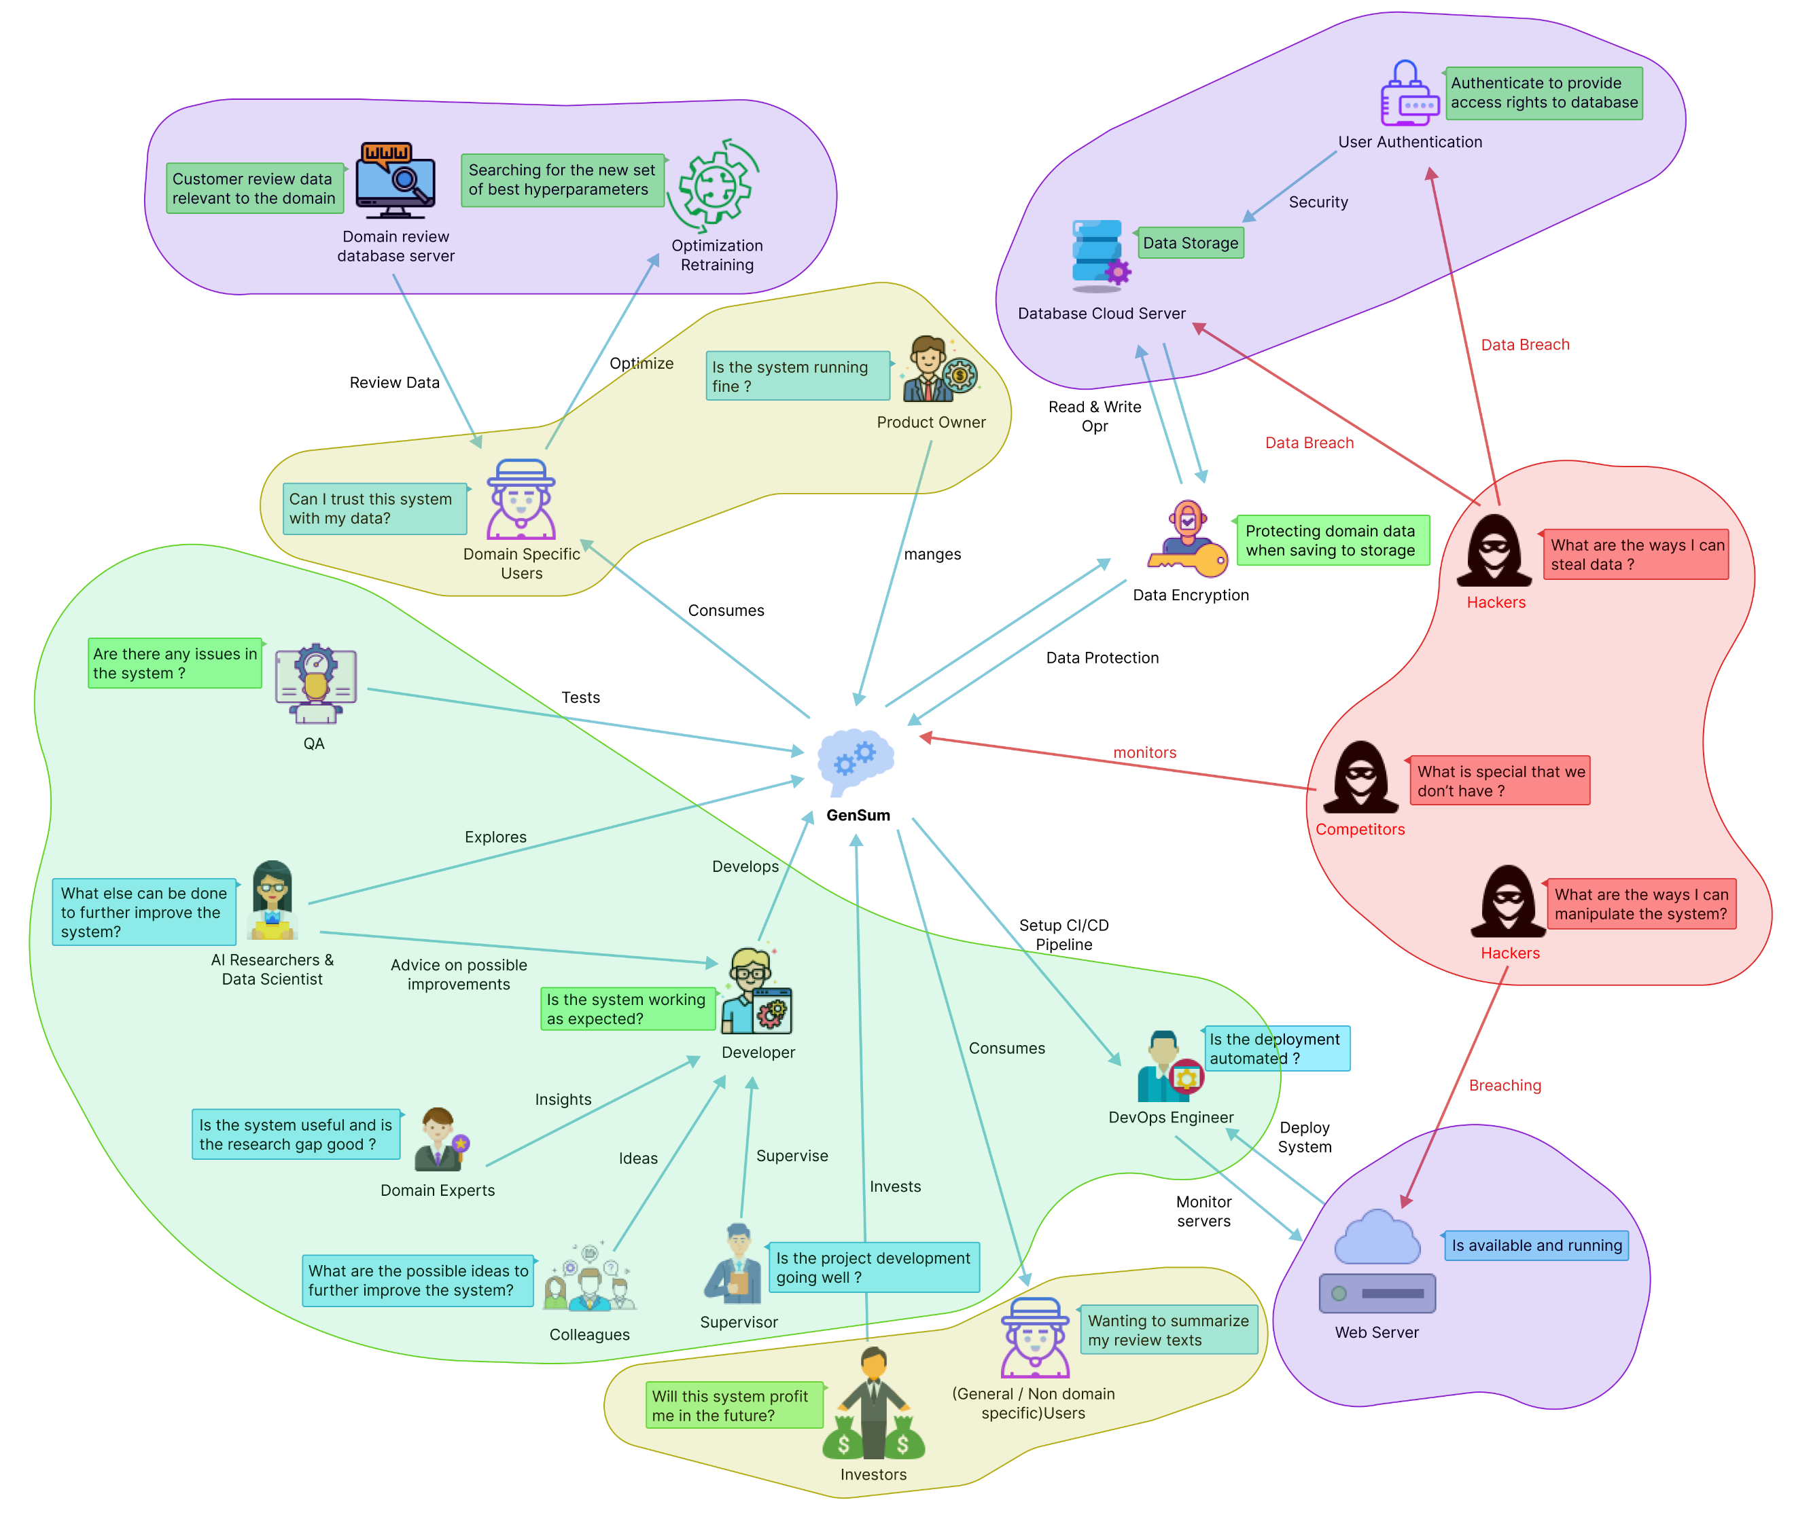

The diagram shows a bird's-eye view of the surrounding region and stakeholder interactions with the system. It also identifies potential negative impacts and prospective critical analyses in addition to the researcher's gained knowledge to improve the system.

# **4.3 Stakeholder analysis**

The section identifies important stakeholders in the system, their relationships, and roles using the stakeholder onion model. It further elaborates on their perspectives.

## **4.3.1 Stakeholder onion model**

Figure 4: Stakeholder onion model (self-composed)

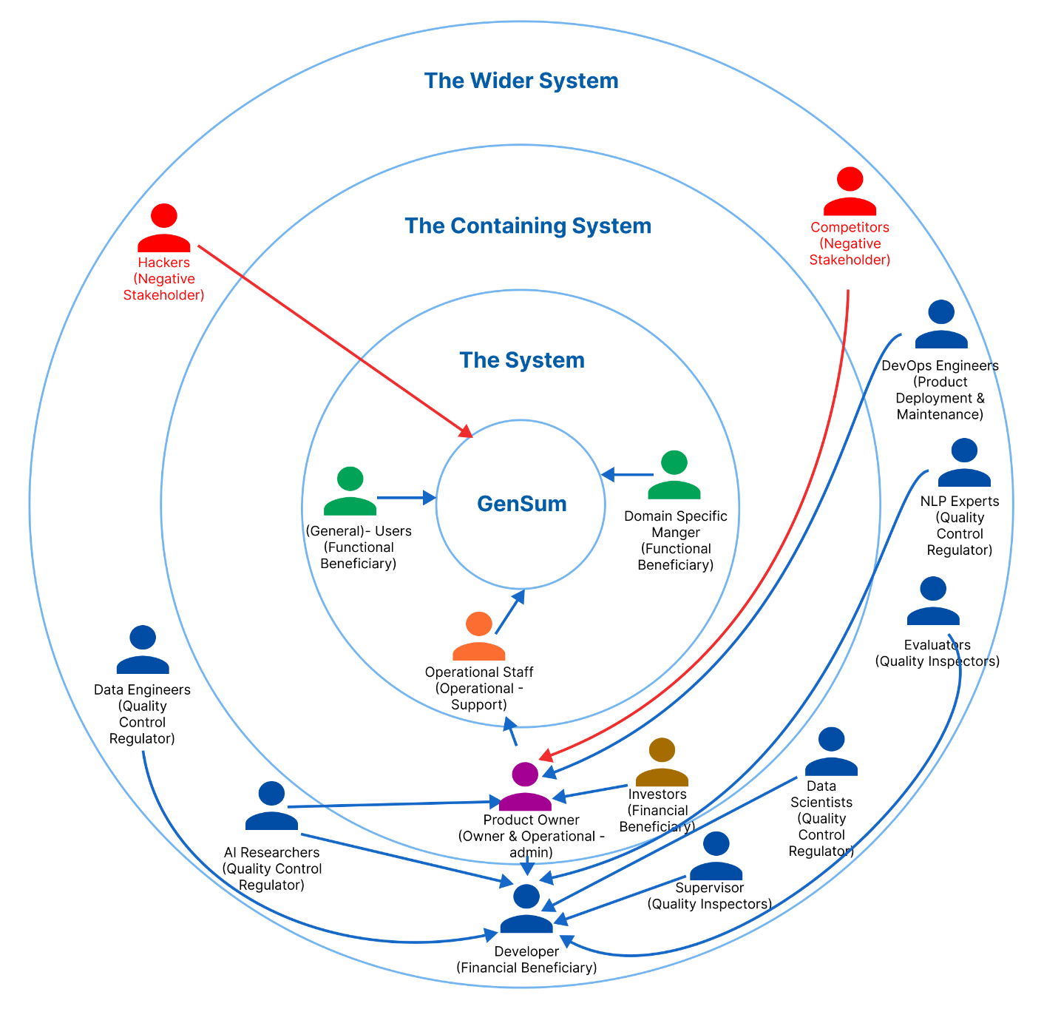

## **4.3.2 Stakeholder viewpoints**

Table 8: Stakeholder viewpoints & requirements

|  |  |  |
| --- | --- | --- |
| **Stakeholder** | **Role** | **Benefits/Description** |
| Developer | Financial  beneficiary | Works on developing the system |
| Investors | Profit is generated through system investment and money from marketing and user subscriptions. |
| Product Owner | Owner & operational admin | Owns the system and has control over the system |
| Data Scientists | Quality control regulator | Provides performance enhancements for the models and algorithms used in data science. |
| Data Engineers | Gives guidance on potential data that may be used to generate the best suggestions possible. |
| AI Researchers | Conduct research in the specified area to enhance and implement reliable text summarizing models. |
| NLP Experts | Offers specialized guidance and insights on the field, to enhance the functionality of the system. |
| Domain Specific Manager | Functional beneficiary | Text reviews are used as inputs for abstractive summarization, and the model is retrained with prior inputs as new data to increase performance. |
| General Users | Unless specifically assigned or retrained, typical users will utilize a general abstractive summarization model. |
| Operational Staff | Operational - support | Ensures that the system is up and functioning while responding to user requests and problems. |
| DevOps Engineers | Product deployment & maintenance | Makes ensuring the system is up and running in the cloud and is serving users without being throttled |
| Hackers | Negative stakeholder | May manipulate the review data stored in the database which will affect the retraining process. |
| Competitors | May build competing systems that may outperform the existing system. |
| Evaluators | Quality inspector | Checks to see if the system is ready for production use and puts it through its paces. |
| Supervisor | Checks to see if the system development is progressing well without any issues. |

# **4.4 Selection of requirement elicitation methodologies**

To gather the necessary information for the development of the research project, multiple approaches for requirement elicitation were employed. These approaches included a literature review, a survey, interviews, prototyping, brainstorming, and self-evaluation. The reasons for selecting each of these requirement elicitation approaches will be discussed in the following section.

Table 9: Requirement elicitation methodologies

|  |  |
| --- | --- |
| **Method** | **Description** |
| Literature Review | At the beginning of the project, the author performed an extensive literature analysis to identify research gaps in the chosen domain of interest and the intended topic of study. The author researched current systems and also examined comparable technologies that could potentially be applied to the existing systems referenced in the literature, in order to identify any research gaps related to the use of these technologies. |
| Survey | In order to gather requirements and opinions from potential users of the proposed system, a questionnaire was employed as a survey tool. This type of survey will be useful for the author in gaining insight into the thought processes and expectations of users regarding the prototype. Additionally, it will allow the author to determine whether the targeted users will derive benefits from the proposed solution. |
| Interviews | Expert insights into domain-specific requirements and the most effective approach to addressing the issue while contributing to the body of knowledge through research were obtained through interviews. Given the novelty of the field and the need for very precise technical expertise, interviews were identified as the most valuable source of information. Moreover, this approach facilitated a qualitative assessment of the proposed system, making it possible to identify any shortcomings or challenges that might require resolution during prototyping. |
| Prototyping | The project was chosen to follow the Agile Software Development Life-cycle, thus prototyping would allow the author to test and evaluate the prototype while iteratively trying out several alternative implementations to find any potential areas for improvement. |
| Brainstorming | In order to access the system personally, brainstorming is done. A valuable technique for generating ideas at every stage of the research process, whether one is seeking to develop a broad topic, focus more specifically, or identify evidence for a particular paragraph. The author utilized this approach to evaluate the system personally, engaging in multiple brainstorming sessions with colleagues at different stages of the project. |
| Self-Evaluation | Self-evaluation is done in order to examine the currently available applications, do competitor analyses on the current systems, and get insight into how negative stakeholders, such as hackers, can breach the system and find a way around to protect the data and the system. |

# **4.5 Discussion of findings**

The relevant key stakeholders are split up into groups where the chosen best methodology was used for each group. **APPENDIX C.1** contains a complete breakdown of these stakeholders.

## **4.5.1 Literature review**

Table 10: Literature review findings

|  |  |
| --- | --- |
| **Discussion of Findings** | **Citation** |
| Upon concluding the review of existing literature, it was determined that abstractive text summarization systems applied to customer reviews can aid users in making more informed and expeditious decisions, whether those decisions pertain to purchasing products or selecting a movie. The summarization of user reviews has been shown to be a time-saving approach for customers. | Boorugu, Ramesh and Madhavi (2019) |
| During the investigation of technologies suitable for achieving the desired outcome, it became evident that conventional machine learning and deep learning methods were solely utilized for abstractive text summarization in the movie review domain, while more sophisticated deep learning techniques such as Transformers remained unexplored for this specific domain. | Khan et al. (2020) |
| It was observed that the optimization of transformers has not been examined in the context of abstractive text summarization in general, rather than solely in the movie domain. | Gupta et al. (2021) |
| Previously, datasets that are relevant to achieving model generalization have been utilized and are suggested for use by researchers who aim to explore the concept of generalization in the abstractive text summarization domain. | Kouris, Alexandridis and Stafylopatis (2019) |

## **4.5.2 Brainstorming**

The author brainstormed with colleagues, supervisors, and through self-analysis across various project phases.

Table 11: Observations findings

|  |
| --- |
| **Criteria** |
| Any gaps or limitations in the research related to the current project domain, which could be addressed to broaden the scope of research. |
| **Discussion of Findings** |
| After a brainstorming session, multiple ideas were generated. The author's supervisor suggested creating a performance adaptive generalization model and utilizing newly acquired data from domain users for retraining purposes. They also proposed amalgamating all data related to the common domain for retraining, which would increase data count to enhance the system's performance. |

## **4.5.3 Interviews**

Interviews with experts and researchers in the relevant domains were performed to obtain insights on the technical domain competence. To determine the project requirements, experts and researchers in ML and abstractive text summarizing systems were chosen. 2 PhD candidate in ML and Computational Linguistics, 1 NLP Researcher, 2 Software Architects, 1 Software Engineer and 1 Lecturer with MSc completion were interviewed. The interview outcomes were processed to a thematic analysis based on the following themes. Interview participant details along with the related evidence can be found at **APPENDIX C.2**

Table 12: Interview analysis codes

|  |  |
| --- | --- |
| **Theme** | **Code** |
| Data handling | Data Collection & Data Preprocessing |
| Transformer architectures | Best performing transformer architectures |
| Generalization | Handling adaptive generalization |
| Research scope | Research gap and scope |
| Hyperparameter tuning | Automatic hyperparameter tuning & model retraining |
| Hybrid transformers | Looking into hybrid transformer combinations |
| Custom transformers | Customizing the transformer architecture |
| Prototype | Prototype features and suggestions |
| Business benefits | Understanding which and how businesses would benefit |
| Evaluations | Understanding the importance and evaluation ways |

Table 13: Interview results

|  |  |
| --- | --- |
| **Theme** | **Conclusion** |
| Data handling | Data accessibility and preparation are crucial factors in a data science project. PhD candidates recommended using well-researched and validated datasets for the generalization field to ensure data quality. However, NLP experts raised concerns about including text data with characters from other languages, unless the project is restricted solely to English language support. |
| Transformer architectures | Interviewees suggested that transformer architectures like BERT, GPT-2, Roberta, and T5 can effectively address NLP tasks such as text summarization and sentiment analysis. They recommended using the latest versions of these models, as they are regularly updated and improved. To stay informed about these updates, they suggested monitoring daily analytics from websites like Hugging Face, including download and like counts. |
| Generalization | Software engineers and architects recommended utilizing NoSQL databases such as MongoDB or Firebase for storing data pertaining to domain-specific managers, citing their scalability and performance benefits. |
| Research scope | The experts concur that utilizing optimized transformers to address the issue is a commendable idea, but due to the time constraints of the project, they suggest giving priority to the movie domain and delaying the development of a more comprehensive adaptive solution. |
| Custom transformers | PhD applicants also mentioned that customizing the transformer architecture will also help contribute to the performance of the system. |
| Hyperparameter tuning | NLP researchers and lecturers proposed several methods of employing tools and libraries to facilitate hyperparameter tuning, as doing so manually can be excessively time-consuming and unnecessary. |
| Hybrid transformers | PhD applicants expressed a positive response towards the hybrid transformer combination with ensemble techniques. However, many believed that the project's scope was expanding beyond the available time and increasing its riskiness. |
| Prototype | The interviewees showed an interest in the novel domain-specific retraining system and suggested incorporating a pretrained model for sentiment analysis if time permits. |
| Business benefits | According to most interviewees, the movie domain, tourism, e-commerce, book industry, and researchers would find the use of text summarization systems for customer reviews beneficial in their businesses. |
| Evaluations | The PhD candidates and NLP experts stressed the importance of evaluations in the adaptive generalization model and proposed limiting the project to a maximum of three domains to facilitate comparison and demonstrate the model's effectiveness more clearly. |

## **4.5.4 Survey**

Table 14: Survey analysis

|  |  |
| --- | --- |
| **Question** | Have you ever realized that reading lengthy reviews takes a significant amount of time? |
| **Aim of question** | To determine whether the audience as a whole considers reading lengthy reviews to be a time-consuming activity. |
| **Findings & Conclusion**  The findings suggest that over 90% of the audience considers reading lengthy reviews to be a time-consuming and burdensome task, and they would appreciate a faster solution to this issue, such as summarization. These results confirm the author's initial hypothesis regarding a positive correlation.. | |
| **Question** | Do you believe that developing a generic system for all domains would be a wise course of action? |
| **Aim of question** | Ensuring that developing a generic system would be beneficial in all domains |
| **Findings & Conclusion**  The results suggest that over 90% of the participants are in favor of developing a generalized system that can adapt to the specific domain as it is being used. They believe that this effort is valuable and worth pursuing in the context of the project. This finding is in line with the author's expectations and indicates a positive correlation between the intended goal of the project and the participants' views. | |
| **Question** | Who do you think will most benefit from this system? |
| **Aim of question** | Getting to know about the thoughts of the participants about to whom the system would mostly benefit from? |
| **Findings & Conclusion**  The conclusion is that more than 60% of the participants believe the proposed system would be beneficial for movie, restaurant, tourism, hotel, and e-commerce domains as they interact with users on a daily basis and use customer reviews as part of their business. The system could also benefit general users. | |
| **Question** | How much do you think that this system would benefit you? |
| **Aim of question** | Getting to know how much the system would benefit the general participants which are NOT domain specific |
| **Findings & Conclusion**  Based on the statistics graph, it can be inferred that approximately 75% of the respondents believe that the system would be helpful for their general work or needs, provided that it is not limited to a specific domain. This result indicates a positive correlation with the collected statistics. | |
| **Question** | How much do you think that this system would benefit businesses? |
| **Aim of question** | Getting to know from the participants as to how much the system would benefit businesses/domains in solving this problem. |
| **Findings & Conclusion**  Based on the statistics graph, it can be inferred that around 84% of the participants believe that the system would be beneficial for businesses. This aligns with the author's initial expectation and is a positive correlation from the obtained statistics. | |
| **Question** | Before making a reservation or booking a movie or a hotel, do you read the customer reviews? |
| **Aim of question** | Getting an idea from the audience if in general they give importance to customer/user reviews to any domain before consuming their product or services. |
| **Findings & Conclusion**  Based on the results, it can be inferred that over 95% of the audience considers customer reviews a crucial element in their decision-making process when it comes to purchasing a product or service. This highlights the significance of customer reviews in fostering business growth. | |
| **Question** | How much you think customer reviews are important with respect to any domain? |
| **Aim of question** | Getting an idea from the audience to see how much they value customer reviews. |
| **Findings & Conclusion**  From the statistics graph, it can be concluded that roughly 90% of the audience finds that customer/user reviews are very important irrelevant to the domain, which is a positively correlated results from the achieved statistics and that’s what the author expected to achieve. | |
| **Question** | Which additional features would you want to see in this system. |
| **Aim of question** | To identify the systems non-functional requirements which could potentially improve the system. |
| **Findings & Conclusion**  The majority of participant responses were concerned with classifying the review text's sentiment after it had been summarized and with managing a list of review uploads so as to add filtering for the summarized review text based on the sentiment, whether it was positive or negative, along with the sentiment score. | |

Table 15: Survey thematic analysis codes

|  |  |
| --- | --- |
| **Code** | **Theme** |
| Convenience | User-friendly |
| Adjustability | Flexibility |
| Insights | Reliability |
| Advancement | Future Enhancement |

Table 16: Survey thematic analysis

|  |  |
| --- | --- |
| **Theme** | **Conclusion** |
| User-friendly | A group of participants required to upload more than one review and a time/bulk at once. |
| Flexibility | A majority of the participants requested for sentiment of the summary and the sentiment score to be also included with the output. |
| Reliability | A majority of the participants found the system being useful in the industry with time. |
| Future Enhancement | Few participants requested integrate a recommendation system for a specific domain. |

## **4.5.5 Self evaluation**

Author does competitor analysis, self-evaluates data protection from hackers and lists abstractive text summarization tools.

Table 17: Competitor analysis

|  |  |  |  |  |  |
| --- | --- | --- | --- | --- | --- |
| **Competitor Analysis Table** | | | | | |
| **Tools**  **Feature** | **Summarize Bot** | **Resoomer** | **Smmry** | **Text Compactor** | **GenSum** |
| Summarizing Text | **✓** | **✓** | **✓** | **✓** | **✓** |
| Domain Specific Generalization | 🗶 | 🗶 | 🗶 | 🗶 | **✓** |
| Ease of Use via GUI | 🗶 | **✓** | **✓** | **✓** | **✓** |
| Summary sentiment and score | 🗶 | 🗶 | 🗶 | 🗶 | **✓** |

GenSum is **unique** due to its Domain Specific Generalization feature, not found in other tools. Competitor tools lack sentiment information, and encryption can protect text data in the database from theft during model retraining.

## **4.5.6 Prototyping**

Table 18: Prototyping findings

|  |
| --- |
| **Criteria** |
| To investigate the viability of proceeding with the project research. |
| **Discussion of findings** |
| Throughout the iterative prototype process, the author faced various requirements and difficulties. One such challenge was the search for an appropriate dataset with the desired metadata within the movie domain.  Following a thorough assessment, the author identified a substantial dataset comprising 8 million records. However, its size and the presence of noisy text made it challenging to preprocess, although it was eventually accomplished. As the project's focus shifted towards generalization, the author explored different datasets to ensure it.  The author conducted experiments using a framework known as "Optuna" to automate the hyperparameter search for the model training and model architecture customization. Additionally, the system will undergo retraining using fresh data from the domain user, and the author intends to investigate at least three high-quality transformer designs to determine the optimal one.  In preparation for the testing phase and to assess the model's generalization ability, the author gathered datasets from two domains, specifically movies and hotels. Additionally, the author explored data encryption techniques to ensure the security of the data. |

## **4.5.6 Summary of findings**

Table 19: Summary of findings

|  |  |  |  |  |  |  |  |
| --- | --- | --- | --- | --- | --- | --- | --- |
| **Id** | **Finding** | **LR** | **Survey** | **Self-Evaluation** | **Interview** | **Brainstorming** | **Prototyping** |
| 1 | The proposed system benefits domain-specific and general users. |  | ✓ |  |  | ✓ |  |
| 2 | Optimized transformers can enhance abstractive text summarization performance in the movie domain, which is currently limited. | ✓ |  |  | ✓ | ✓ |  |
| 3 | Customer reviews are highly valued by the majority of users before using a product/service, across all domains. | ✓ | ✓ |  | ✓ | ✓ |  |
| 4 | Users prefer shorter reviews to save time and make quicker decisions. | ✓ | ✓ |  |  | ✓ |  |
| 5 | Hyperparameter tuning improves system performance and can be done manually or automatically. | ✓ |  |  | ✓ |  | ✓ |
| 6 | Preprocessing movie data for generalization requires considerable effort due to raw datasets that are difficult to obtain, especially with expected metadata. | ✓ |  |  |  |  | ✓ |
| 7 | Users mostly expect sentimental analysis and score for the review summary. |  | ✓ |  |  |  |  |
| 8 | Suggest creating a hybrid transformer model to improve performance. |  |  |  | ✓ | ✓ |  |
| 9 | Suitable evaluation metrics for abstractive text summarization are clear. | ✓ |  |  | ✓ |  |  |
| 10 | It’s clear on what the top tier transformer architecture that could be explored. | ✓ |  |  | ✓ |  |  |
| 11 | Retrain using larger new data from businesses within the same domain (e.g., combine data from 50 restaurants for retraining if the domain is "Restaurants"). |  |  |  | ✓ | ✓ |  |
| 12 | Using data encryption to protect against data theft by hackers. |  |  | ✓ |  | ✓ |  |
| 13 | Model architecture customization contributes to the increase in performance | ✓ |  |  | ✓ |  | ✓ |

# **4.6 Context diagram**

The boundaries and interactions of the system should be established before development. The graphic below shows how the system is situated.

Figure 6: Context diagram



# **4.7 Use case diagram**

Figure 7: Use case diagram (self-composed)

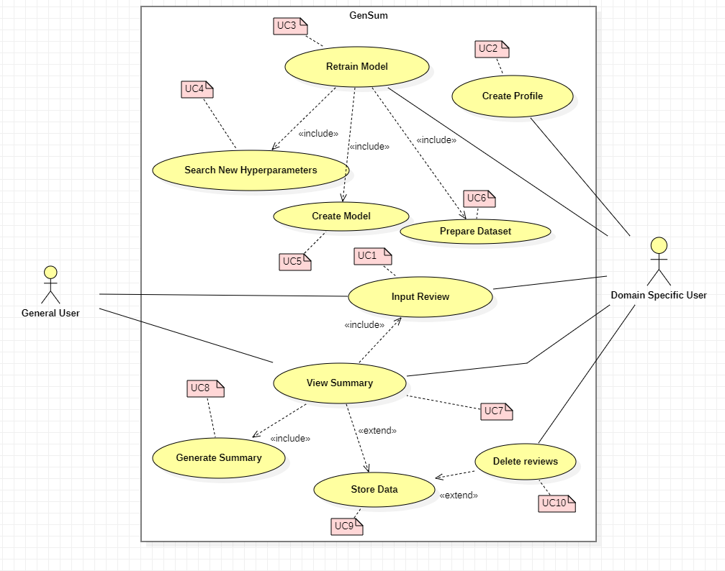

# **4.8 Use case descriptions**

Usecase diagrams with the highest importance are given below, the rest of the usecase descriptions are available at **APPENDIX C.3.**

Table 20: Use case description UC:07

|  |  |  |
| --- | --- | --- |
| Use Case Name | View Summary | |
| Use Case Id | UC:07 | |
| Description | Displays a summarized version of the uploaded review text from the domain user’s end. | |
| Primary Actor | General User, Domain Specific User | |
| Pre-Conditions | The text review data must go through specific text preparation techniques before the summary can be produced. | |
| Extended use cases | UC:09 | |
| Included use cases | UC:01, UC:08 | |
| Trigger | A user selects to summarize a given customer/user review text. | |
| Main flow | **Actor** | **System** |
| 1. The user enters the review text on the text field from the GUI. 2. Clicks on “Generate Summary” from the GUI | 1. The system does the data preprocessing for the input review text. 2. Loads the generalized transformer model. 3. Generates the summary using the model. 4. **(If Domain Specific User)** stores the input review and summary into the database. 5. Returns the summary response back to the GUI |
| Expectational flows | Displays an error message if the network request fails (server is down, or internet issues from client). | |
| Post Conditions | Success end condition: The user is presented with the summarized review text. | |

Table 21: Use case description UC:03

|  |  |  |
| --- | --- | --- |
| Use Case Name | Retrain Model | |
| Use Case Id | UC:03 | |
| Description | Performs model retraining with the new data from the database, to find the new best set of hyperparameters for model customization and model training. | |
| Primary Actor | Domain Specific User | |
| Pre-Conditions | The actor should be a Domain Specific User and have an account created. | |
| Extended use cases | None | |
| Included use cases | UC04, UC05, UC06 | |
| Trigger | The Domain Specific User clicks on the “Perform model retraining” button | |
| Main flow | **Actor** | **System** |
| 1. Domain Specific logs into their account 2. Clicks on “Perform model retraining” from the GUI | 1. The system pulls all the data with respect to the user id from the database. 2. Combines data of the common domains (only if user consent is given to use their data) 3. Finds new set of hyperparameters for the model with respect to new data. 4. Trains the model using the new hyperparameters. 5. Saves the model with the user Id 6. Updates the status in the database if succeed/fails |
| Expectational flows | Displays an error message if the network request fails (server is down, or internet issues from client). | |
| Post Conditions | Success end condition: The user will be able to see the recent status of the model if the retraining is successful or failed | |

# **4.9 Requirements**

## **4.9.1 Functional requirements**

Based on the significance of the system demands, the ‘MoSCoW’ approach was utilized to identify their priority levels. The details related to the priority levels are detailed at **APPENDIX C.4.** The Usecase description along its mapping id is also listed at **APPENDIX C.3.**

Table 22: Functional requirements

|  |  |  |  |
| --- | --- | --- | --- |
| **FR ID** | **Requirement** | **Priority level** | **Use case** |
| FR1 | Both general and domain-specific users can input review text from the GUI for summary generation. | M | UC:01 |
| FR2 | Retrain system with new data for specific domains after obtaining user consent via GUI. | M | UC:03 |
| FR3 | The system must be able to find the new set of best hyperparameters with the usage of the new data. | M | UC:04 |
| FR4 | The system must be able to able to retrain the model with the new best hyperparameters and create the model | M | UC:05 |
| FR5 | The system must be able to pull the new data from the database to recreate the new dataset for retraining. | M | UC:06 |
| FR6 | The system must be able to process the review text and display the summary output on the GUI | M | UC:07 |
| FR7 | The system must be able to use the latest trained model to generate the summary for the review text | M | UC:08 |
| FR8 | User review and generated summary should be stored in the database for retraining. | M | UC:09 |
| FR9 | The system should encrypt the data when saving into the database (both the review and summary) | S | UC:09 |
| FR10 | Only domain-specific users can create an account after providing required details. | S | UC:02 |
| FR11 | The system could allow the ability to update the account details of the domain user after creating the account | C | UC:02 |
| FR12 | The system could be able to perform model retraining automatically during off peak hours every day. | C | UC:03 |
| FR13 | The system could also find the sentiment of the generated summary if its positive or negative and return the result. | C | UC:08 |
| FR14 | The system could make use of a hybrid model for the text summarization. | C | UC:08 |
| FR15 | Combine data from common domain groups for dataset creation only with approved consent. | C | UC:06 |
| FR16 | The system could allow the domain users to delete the reviews from the database. | C | UC:10 |
| FR17 | The system could automate and update the model architecture to increase performance. | C | UC:04 |

## **4.9.2 Non-functional requirements**

The non-functional requirements are also prioritized based on the ‘MoSCoW’ approach.

Table 23: Non-functional requirements

|  |  |  |  |
| --- | --- | --- | --- |
| **NFR ID** | **Requirement** | **Specification** | **Priority level** |
| NFR1 | The system needs to be simple enough for non-technical individuals to utilize without much effort. | Usability | M |
| NFR2 | Summary generation should be done within 3000ms | Performance | M |
| NFR3 | Following coding standards and best practices | Maintainability | M |
| NFR4 | Application can be used by any domain users and model adapts to the domain. | Generalization | M |
| NFR5 | Meaningful error messages should be displayed if anything goes wrong | Usability | C |
| NFR6 | The system should protect against data corruption by attackers, and testing can ensure this. | Security | C |
| NFR7 | The prototype must support many concurrent user-requests from multiple businesses under a single domain. | Scalability | C |

# **4.10 Chapter summary**

A Rich Picture Diagram was used to show the system's interaction with society and stakeholders, with the Saunder's Onion model used to depict stakeholders. Requirement gathering techniques were used to collect data and opinions, and use cases, functional and non-functional requirements were specified accordingly.

# **CHAPTER 05. SOCIAL, LEGAL, ETHICAL & PROFESSIONAL ISSUES**

# **5.1 Chapter overview**

In this chapter, the social, legal, ethical, and professional concerns that emerged during the course of this project are delineated, along with the measures that were implemented to address them.

# **5.2 SLEP issues and mitigation**

The table presented below provides a detailed analysis of the identified social, legal, ethical, and professional (SLEP) issues, as well as the corresponding mitigation strategies that were employed.

Table 24: SLEP issues & mitigation

|  |  |
| --- | --- |
| **Social** | **Legal** |
| The thesis included a summary of questionnaire responses without exposing personal opinions. Interviewees were informed that their responses would be used and their consent was obtained for including their name or job title. | Study datasets are free to the public, and the research tools and technologies are open source or free to students, making them widely available. The codebase used in the research is also open source and accessible on GitHub under the MIT license. |
| **Ethical** | **Professional** |
| The participants were given clear information about the use of their collected data. The report contains original work and all external sources have been appropriately cited and credited. | The author maintained professional standards for the project and did not alter any collected responses or evaluations. Any limitations encountered during the study were acknowledged. |

# **5.3 Chapter summary**

In this chapter, the author has expounded upon the social, legal, ethical, and professional issues that were encountered during the research process, and has outlined the measures taken to address and resolve them.

# **CHAPTER 06. DESIGN**

# **6.1 Chapter overview**

This chapter discusses the design decisions made to establish an appropriate architecture for implementation based on the requirements obtained. High-level design, low-level design, design diagrams, and UI wireframes have been used to describe how the design goals are meant to be achieved while demonstrating the reasoning for selected design decisions.

# **6.2 Design goals**

The design goals that should be achieved by the system are specified at APPENDIX D.1.

# **6.3 High level design**

## **6.3.1 Architecture diagram**

The system has a three-tier architecture that separates the data, logic, and presentation levels.

Figure 8: Three-tiered architecture (self-composed)

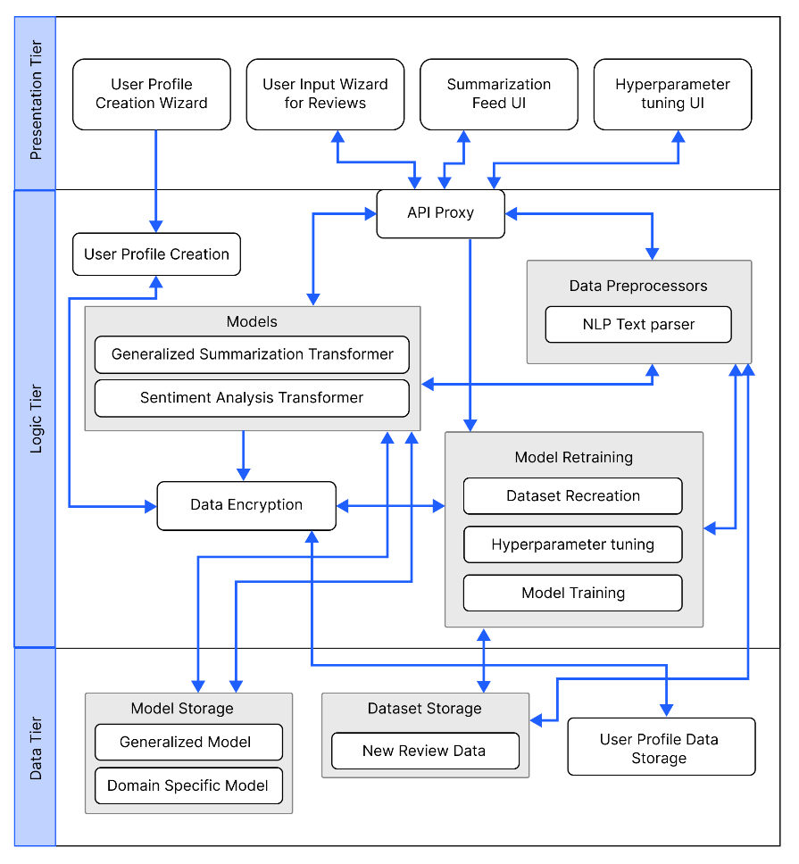

## **6.3.2 Discussion of tiers of the architecture**

**Data tier**

1. **Model storage** - The text summarization models which will be used for both generalized text summarization and domain specific text summarization will be stored here.
2. **Generalized model** – The model which will be used by general users to generated summarized text (this can be a review or any piece of text).
3. **Domain specific model** – The model will be used by domain specific users for review summarization, this model will be replaced whenever the model retraining is triggered from the domain user.
4. **Dataset storage** – The data which is required for model training will be available.
5. **New review data** – The data stored here are from the domain users when they use the application, the data will be storage and used for retraining.
6. **User profile data storage** – The metadata related to the domain specific user when creating the user profile will be stored, for updating and profile deletion.

**Logic tier**

1. **User profile creation** – Allowing to create unique user profiles for each domain user, main purpose comes when working with model retraining to figure out the data to be used.
2. **API proxy** – Interface which allows the frontend to communicate with the backend services via HTTP calls/ request.
3. **Data preprocessors** – The text data that will be used as input for the text summarizer must be cleaned using the preprocessing code.
4. **NLP text parser** – Responsible for cleaning the input text review when received from the API endpoint.
5. **Models** – The model which will be responsible in generating the summary from the input review and find the sentiment of the summary generated.
6. **Generalized summarization transformer** – This is the summarization model which will be used, an adaptive custom model depending on the domain and type of user interacting with the model.
7. **Sentiment analysis transformer** – This model will be used to classify the generated summary into positive or negative sentiment.
8. **Data encryption** – Data encryption is in charge of data protection/safety, keeping domain data extremely secure and leaving it useless even if it is stolen.
9. **Model retraining** – Responsible for retraining the model with new data and finding new set of hyperparameters.
10. **Dataset recreation** – Responsible for recreating the dataset with new data which has been given as input from the domain users
11. **Hyperparameter tuning** – Responsible for finding the new best set of hyperparameters using the new data.
12. **Model training** – Responsible for training the new model with the new set of hyperparameters found.

**Presentation tier**

1. **User Profile creation wizard** – UI offers users two options: create a new profile for domain business use, or skip sign up for a general summary.
2. **User input wizard for reviews** – The UI that will request the user to input the review which needs to be summarized.
3. **Summarization feed UI** – The UI that displayed the summarized text for the input review.
4. **Hyperparameter tuning UI** – The UI that triggers model retraining when the domain user performs an action on it.

# **6.4 System design**

## **6.4.1 Choice of design paradigm**

The author chose **SSADM** over OOAD for building a prototype due to its ability to easily extend system features in future development. Other reasons for choosing SSADM include its compatibility with existing company systems, availability of skilled personnel, and ability to produce comprehensive documentation. SSADM's phased approach and focus on requirements analysis were also seen as beneficial:

* Due to the main focus of the project being on Data Science, Object Oriented approaches are not expected to provide significant advantages.
* Ability to demonstrate the MVP (Minimum Viable Product) prototype implementation for the research application is more convenient.
* More time efficient when concerned with the time constraint of having to complete the documentation research along with the project implementation.

# **6.5 Design diagrams**

## **6.5.1 Data flow diagrams**

In order to show the relationships between components and provide a clearer understanding of how data flows across the whole system, the context diagram's components have been extensively broken down in the diagram below, which was detailed in the SRS previously.

### **6.5.1.1 Level 01 data flow diagram**

Figure 9: Data flow diagram - level 01 (self-composed)



### **6.5.1.2 Level 02 data flow diagram**

The level 02 data flow diagram given below is a further breakdown of the core hyperparameter tuning (training phase and model architecture customization) and model retraining proposed in the level 01 data flow diagram.

Figure 10: Data Flow Diagram - Level 02 (Self-Composed)

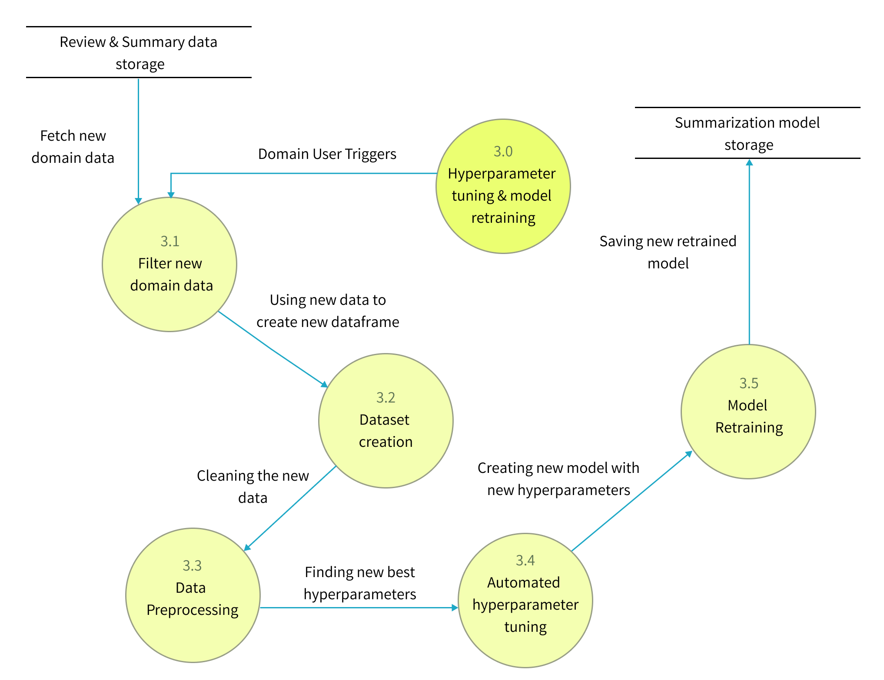

## **6.5.2 UI design**

Given the specifications acquired from the target audience, the author chose a web application for the simulation of the proof-of-concept application. A wireframe design was created to depict the key user interface aspects in the system and is available in **APPENDIX D.2.**

## **6.5.3 System process flowchart**

The flowchart given below represents the algorithm’s flow and the decision structures which explains the flow of the system which is the expected requirement.

Figure 11: System process flow chart (self-composed) – *(*[*view high qual version*](https://drive.google.com/file/d/11YyNSDSeN89-tCgTe2Yb1IinlAa0x98n/view?usp=share_link)*)*



# **6.6 Chapter summary**

This chapter provides an in-depth examination of the project's design, including its architectural features and explains the core flow via data flow diagrams. The chapter concludes with a preview of the user interface wireframes that will be utilized to facilitate interaction between the end-user and the system.

# **CHAPTER 07. IMPLEMENTATION**

# **7.1 Chapter overview**

This chapter will provide a thorough overview of the technologies, supporting tools, and languages utilized for the project development, as well as the fundamental implementation of the research prototype.

# **7.2 Technology selection**

## **7.2.1 Technology stack**

The technologies utilized to implement the prototype at each tier are given below.

Figure 12: Technology stack (self-composed)



In preference to macOS and Linux, **Windows** will be the operating system used for project development and documentation. This is due to a wider variety of software available, which ensures that it has more industry-standard tools than Linux and macOS, along with better compatibility and familiarity, which make things simpler to use and manage.

## **7.2.2 Data selection**

To ensure the accuracy of the generalized text summarization model, it is essential to use trustworthy data sources for training. The project relies heavily on data science for this purpose. To develop an adaptive generalized text summarization model, a generalized dataset was necessary for establishing the base model. TensorFlow datasets provided several options for this dataset, being a reputable source of data.

Table 25: Dataset sources

|  |  |  |
| --- | --- | --- |
| **Dataset** | **Source** | **Purpose** |
| CNN Dailymail | TensorFlow Datasets | Model Generalization |
| Gigaword | TensorFlow Datasets | Model Generalization |
| Xsum | TensorFlow Datasets | Model Generalization |
| Amazon movie reviews | Stanford University Data | Domain Testing |
| Hotel Reviews | Kaggle | Domain Testing |

All three datasets, CNN Dailymail, Gigaword, and Xsum, were used during the training process with various transformer architectures to determine which one had the best evaluation metrics. Xsum performed the best, so it was selected as the final dataset for the project. Resources related to the dataset used can be found in **APPENDIX E.1.**

## **7.2.3 Programming language selection**

**Python** was selected for the implementation of machine learning models and backend APIs in this study owing to its readability, simplicity, versatility, and wide range of use cases, which include web development, data analysis, scientific computing, and machine learning. Python benefits from a large and active community that provides abundant resources and support. Moreover, the availability of diverse libraries and frameworks such as NumPy, pandas, and TensorFlow has made Python a powerful tool for data science and machine learning tasks. On the other hand, **TypeScript**, superset of JavaScript, was chosen for frontend development with the aim of creating a highly interactive and engaging user experience, enabling dynamic content to be displayed**.** A further analysis of this can be found at **APPENDIX E.2**

## **7.2.4 Development framework selection**

The author has chosen several development frameworks for the project covering all areas, the table given below describes the purpose of choosing each framework and whats it used for in the project.

The author has conducted an analysis on the deep learning frameworks at **APPENDIX E.3****,** an analysis on the UI frameworks at **APPENDIX E.4**and about the API frameworks at **APPENDIX E.5**

Table 26: Development framework utilized

|  |  |
| --- | --- |
| **Framework** | **Reason for choosing** |
| React | ReactJS offers reusable components for efficient application development and has strong community support, making it a handy solution for developers. |
| Ant Design | Ant Design: React UI framework with pre-built components, customization, and tree-shaking compatibility for efficient frontend development. |
| Flask | Flask is a Python micro web framework for backend API development. It's lightweight, flexible, and offers a simple way to manage routing and processing with built-in server and extensions. |
| Optuna | Optuna: Python framework for efficient hyperparameter optimization with parallelization, ML library support, and automated features. |
| PyTorch | PyTorch is a Python-based machine learning framework with GPU support, pre-built neural network layers, and dynamic computation graphs. It's popular for its simplicity and powerful features in business and academia. |

## **7.2.5 Libraries utilized**

Table 27: Libraries used with reasonings

|  |  |
| --- | --- |
| **Library** | **Reasoning for selection** |
| Firebase | Backend services for mobile and web app dev. |
| Axios | Used for handling HTTP requests in JavaScript. |
| Redux | Used to control the state of JavaScript applications in a predictable manner by the use of actions, reducers, and a central store. |
| Hugging face Transformers | Hugging Face transformers library offers pre-trained models and tools for NLP tasks. |
| NLTK | NLTK is a NLP library with tools for tokenization, stemming, part-of-speech tagging, and language model training/evaluation. |
| Rouge | Library to evaluate text summaries by comparing them to reference summaries. |
| Pandas | Pandas is a data manipulation and analysis library widely used in data science for handling numerical tables and time series data. |
| NumPy | NumPy is a Python library for scientific computing that supports large multi-dimensional numerical arrays and mathematical functions to operate on them. |
| Matplotlib & Seaborn | Used for creating static, animated, and interactive visualizations in Python |
| Gramformer | Hugging Face's API allows easy fine-tuning and use of GPT-3 models for various text generation tasks. |
| Flask | Used for creating web APIs using Python to communicate with the transformer model and handling HTTP requests. |

## **7.2.6 IDE’s utilized**

Table 28: IDE’s used along with justifications

|  |  |
| --- | --- |
| **IDE** | **Justification for selection** |
| VSCode | VSCode is a highly adaptable and efficient code editor with features such as debugging, Git integration, syntax highlighting, and customizable extensions. |
| Google Colab | Due to its connection with Google Drive and availability of free GPUs, it’s helpful for developing machine learning models via a cloud environment. |
| Jupyter Notebook | Due to their interactive and readable format, making it ideal for local experimentation, documentation and collaboration. |

## **7.2.7 Summary of technology selection**

Table 29: Summary of technology selection

|  |  |
| --- | --- |
| **Component** | **Tools** |
| Programming Languages | TypeScript, Python |
| Development Framework | Flask, PyTorch, Optuna |
| UI Framework | Ant Design, React |
| Libraries | NLTK, Rouge, React, Pandas, Gramformer, Matplotlib & Seaborn, Axios, Transformers (from hugging face) |
| IDE – Research | Google Colab, Jupyter Notebook |
| IDE – Product | VSCode |
| Version Control | Git, GitHub |
| Data storage | Firebase |

# **7.3 Implementation of core functionalities**

The project's core functionalities include the experiments of top-tier transformer architectures to determine the optimal one, applying data preprocessing steps, automating hyperparameter searching & model customization, retraining the model with new data fetched from the database and new hyperparameters, and having the model be able to summarize reviews from both domain users and general users.

## **7.3.1 Automated hyperparameter search & model customization**

The author conducted a study on automating hyperparameter search for model training and customization to avoid the time waste of manual tuning. Optuna was selected as the preferred framework due to its flexibility and user-friendliness.

Figure 13: Model customization parameter initialization

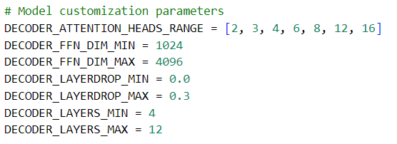

The code initializes the range of model architecture parameters based on the transformer decoder. These parameters will be utilized in automated hyperparameter search to determine the optimal parameters for the data input.

Figure 14: Training hyper-parameter initialization

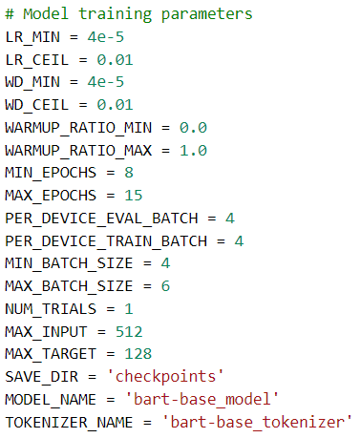

The code segment provided initializes the range of hyperparameters used during the training phase, taking into consideration the data and customized model, in order to obtain an optimized output.

Figure 15: Model decoder customization

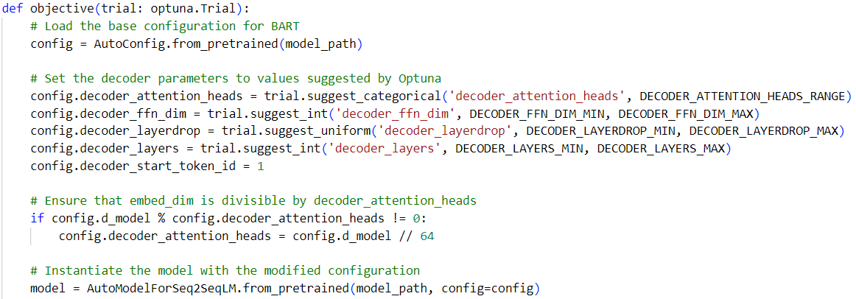

The presented code segment demonstrates the range of decoder parameters that are designated for searching using the Optuna framework. Once the best parameters are identified, they are configured and the model is initialized for the subsequent phase.

Figure 16: Model training hyperparameter tuning

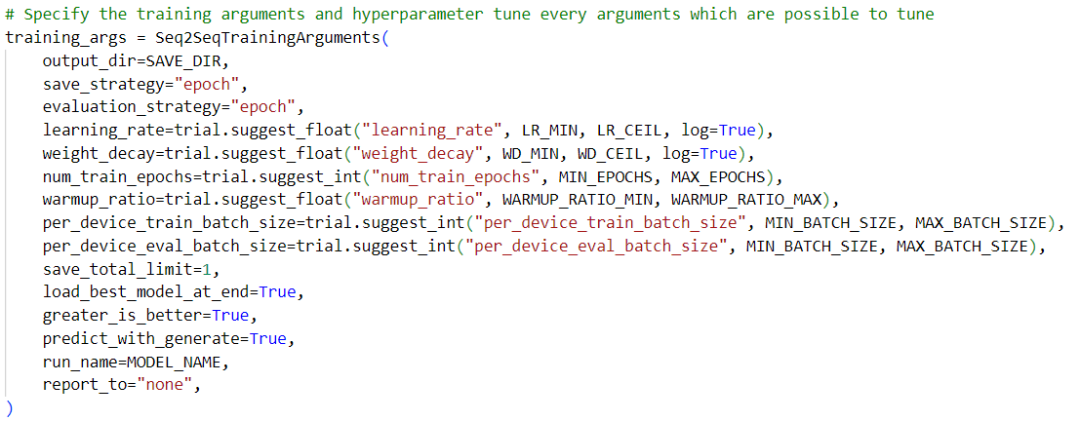

The above snippet shows how the Optuna framework is integrated with the model training code to perform automated hyperparameter search. The main performance contributing parameters for model training are considered for the hyperparameter searching this includes learning rate, weight decay, num of training epochs, warmup ratio, batch size.

Figure 17: Hyperparameter results and training arguments (self-composed)

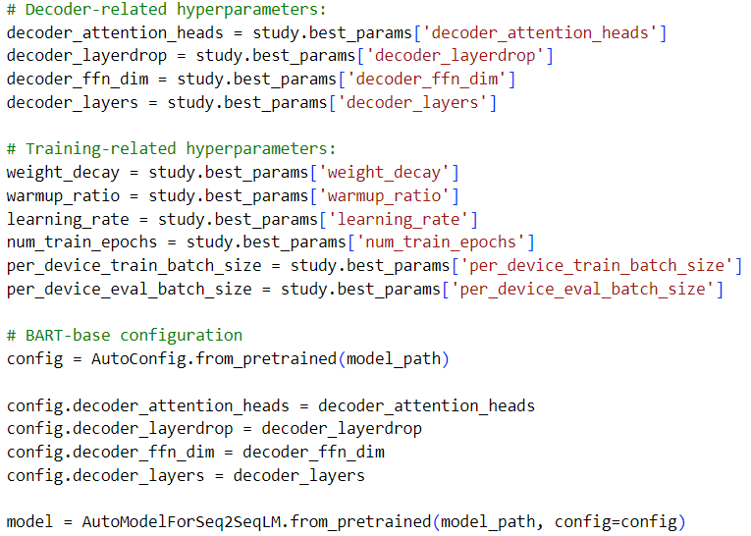

The above snippet demonstrates how to result of the hyperparameter search is used, to initialize the model.

Figure 18: Model training (self-composed)

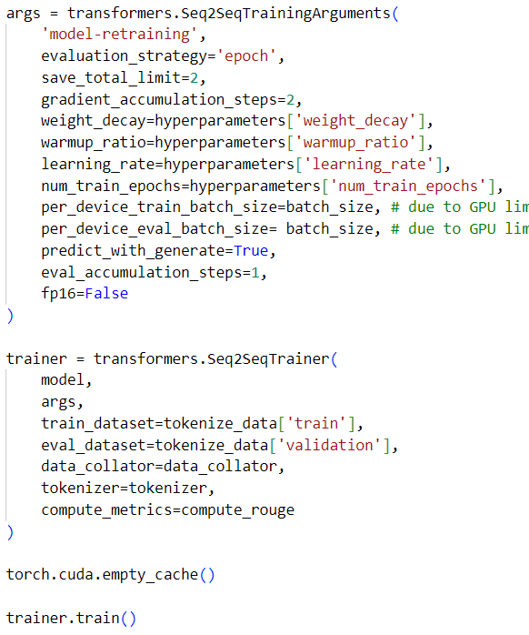

The above code snippet is the model training initiation with the optimal hyperparameters.

## **7.3.2 Model usage general & domain specific users**

Figure 19: General user review text summarization (self-composed)

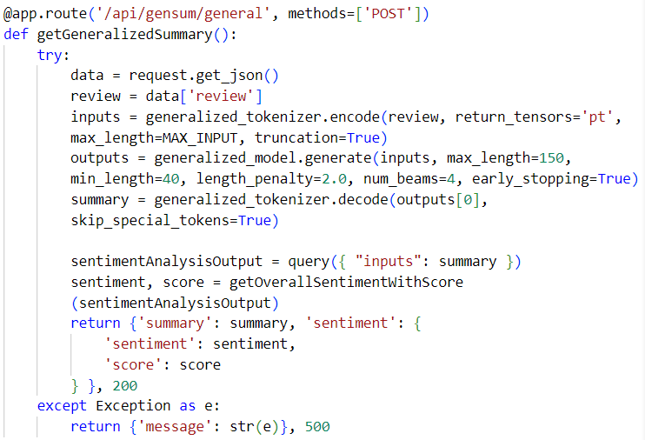

The provided code snippet above depicts an API endpoint that is responsible for generating text summaries (reviews) for regular users who are not required to create an account or have a specialized model allocated to them. Instead, a general model is employed.

Figure 20: Assigning a specific model for the new domain user (self-composed)

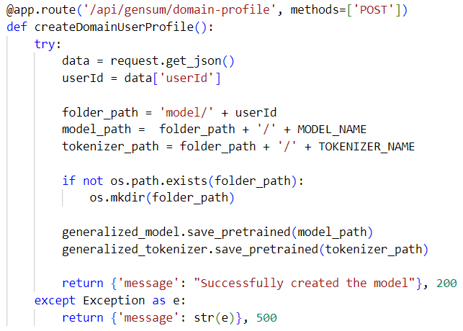

The above code snippet describes an API for assigning a copy of the generalized model for the user id of the domain (given that the domain user signed up for the application), the reason for creating a copy is for retraining purposes with new data.

Figure 21: Domain specific text review summarization (self-composed)

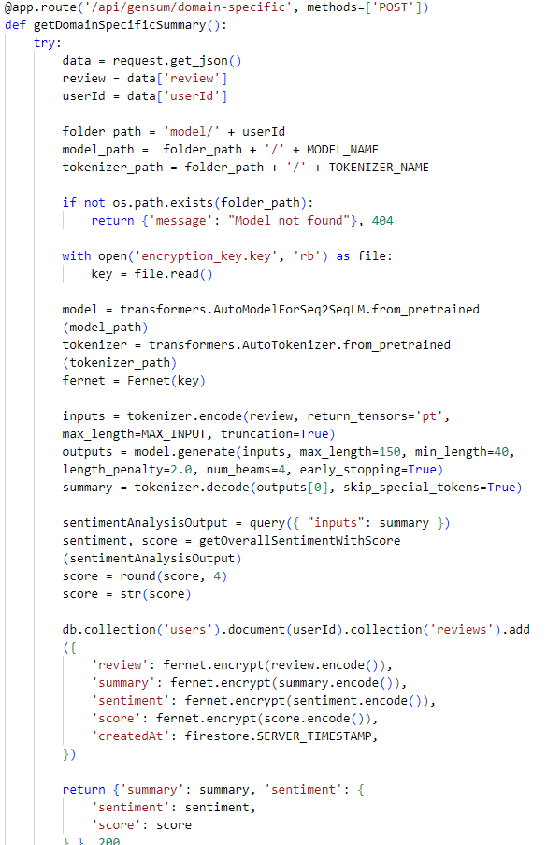

The code uses a domain-specific model to generate a summary, saves the input/output to a database, and analyzes sentiment using a pre-trained transformer from Hugging Face API.

## **7.3.3 Model retraining**

Figure 22: Fetching related data for model retraining (self-composed)

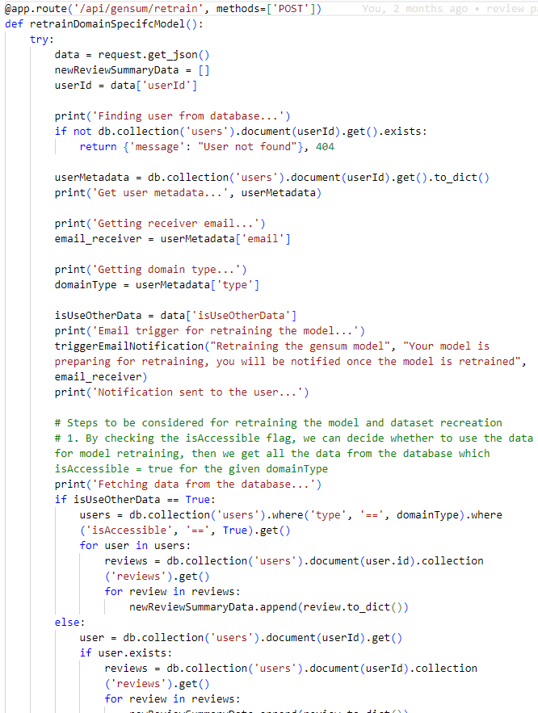

The code snippet above describes the necessary data fetched from the database to create the new dataset for model retraining, once the new dataset is created it is passed through a function to perform model customization & hyperparameter tuning and then retrain the model. Once completed retraining, the old model will be replaced with the new model in the folder path location.

## **7.3.4 Data preprocessing**

The raw dataset was contaminated with a lot of noise, numerous data preprocessing steps were required to clean the data before model training. The related preprocessing scripts can be found at **APPENDIX E.6**.

## **7.3.5 Generalized model training**

The steps taken to create the generalized model after the top tier transformer model experimentations can be found at **APPENDIX E.7**

# **7.4 User interface**

Screenshots of the final GUI are placed under **APPENDIX E.8**.

# **7.5 Chapter summary**

The chapter discusses the tools, technology, and languages utilized to create the research prototype. The fundamental functionality is covered, along with insights and samples of code for the implemented algorithms, moreover the testing and evaluation related code for the models is discussed.

# **CHAPTER 08. TESTING**

# **8.1 Chapter overview**

After achieving an acceptable level of implementation, it is imperative to subject the system to rigorous testing to ascertain that its functionalities operate as intended. This chapter entails conducting comprehensive testing on both the system and the utilized model. The testing methodologies employed encompass functional, non-functional, integration, and model testing, all aimed at providing an extensive evaluation of the system's performance.

# **8.2 Testing objectives & goals**

The primary objective of testing is to verify that the system functions in the expected manner. Achieving this objective requires meeting several testing goals:

* Confirm the model's performance is optimized.
* Ensure that the implemented functionalities are in line with the "Must have" and "Should have" criteria of the MoSCoW technique.
* Identify any necessary bug fixes or improvements that need to be applied to the application.
* Ascertain if the critical non-functional requirements have been satisfied.
* Perform benchmarking to establish a standard for comparing the system's future performance.

# **8.3 Testing criteria**

Before proceeding with the testing phase, a specific set of standards was established to assess the system using two different methods.

* **Functional Quality** – This involves examining the system's developmental traits and technical specifications to determine its conformity to the designated design based on functional requirements.
* **Structural Quality** – This evaluates the system's non-functional requirements while simultaneously ensuring that it satisfies the functional requirements' performance criteria.

# **8.4 Model testing & evaluation**

## **8.4.1 Model testing**

Three transformer architectures were trained and tested on the datasets. Validation accuracy and loss for each model are displayed below to select the best-performing model.

|  |  |
| --- | --- |
| Figure 23: Validation Accuracy by number of epochs – bart model (*Self-Composed*) | Figure 24: Validation Loss by number of epochs – bart model (*Self-Composed*) |

The BART model was tested and the rouge scores increased with more epochs after the optimization, yielding higher scores than previous research benchmarks. The validation loss decreased, indicating improved prediction accuracy.

|  |  |
| --- | --- |
| Figure 25: Validation Accuracy by number of epochs – t5 model (*Self-Composed*) | Figure 26: Validation Loss by number of epochs – t5 model (*Self-Composed*) |

Testing results of the T5 model are shown, with all ROUGE scores increasing exponentially and validation loss decreasing exponentially with the number of epochs. However, the results suggest that the BART model performs slightly better than the T5 model.

|  |  |
| --- | --- |
| Figure 27: Validation Accuracy by number of epochs – Pegasus model (*Self-Composed*) | Figure 28: Validation Loss by number of epochs – Pegasus model (*Self-Composed*) |

Pegasus model performed poorly in testing despite optimizing hyperparameters. Rouge scores remained low, and the validation loss graph showed no improvement in accuracy.

## **8.4.2 Model evaluation**

The models were evaluated based on recommended criteria from literature review and author's proficiency, and the evaluation metrics were presented in the **LR Chapter** under the "**Evaluation**" topic. Previous research by Steinberger and Jezek (2009) suggests that ROUGE and its metric versions are more appropriate for achieving optimal results compared to BLEU among the primary scoring methods.

Table 30: Model evaluation results

|  |  |  |  |  |
| --- | --- | --- | --- | --- |
| **Model** | **Rouge1** | **Rouge2** | **RougeL** | **RougeLSum** |
| Bart | 80.78 | 79.42 | 80.80 | 80.83 |
| T5 | 80.75 | 79.76 | 80.77 | 80.79 |
| Pegasus | 10.07 | 1.21 | 8.34 | 8.33 |

The evaluation shows that Bart performs better than the other two models, while Pegasus has the poorest performance, which could be due to various reasons despite optimization and suitable preprocessing. Bart and Pegasus have different model architectures, which could affect their understanding and representation of text data. One architecture may be more suitable for a specific dataset than the other.

**Domain model evaluation**

The adaptive generalized solution was tested with two different domains - **movies** and **hotels** - to demonstrate the effectiveness of the approach.

Testing dataset:

1. **Movie review**: The dataset was provided by Stanford University, which are amazon movie review data (SNAP, no date).
2. **Hotel review**: The dataset was provided by Kaggle (Jonathanoheix, 2018).

The following are the evaluation results for each domain when tested with the corresponding dataset listed above after model retraining with unseen data.

Figure 29: Hotel domain (cinnamon type) evaluation



Figure 30: Movie domain (scope cinema type) evaluation



Adding new data improves the performance of the domain-specific model, indicating the need for each domain to have its own continually improving model. The results support the idea of generalization.

# **8.5 Benchmarking**

The authors performed a benchmark comparison of his results along with the findings of previous researches. The results were presented in a table in the "**Benchmarking**" section of the literature review chapter.

Table 31: Benchmarking results

|  |  |  |  |  |  |  |
| --- | --- | --- | --- | --- | --- | --- |
| **Year** | **Type of model** | **Rouge1** | **Rouge2** | **RougeL** | **Is optimized** | **Dataset** |
| 2019 | Transformer | 36.73 | 14.93 | 29.66 | No | Xsum |
| 2019 | Bart | 45.14 | 22.27 | 37.25 | No | Xsum |
| 2020 | RoBERTa | 45.42 | 22.13 | 36.92 | No | Xsum |
| 2023 | Bart | 80.78 | 79.42 | 80.80 | Yes | Xsum |

The table compares the benchmarking results of transformer models on the Xsum dataset between previous researchers (2019-2020) and the author's evaluation (2023), showing a significant improvement in performance due to model optimization.

# **8.6 Functional testing**

The system was assessed to determine if it complies with the functional requirements outlined in **SRS** **Chapter**through the use of functional testing. A breakdown of the functional testing that was conducted can be found in **APPENDIX F.1**.

* **11/11 test case passed.**

# **8.7 Module & integration testing**

The high-level architecture diagram depicted in **Design** **Chapter** illustrated that the system's logic was divided into modules. To ensure that each module operates as intended, they underwent testing. The table give below indicates the module & integration testing results.

* **6/6 test cases passed.**

Table 32: Module & integration testing

|  |  |  |  |  |  |
| --- | --- | --- | --- | --- | --- |
| **Test case** | **Module** | **Input** | **Expected result** | **Actual result** | **Status** |
| 1 | NLP Text parser | Triggered when input review text | Preprocessing the input data | Preprocessing the input data. | Passed |
| 2 | Dataset recreation | Triggered during model retraining | Decrypts data from the database and creates new dataset | Decrypts data from the database and creates new dataset | Passed |
| 3 | Data Encryption | Triggered when domain user generates summary | Review text gets encrypted and stored into the database | Review text gets encrypted and stored into the database | Passed |
| 4 | Hyperparameter tuning | Triggered during model retraining | Using the new dataset, new hyperparameters are found along with the model customization | Using the new dataset, new hyperparameters are found along with the model customization | Passed |
| 5 | Model training | Triggered during model retraining | Using the new dataset and new hyperparameters, the custom model retraining is triggered | Using the new dataset and new hyperparameters, the custom model retraining is triggered | Passed |
| 6 | User profile creation | Triggered when domain user firstly signup | Assigns a copy of the generalized model for the user | Assigns a copy of the generalized model for the user | Passed |

# **8.8 Non-functional testing**

The system's non-functional requirements were evaluated to assess how well they correspond with the non-functional requirements and design objectives specified in **SRS** &**Design**chapterrespectively. **APPENDIX F.2** details the specific breakdown of the non-functional testing that was executed.

Table 33: Performance testing results

|  |  |
| --- | --- |
| **CPU**: 19% at 2.22 GHz | **Internet required**: Yes |
| **RAM**: 71% at 11.3 Gb | **GPU**: 14% |
| **SSD**: 3% |

Table 34: GUI testing results

|  |  |  |  |  |
| --- | --- | --- | --- | --- |
| **Page** | **Performance** | **Accessibility** | **Best Practices** | **SEO** |
| Landing page | 78% | 90% | 100% | 91% |
| Records page | 93% | 92% | 100% | 91% |
| User profile page | 78% | 91% | 100% | 91% |

* **Maintainability testing results**

1). CodeQL: passed

2). CodeFactor: passed

* **Non-functional requirements testing results**:

1). 6/6 testcases passed.

# **8.9 Limitations of the testing process**

Although the system underwent comprehensive testing, it has not been deployed or hosted yet, which makes it difficult to conduct production-grade load testing within the given timeframe.

# **8.10 Chapter summary**

In the beginning of this chapter, the aims of the testing process and the standards for conducting it were introduced. The evaluation of the models in use was performed by testing the main research component, and functional, non-functional, and integration testing were utilized to assess the system. Ultimately, any constraints of this methodology were identified.

# **CHAPTER 09. EVALUATION**

# **9.1 Chapter overview**

Once the prototype design was successfully implemented and optimized through multiple testing combinations to achieve maximum performance, the system was assessed in accordance with the requirements outlined in the **SRS chapter**. This particular chapter is devoted to the project's evaluation, which includes self-evaluation by the author and evaluations by technical, domain, and industry experts.

# **9.2 Evaluation methodology & approach**

The primary focus of this research to design and implement an adaptive generalized abstractive text summarization system using optimized transformers. Although the system produces text output, it employs numerical data for decision-making, rendering it a quantitative analysis for assessing its efficacy. Additionally, a qualitative analysis by domain experts is necessary to establish its reliability. This chapter will present the results of a **thematic analysis** of the feedback obtained through the aforementioned qualitative analysis.

The demonstration video of the research, which was utilized for assessments, can be located at the following URL: [**https://youtu.be/V5TVzauaU6A**](https://youtu.be/V5TVzauaU6A)**.**

# **9.3 Evaluation criteria**

In preparation for the evaluation process, it is essential to establish unambiguous criteria to evaluate all aspects of the research thoroughly. The following table delineates the specific criteria that the author established before initiating the evaluation.

Table 35: Evaluation criteria

|  |  |  |
| --- | --- | --- |
| **CR ID** | **Criterion** | **Purpose** |
| CR1 | Selection of research domain | To confirm the importance of the selected area of study, subject matter, and gap in research. |
| CR2 | Research contribution | To assess the importance of the discovered results and their contributions to the existing pool of knowledge. |
| CR3 | Research documentation quality | To verify that sufficient literature has been examined and that the entire research procedure has been recorded and presented with an acceptable level of quality. |
| CR4 | Development approach | The implementation of the prototype was carried out to ensure that the best possible development approach had been employed to address the problem at hand. |
| CR5 | Quantitative analysis of results | To verify the metrics employed to assess and analyze the outcomes generated by the research. |
| CR6 | Limitations & Improvements | To recognize any constraints or shortcomings and opportunities for future research. |
| CR7 | Usability & UI/UX | To confirm that the product created for demonstration purposes is user-friendly for end-users. |

# **9.4 Self-evaluation**

The table presented below depicts the author's self-assessment based on the aforementioned standards.

Table 36: Self-evaluation of the author

|  |  |
| --- | --- |
| **CR ID** | **Author’s self-evaluation** |
| CR1 | The selected research domain pertained to a technical application of significant utility, which holds promise for adoption by various users across diverse domains. However, given its relatively recent introduction, identifying domain experts presents a challenge. |
| CR2 | This research has made significant contributions in several areas aimed at enhancing the performance of text summarization using transformers. Firstly, it has made technical contributions in developing a generalized system for text summarization that can enhance domain-specific performance. Secondly, the contribution to the domain being to improve performance for review summarization for the domain of movies. |
| CR3 | The documentation has been produced to an exceptional level of quality, with Microsoft Word being utilized for all report documentation in order to ensure consistency across diagrams, tables, and internal links along with external links (video demonstration links). Nevertheless, LaTeX has been employed for the creation of both review papers and research papers. |
| CR4 | Considerable resources have been dedicated to gathering and preparing data to achieve optimal outcomes. Extensive experimentation has been conducted on several high-level transformer structures with diverse comprehensive datasets. Furthermore, state-of-the-art technologies and software have been employed throughout the process. |
| CR5 | The assessment outcomes of the model were produced within the Google Colab notebooks that were utilized for training the model. |
| CR6 | After finalizing the system, the author recognized a few areas where enhancements and improvements could be made, and suggested these as potential areas for future research. |
| CR7 | The user interface and experience of the final product has been designed in a way that is both usable and minimalistic. |

It's great to see that the author was able to complete the core functionalities for the prototype, even with the challenge of time constraints mentioned by the experts interviewed for the requirement gathering. It shows the author's determination and ability to overcome obstacles to achieve the project's goals

# **9.5 Selection of evaluators**

Evaluators were selected based on grouping, which was necessary to receive feedback on all aspects of the project. The table below illustrates the breakdown of the groups. The list of evaluators considered for the project can be found at **APPENDIX G.1**

Table 37: Categorization of selected evaluators

|  |  |
| --- | --- |
| **CAT ID** | **Category** |
| CAT1 | Experts who have conducted research in the areas of Text Summarization Systems, Data Science, Data Engineering, and Machine Learning. |
| CAT2 | Experts who possess expertise in NLP (Natural Language Processing) and transformers. |
| CAT3 | Possible end users of the application |

# **9.6 Evaluation results & expert opinions**

The opinions and feedback from the experts mentioned earlier were analyzed using thematic analysis. The results of this analysis are presented in the table below.

Table 38: Thematic analysis of expert feedback

|  |  |  |  |
| --- | --- | --- | --- |
| **CR ID** | **CAT ID** | **Theme** | **Summary of opinions** |
| CR1 | CAT1 | Text Summarization System choice gap | The utilization of text summarization can be highly advantageous for businesses, particularly in the realm of ecommerce where reviews play a crucial role in driving sales. |
| Technical research gap | The adoption of transformers as an approach for the domain is preferred over conventional methods, and further investigation into its optimization can prove advantageous. |
| CAT2 | Domain research gap | The identified objective is to bridge the gap in performance optimization and develop a solution that is more generalized. |
| CAT3 | Usefulness of domain research. | As it is an adaptive solution, there currently exists no generalized application to address the performance issue in this new domain application. |
| CR2 | CAT1 | Contribution of technology to text summarization systems. | The issues with conventional approaches have been clearly identified, and there is a clear understanding of the methods required to resolve this problem. |
| CAT2 & CAT3 | Domain Contribution | The proposed solution is a valuable contribution since there is currently no such solution available, and creating it as a plugin for businesses could provide significant benefits. |
| CR3 | CAT1 | Displaying of content | The utilization of Microsoft Word documents to their fullest potential was acknowledged, and the research conducted was thorough, including the presentation of statistical data. |
| CAT1 & CAT2 & CAT3 | The problem-solving approach used | A comprehensive analysis of various angles was undertaken to approach the solution, and a more logical approach has been adopted. |
| CR4 | CAT1 | Data preprocessing | Significant effort has been devoted to data pre-processing, as experimentation was conducted using multiple datasets, requiring additional time and resources. |
| CAT1 & CAT2 | Experimentation of transformers with datasets for generalization | The selection of transformer models for experimentation was thoroughly considered and adequately justified. |
| CAT1 & CAT2 & CAT3 | Development approach for adaptive generalization | The chosen direction was deemed suitable by all, and a systematic and methodical approach was employed within the given timeframe. |
| CR5 | CAT1 & CAT2 & CAT3 | Analysis of the text summarization model | The current evaluation, using the ROUGE metric, indicates a significant improvement in performance compared to previous benchmarking results, with a performance gap exceeding 50%. ROUGE is considered the most suitable metric for evaluating such models. |
| CR6 | CAT1 & CAT2 | Automated model customization | It’s great to see that customizing the transformer architecture is automated using Optuna in order to find out the best suited. |
| CAT3 | New feature additions | Prior to generating a summary, it would be advisable to incorporate a paraphrasing function, considering the possibility that users might input text with grammatical errors. |
| CR7 | CAT1 & CAT2 | Great to have a working application for the model | As the model appears to be functioning well during testing, developing a functional application for users would be a wise choice. |
| CAT 3 | Minimalistic UI design | The design of the UI is very simple and clean, where most of the users found it attractive to use. |

# **9.7 Limitations of evaluation**

As there is a scarcity of experts in the research domain (Transformers), only a limited number of expert opinions were obtained. This was apparent during the requirement gathering phase, as the author reached out to numerous ML/DL domain experts for more insights on the research concept, but only a few were able to provide relevant information. Therefore, only the experts specified in **APPENDIX G.1** possessed the required knowledge and expertise to provide constructive feedback. Nevertheless, traditional ML/DL experts were also approached to obtain feedback, as it could still prove to be beneficial.

# **9.8 Evaluation of functional requirements**

The breakdown of implementation of functional requirements is provided in **APPENDIX G.2**. It’s clear that **16 out of 17** functional requirements have been completed (**94.11% implemented**)

# **9.9 Evaluation of non-functional requirements**

The breakdown of completed non-functional requirements and the attainment of the design goals are presented in **APPENDIX G.3**. It’s clear that **6.5 out of 7** non-functional requirements have been completed which is of **(92.9% implemented**)

# **9.10 Chapter summary**

In this chapter, the implemented system was evaluated by establishing evaluation criteria that comprehensively covered all aspects of the system. The author conducted self-evaluation and obtained feedback from evaluators, which was analyzed through thematic analysis. The evaluation report presented the achievement of the proposed design goals, along with the evaluation of functional and non-functional requirements.

# **CHAPTER 10. CONCLUSION**

# **10.1 Chapter overview**

This chapter concludes the research project, highlighting the core functionality of the MVP's implementation. It reviews the project's achievements, obstacles encountered, and documents the author's prior knowledge and modules of the program that supported the project, along with any new knowledge and skills acquired.

# **10.2 Achievement of research aim & objectives**

## **10.2.1 Achievement of aim**

**“***The aim of this research is to design, develop and evaluate an optimal adaptive generalized transformer architecture from a range of popularly used architectures by automating the process of model customization and hyperparameter tuning for optimization, therefore obtaining the recommended architecture's optimum performance.***”**

The aim of the research was achieved by **designing, developing, and evaluating** a performance adaptive generalized transformer. The core functionality was automated to meet the project requirements, and the evaluation of the work is presented in the implementation chapter.

## **10.2.2 Achievement of objectives**

**APPENDIX H.1** lists the achievement status of the research objectives mentioned in Chapter 01, with "Completed" next to successfully completed tasks and "Incomplete" next to unfinished ones.

# **10.3 Utilization of knowledge from the degree**

Table 39: Utilization of knowledge gained from the course

|  |  |
| --- | --- |
| **Module(s)** | **Utilized Knowledge** |
| Machine Learning | Having a solid grasp of the concept of data collection and preprocessing, as well as machine learning model training, proved to be instrumental in creating the models used in this research project. |
| Applied AI | The author gained a comprehensive understanding of the theoretical principles behind ML models through their knowledge of how algorithms interact during the model-building process. |
| Software Development Group Project | The module acted as a trial run for the Final Year Project, giving students the basic skills needed to plan, conduct and evaluate research, thus providing them with the necessary confidence and knowledge for their final year project. |
| Object Oriented Programming | The understanding of object-oriented programming and the significance of creating classes helped improve the development aspect of the project. |
| Python Programming (PP1) | This project involves the use of Flask, a web framework for the Python programming language. The PP1 module introduced the author to working with Python. |
| Database Systems | The understanding of using queries to communicate with the database from the webserver system facilitated read and write operations for the project. |
| Web Design & Development | The concepts learned from this module were used to develop the user interface (UI) of the prototype, and the foundational knowledge of using HTML, CSS, and JS was instrumental in transitioning to working with more advanced frameworks like React. |

# **10.4 Use of existing skills**

* **Full-Stack Web Development** – The author utilized advanced technologies for a full stack web development project while working on several R&D projects during their internship at 99x.
* **Machine Learning / Deep Learning** – During the author's internship, they were involved in several R&D projects related to data science and also utilized various online learning resources to develop their skills in machine learning.
* **Documentation Writing** – The author became proficient in project documentation during their internship and while working on the SDGP module report.

# **10.5 Use of new skills**

* **Text Summarization Systems –** The author lacked prior experience in text summarization systems and thus conducted research on various techniques using publicly accessible online resources from YouTube, GitHub, Google Colab, and others.
* **Data Preprocessing Techniques –** The project domain being text summarization, the author had to acquire new text preprocessing techniques to ensure the data was meaningful.
* **Hyperparameter Optimization –** The author explored and experimented with hyperparameter tuning frameworks to automate the hyperparameter search & model customization, referring to tutorials and technical articles to implement this in the project.

# **10.6 Achievement of learning outcomes**

In **APPENDIX H.2**, there is a presentation of the accomplishment of the learning objectives.

# **10.7 Problems and challenges faced**

Table 40: Mitigations to problems and challenges faced

|  |  |
| --- | --- |
| **Problem/Challenge** | **Mitigation** |
| Significant training time and computing resource limitations. | The author uses Google Colab to train transformer-based models due to the high GPU power demands of the training process. |
| Limited experts for the domain (transformers) | The author conducted interviews with domain experts for requirement gathering by reaching out to them via LinkedIn since there were limited opportunities for in-person interactions with domain experts. |
| Time constraint when focusing on solving multiple gaps at the same time. | The author prioritized the research gaps which were planned to be addresses and worked accordingly to its importance. |
| The project experienced extended power cuts for more than one month towards the end, resulting in low battery levels and loss of internet connectivity. | To address the issue of power cuts and ensure continuous work, the individual worked overnight and utilized co-working spaces. They also acquired an Uninterruptible Power Supply (UPS) to power the WiFi router and other necessary peripherals. |

# **10.8 Deviations**

The author's original goal was to develop an optimized solution for ***movie review summarization*** using transformers. However, after discussions with supervisors, it was decided that the author's technical contribution of automated hyperparameter tuning for transformers model training was not significant enough. As a result, the idea of creating a ***performance adaptive generalized solution with model customization*** was considered to continue the research implementation. The Gantt chart plan at the beginning and end of the project can be located in **APPENDIX H.3.**

# **10.9 Limitations of the research**

* The author tried to implement additional performance improvements like model hybridization & model layer customization after completing the core implementation. However, due to the limited time available, the amount of research required for transformer hybridization was significant, which prevented the author from continuing.
* The author did not explore various other transformer models for abstractive text summarization due to limitations of GPUs.

# **10.10 Future enhancements**

* It’s suggested that transformer hybridization can be used to improve the performance of text summarization models in the future.
* The author suggests that including text paraphrase models for user reviews would be a sensible approach since there is a potential that user reviews entered are not always accurate.
* The author suggests applying key word extraction for the sentiment classification of the review summary in order to identify which key words contributed to the sentiment classification and to help domain users improve their service.

# **10.11 Achievement of the contribution to the body of knowledge**

The author made successful contributions to the problem domain of movie review summarization by implementing the system and making deviations from the initial goal to create a generalized solution. They also made technical contributions to improve the system's performance, but due to limited time, they were unable to explore all possibilities. Finally, the author made additional contributions to bring the research project to a conclusion.

## **10.11.1 Domain contributions**

The author was able to address the performance gap listed for movie review summarization, in order for the need of advanced approaches to increase the performance and achieve a better result.

Moreover, generalization approach considered by the author could solve similar issues related to other domains for review summarization.

## **10.11.2 Technical contribution**

Using a top-tier explored transformer model, automating hyperparameter search for every domain, and using the newly exposed data to automate model retraining with the searched optimal set of training & model customization hyperparameters which is adaptive with respect to the domain.

***The author has proposed a novel solution that has not been previously addressed in the literature or in any related applications.***

## **10.11.3 Additional contributions**

1. Research-based data preprocessing scripts specifically for text summarization issue domains.
2. Sentiment Analysis on the generated review summary.
3. Experimented the model training with multiple datasets, to get the best possible set of evaluation results.
4. Integrating email notifications to inform domain users about the status of model retraining.

# **10.12 Implementation code**

All related code and documentation material are made available in GitHub by the author at [**https://github.com/nazhimkalam/gensum**](https://github.com/nazhimkalam/gensum)

# **10.13 Concluding remarks**

The study designed, built, and evaluated an adaptive generalized abstractive text summarization system using optimized transformers. The author met the goals and objectives of the project and discussed the role of their prior knowledge and academic background in supporting the research. The author acquired new skills during the project and faced challenges and obstacles. They discussed deviations taken and limitations of the research, as well as opportunities for future improvements. The research contributed to the body of knowledge with domain, technical, and additional contributions made. The author plans to publish a research paper based on their findings.

# **REFERENCES**

Abolghasemi, M., Dadkhah, C. and Tohidi, N. (2022). HTS-DL: Hybrid Text Summarization System using Deep Learning. 2022 27th International Computer Conference, Computer Society of Iran (CSICC). 23 February 2022. Tehran, Iran, Islamic Republic of: IEEE, 1–5. Available from https://doi.org/10.1109/CSICC55295.2022.9780395 [Accessed 26 October 2022].

Alsaqer, A.F. and Sasi, S. (2017). Movie review summarization and sentiment analysis using rapidminer. 2017 International Conference on Networks & Advances in Computational Technologies (NetACT). July 2017. Thiruvanthapuram, India: IEEE, 329–335. Available from https://doi.org/10.1109/NETACT.2017.8076790 [Accessed 10 October 2022].

Abadi, M. et al. (2016) [PDF] tensorflow: A system for large-scale machine learning: Semantic scholar, ArXiv. Available at: https://www.semanticscholar.org/paper/TensorFlow%3A-A-system-for-large-scale-machine-Abadi-Barham/46200b99c40e8586c8a0f588488ab6414119fb28 (Accessed: April 25, 2023).

aws.amazon.com. (2022). Hyperparameter optimization for fine-tuning pre-trained transformer models from Hugging Face | AWS Machine Learning Blog. [online] Available at: https://aws.amazon.com/blogs/machine-learning/hyperparameter-optimization-for-fine-tuning-pre-trained-transformer-models-from-hugging-face/ [Accessed 9 Nov. 2022].

Barna, N.H. and Heickal, H. (2022). An Automatic Abstractive Text Summarization System. Dhaka University Journal of Applied Science and Engineering, 6 (2), 39–48. Available from https://doi.org/10.3329/dujase.v6i2.59217.

Boorugu, R., Ramesh, G. and Madhavi, K. (2019). Summarizing Product Reviews Using Nlp Based Text Summarization. International Journal of Scientific & Technology Research Volume, 8 (10), 1127–1133.

Brasoveanu, A.M.P. and Andonie, R. (2020). Visualizing Transformers for NLP: A Brief Survey. 2020 24th International Conference Information Visualisation (IV). September 2020. Melbourne, Australia: IEEE, 270–279. Available from https://doi.org/10.1109/IV51561.2020.00051 [Accessed 2 November 2022].

Chauhan, N. et al. (2019) [PDF] implementation of database using Python Flask Framework: Semantic scholar, International Journal of Engineering and Computer Science. Available at: https://www.semanticscholar.org/paper/Implementation-of-database-using-python-flask-Chauhan-Singh/7de6ad96c6f431cc9084be0a0d788149ad267ffc (Accessed: April 25, 2023).

Canesche, M. et al. (2021) Google colab CAD4U: Hands-on cloud laboratories for digital design: Semantic scholar, 2021 IEEE International Symposium on Circuits and Systems (ISCAS). Available at: https://www.semanticscholar.org/paper/Google-Colab-CAD4U%3A-Hands-On-Cloud-Laboratories-for-Canesche-Bragan%C3%A7a/6d0cbb5d66d8dc80a447d68b86fa1bddf0498494 (Accessed: April 25, 2023).

Etemad, A.G., Abidi, A.I. and Chhabra, M. (2021). A Review on Abstractive Text Summarization Using Deep Learning. 2021 9th International Conference on Reliability, Infocom Technologies and Optimization (Trends and Future Directions) (ICRITO). 3 September 2021. Noida, India: IEEE, 1–6. Available from https://doi.org/10.1109/ICRITO51393.2021.9596500 [Accessed 10 October 2022].

Gupta, A. et al. (2021). Automated News Summarization Using Transformers. ArXiv, abs/2108.01064.

Gupta, V. and Lehal, G.S. (2010). A Survey of Text Summarization Extractive Techniques. Journal of Emerging Technologies in Web Intelligence, 2 (3), 258–268. Available from https://doi.org/10.4304/jetwi.2.3.258-268.

Jonathanoheix (2018) Sentiment analysis with Hotel Reviews, Kaggle. Kaggle. Available at: https://www.kaggle.com/code/jonathanoheix/sentiment-analysis-with-hotel-reviews/input (Accessed: April 25, 2023).

Joy, J. and Selvan, M.P. (2022). A comprehensive study on the performance of different Multi-class Classification Algorithms and Hyperparameter Tuning Techniques using Optuna. 2022 International Conference on Computing, Communication, Security and Intelligent Systems (IC3SIS). 23 June 2022. Kochi, India: IEEE, 1–5. Available from https://doi.org/10.1109/IC3SIS54991.2022.9885695 [Accessed 24 October 2022].

Khan, A. et al. (2020). Movie Review Summarization Using Supervised Learning and Graph-Based Ranking Algorithm. Computational Intelligence and Neuroscience, 2020, 7526580. Available from https://doi.org/10.1155/2020/7526580.

Kirmani, M. et al. (2019). Hybrid Text Summarization: A Survey. In: Ray, K. Sharma, T.K. Rawat, S. et al. (eds.). Soft Computing: Theories and Applications. Advances in Intelligent Systems and Computing. Singapore: Springer Singapore, 63–73. Available from https://doi.org/10.1007/978-981-13-0589-4_7 [Accessed 1 November 2022].

Kouris, P., Alexandridis, G. and Stafylopatis, A. (2019). Abstractive Text Summarization Based on Deep Learning and Semantic Content Generalization. Proceedings of the 57th Annual Meeting of the Association for Computational Linguistics. 2019. Florence, Italy: Association for Computational Linguistics, 5082–5092. Available from https://doi.org/10.18653/v1/P19-1501 [Accessed 24 October 2022].

Lackermair, G., Kailer, D. and Kanmaz, K. (2013). Importance of Online Product Reviews from a Consumer’s Perspective. Advances in Economics and Business, 1 (1), 1–5. Available from https://doi.org/10.13189/aeb.2013.010101.

Lin, C.-Y. (2004). ROUGE: A Package for Automatic Evaluation of Summaries. 8.

Liu, X. and Wang, C. (2021). An Empirical Study on Hyperparameter Optimization for Fine-Tuning Pre-trained Language Models. Available from http://arxiv.org/abs/2106.09204 [Accessed 24 October 2022].

McKinney, W. (2017) Python for Data Analysis: Data wrangling with pandas, NumPy, and ipython, Google Books. "O'Reilly Media, Inc.". Available at: https://books.google.com/books/about/Python_for_Data_Analysis.html?id=BCc3DwAAQBAJ (Accessed: April 25, 2023).

Mahajan, R. et al. (2021). Text Summarization Using Deep Learning. International Research Journal of Engineering and Technology (IRJET), 08 (05th May 2021), 1737–1740.

McAuley, J.J. and Leskovec, J. (2013). From amateurs to connoisseurs: modeling the evolution of user expertise through online reviews. Proceedings of the 22nd international conference on World Wide Web - WWW ’13. 2013. Rio de Janeiro, Brazil: ACM Press, 897–908. Available from https://doi.org/10.1145/2488388.2488466 [Accessed 19 November 2022].

Mukherjee, R. et al. (2020). Read what you need: Controllable Aspect-based Opinion Summarization of Tourist Reviews. Proceedings of the 43rd International ACM SIGIR Conference on Research and Development in Information Retrieval. 25 July 2020. 1825–1828. Available from https://doi.org/10.1145/3397271.3401269 [Accessed 10 October 2022].

Najmuddin, S., Atal, Z. and Ziar, R.A. (2021) [PDF] comparative analysis of power consumption of the linux and its distribution operating systems vs windows and mac operating systems.: Semantic scholar, Kardan journal of engineering and technology. Available at: https://www.semanticscholar.org/paper/Comparative-Analysis-of-Power-Consumption-of-the-vs-Najmuddin-Atal/ae640a6873317596bd8869f0a2155e7bc4d5e899 (Accessed: April 25, 2023).

Neyshabur, B. et al. (2017). Exploring Generalization in Deep Learning. undefined. Available from https://www.semanticscholar.org/reader/d53fb3feeeab07a0d70bf466dd473ec6052ecc07 [Accessed 9 November 2022].

Pai, A. (2014). Summarizer Using Abstractive and Extractive Method. International Journal of Engineering Research, 3 (5), 5.

Pizam, A. and Ellis, T. (1999). Customer satisfaction and its measurement in hospitality enterprises. International Journal of Contemporary Hospitality Management, 11 (7), 326–339. Available from https://doi.org/10.1108/09596119910293231.

Paszke, A. et al. (2017) [PDF] automatic differentiation in pytorch: Semantic scholar, [PDF] Automatic differentiation in PyTorch | Semantic Scholar. Available at: https://www.semanticscholar.org/paper/Automatic-differentiation-in-PyTorch-Paszke-Gross/b36a5bb1707bb9c70025294b3a310138aae8327a (Accessed: April 25, 2023).

Paszke, A. et al. (2019) [PDF] pytorch: An imperative style, high-performance deep learning library: Semantic scholar, [PDF] PyTorch: An Imperative Style, High-Performance Deep Learning Library | Semantic Scholar. Available at: https://www.semanticscholar.org/paper/PyTorch%3A-An-Imperative-Style%2C-High-Performance-Deep-Paszke-Gross/3c8a456509e6c0805354bd40a35e3f2dbf8069b1 (Accessed: April 25, 2023).

Relan, K. (2019) Deploying flask applications: Semantic scholar, Building REST APIs with Flask. Available at: https://www.semanticscholar.org/paper/Deploying-Flask-Applications-Relan/f55aa0f7c950e7471068e5fe9f72f6221ca6e3f0 (Accessed: April 25, 2023).

Shi, T. et al. (2020). Neural Abstractive Text Summarization with Sequence-to-Sequence Models. Available from http://arxiv.org/abs/1812.02303 [Accessed 10 October 2022].

Shorten, C. and Khoshgoftaar, T.M. (2019). A survey on Image Data Augmentation for Deep Learning. Journal of Big Data, 6 (1), 60. Available from https://doi.org/10.1186/s40537-019-0197-0.

Socher, R., Bengio, Y. and Manning, C.D. (2012). Deep Learning for NLP (without Magic). Proceedings of the 50th Annual Meeting of the Association for Computational Linguistics: Tutorial Abstracts. July 2012. Jeju Island, Korea: Association for Computational Linguistics, 5. Available from https://aclanthology.org/P12-4005 [Accessed 2 November 2022].

Steinberger, J. and Jezek, K. (2009). Evaluation Measures for Text Summarization. Comput. Informatics, 28 (2), 251–275.

Srivastava, A. (2022) Django, the python web framework: Semantic scholar, INTERANTIONAL JOURNAL OF SCIENTIFIC RESEARCH IN ENGINEERING AND MANAGEMENT. Available at: https://www.semanticscholar.org/paper/Django-%2C-The-Python-Web-Framework-Srivastava/231c909120972252411f85b4bb8c13657ede82c6 (Accessed: April 25, 2023).

Verma, A. et al. (2021) Web application implementation with Machine Learning: Semantic scholar, 2021 2nd International Conference on Intelligent Engineering and Management (ICIEM). Available at: https://www.semanticscholar.org/paper/Web-Application-Implementation-with-Machine-Verma-Kapoor/9f9dc62da64b368e2503eb312b8ef9b687bc5b1a (Accessed: April 25, 2023).

Virtanen, P. et al. (2019) [PDF] scipy 1.0: Fundamental algorithms for scientific computing in python: Semantic scholar, Nature Methods. Available at: https://www.semanticscholar.org/paper/SciPy-1.0%3A-fundamental-algorithms-for-scientific-in-Virtanen-Gommers/f0d35b37fec26c3f1ed09253cbb9304fb62208d1 (Accessed: April 25, 2023).

Web data: Amazon Movie Reviews (no date) SNAP. Available at: https://snap.stanford.edu/data/web-Movies.html (Accessed: April 25, 2023).

Waranashiwar, J. and Ukey, M. (2018) Ionic framework with angular for hybrid app development, Semantic Scholar. Available at: https://www.semanticscholar.org/paper/Ionic-Framework-with-Angular-for-Hybrid-App-Waranashiwar-Ukey/92847c13951213e701e5b3a834e7e45b5c873644 (Accessed: April 25, 2023).

Wahyudi, E.T., Erwin, A. and Lim, C. (2021) [PDF] development of API middleware and mobile application for a job marketplace by using restful API and mobile development framework: Semantic scholar, [PDF] Development of API Middleware and Mobile Application for a Job marketplace by Using RESTful API and Mobile Development Framework | Semantic Scholar. Available at: https://www.semanticscholar.org/paper/Development-of-API-Middleware-and-Mobile-for-a-Job-Wahyudi-Erwin/03166228259cd38cc5c433b77e7d2510fed72764 (Accessed: April 25, 2023).

Wolf, T. et al. (2020). Transformers: State-of-the-Art Natural Language Processing. Proceedings of the 2020 Conference on Empirical Methods in Natural Language Processing: System Demonstrations. 2020. Online: Association for Computational Linguistics, 38–45. Available from https://doi.org/10.18653/v1/2020.emnlp-demos.6 [Accessed 10 October 2022].

Zhang, J. et al. (2020). PEGASUS: Pre-training with Extracted Gap-sentences for Abstractive Summarization. Available from http://arxiv.org/abs/1912.08777 [Accessed 18 October 2022].

Zhou, K. et al. (2021). Domain Generalization with MixStyle. undefined. Available from https://www.semanticscholar.org/reader/4f6eafafc9563a5b904535078df7e74afe39ef59 [Accessed 5 December 2022].

# **APPENDIX A – INTRODUCTION**

# **A.1. Prototype feature diagram**

The illustration presented underneath illustrates the preliminary characteristic diagram suggested in the proposal manuscript. However, there were new additions brought into the features such as automated model customization, which isn’t present in the initial prototype feature diagram.

Figure 31: Prototype feature diagram (self-composed)



# **A.2. Project scope**

**In scope**

* ***System generalization –*** Creating a generalized system to be able to **adapt** to any domain.
* ***Dataset reconstruction*** – Reconstructing the dataset to a format structure which can be used for data preprocessing + model training.
* ***Model refinement on hyperparameter tuning*** – Performing hyperparameter tuning on the top tier transformer architecture models*.*
* ***Evaluating the models*** – Evaluating all the architectures using appropriate metrics to filter out the best architecture from the rest*.*
* ***API integration development*** – REST API endpoints will be created to serve/call the final chosen model for interactions.
* ***GUI development*** – A graphical user interface will be developed; therefore, the end user will be able to perform abstractive text summarization and get visual results.

**Out scope**

* ***Limited architecture explored –*** The system will only be explored with few of the top tier architectures (roughly around 3 or 5 maximum), and will not be exploring more than that.
* ***Only single model integration–*** The final model which outperforms the rest with the best set of hyperparameters will be used as the summary generation model, options to select other architectures explored with their hyperparameters aren’t included.

# **APPENDIX B – LITERATURE REVIEW**

# **B.1. Related work in abstractive text summarization**

Table 41: Related work in abstractive text summarization

|  |  |  |  |
| --- | --- | --- | --- |
| **Ref.** | **Summary** | **Contribution** | **Limitations** |
| (Khan, Gul, Zareei, et al., 2020) | An automatic approach to summarize lengthy movie reviews and allow users to quickly recognize the positive and negative aspects of a movie. | Worked on feature extraction and converting reviews into vector space, followed by the Naïve Bayes machine learning algorithm used for review classification, using an undirected weighted graph based ranking algorithm to rank score for reach review sentence in graph. Finally, the top ranked sentences are chosen based on highest rank scores to produce ***extractive summary*.** | To use advanced deep learning approaches. |
| (Boorugu, Ramesh and Madhavi, 2019) | Using customer reviews on products when making purchasing decisions to give a proper summarization of the reviews to the customer, so that he doesn’t need to go through all the reviews to figure out if the product is what he is looking for and save time. | Using seq2seq model for summarization along with attention mechanism for increased accuracy, also using word embedding model Concept net Number batch which is better than Glove. Finally, using a 1D convolutional layer followed by max pooling layer, LSTM layer and then at the end a fully connected layer. | Focused on improving the accuracy by using the latest models in the field of text summarization. By using transformers architecture, we could improve this. |
| (Mukherjee et al., 2020) | A solution for generating personalized aspect-based opinion summaries from large collections of online tourist reviews, also able to customize the attributes of the summary based on the user’s interest. | Using an Integer Linear Programming (ILP [Unsupervised method]) based extractive technique to select an informative subset of opinions around the identified aspects. Evaluate and compare the summaries using ROUGE based metrics and obtain competitive results. | Motive for the need to create tourist review dataset for our experiments.  The need for also experimenting with the data of lesser known places (Tourist locations) |
| (Gupta et al., 2021) | A comprehensive comparison of a few transformer architecture based pre-trained models for text summarization. | Using the pretrained models such as Pipeline BART, BART modified, T5 and PEGASUS to work with the text summarization. Evaluation metrics we done using the ROUGE Scores. | Future work should focus on building more robust models which can further extend the algorithm to create summaries of variable length and apply for multi-document summarization. |
| (Mahajan et al., 2021) | Generate a text summary along with proper grammar and no repeated words using the Encoder-Decoder model with the attention layer | Developed an encoder-decoder model using Gated Recurrent Units and trained the model to generate abstractive summary from an article. | Real time training required if this is used in production, in order to train with the latest articles with time. |
| (Etemad, Abidi and Chhabra, 2021) | Experimenting the text summarization domain with deep learning approaches and finding which performs the best, from RNN, CNN, Transformers etc.… | Experimenting with RNN based models’ architectures, working with pre-trained transformer-based model architectures. Finally, using evaluation metrics such as BLEU and ROUGE to evaluate the models | NA |

# **APPENDIX C – SRS**

# **C.1. Requirement elicitation methodologies**

Table 42: Stakeholder groups

|  |  |  |  |
| --- | --- | --- | --- |
| **Group** | **Stakeholders** | **Reason** | **Instrument** |
| G1 | Domain experts (NLP Experts, AI Researchers, Data Scientists) | In order to respond to research questions and discover anything the author may have overlooked, gather any insights and information especially in the study area. | Interview |
| G2 | Domain and General Users | Gather requirements which will help develop features expected in the application. | Survey & LR |
| G3 | Competitors | Analyze any existing systems related to the research and understand how the project can be enhanced | Self-Evaluations & Brain Storming |
| G4 | Developers | Cross checking if the project is feasible to be continued with. | Prototyping |

# **C.2. Interview analysis**

Table 43: Interview evidence

|  |  |
| --- | --- |
| **Theme** | **Evidence** |
| Data handling | “Make sure to find a reliable and validated dataset, since a generalized model is to be built initially”.  “Will the system support multi-languages, or only English language” |
| Transformer architectures | “Using transformers for NLP is a very good approach”  “All these models get updated frequently, therefore keep an eye on the most recent versions during the experimentations” |
| Generalization | “Using a scalable datastore would be preferable since the application will be used in a very large scale due to the concept of generalization” |
| Research scope | “Idea is good but challenging with the timeframe since there are many other components aswell” |
| Hyperparameter tuning | “There are several tools where you could integrate to perform the automation with” |
| Hybrid transformers | “Using ensemble approach is another way where you can explore to increase performance of the existing system”  “However, focus on the main scope of the project first and only if time permits go ahead with this” |
| Custom transformers | “Try to do some customization with the models to improve its performance therefore it will add more weightage for the research” |
| Prototype | “It will be nice to see the outcome on a web app or a mobile app” |
| Business benefits | “Movie domain, Tourism, Ecommerce, Book would benefit a lot, since they are mostly the active domains all time” |
| Evaluations | “Keep the evaluation scope limited to around 2 or 3 domains, else it will consume a lot of time” |

Table 44: Interview participant details

|  |  |  |
| --- | --- | --- |
| **ID** | **Affiliation** | **Expertise related to the research** |
| P1 | PhD Research Student in Computational Linguistics | NLP |
| P2 | Machine Learning Expertise | Lecturer with PhD | ML and Neural Networks |
| P3 | NLP Researcher | NLP |
| P4 | Software Architect | Algorithms |
| P5 | Software Architect & ML Researchers | ML & Algorithms |
| P6 | VP Innovations, Software Engineer | ML & Neural Networks |
| P7 | Lecturer with MSc | NLP |

# **C.3. Use case descriptions**

Table 45: Usecase mappings

|  |  |
| --- | --- |
| **Use case Id** | **Use case name** |
| UC01 | Input Review |
| UC02 | Create Profile |
| UC03 | Retrain Model |
| UC04 | Search New Hyperparameters |
| UC05 | Create Model |
| UC06 | Prepare Dataset |
| UC07 | View Summary |
| UC08 | Generate Summary |
| UC09 | Store Data |
| UC10 | Delete reviews |

Table 46: Use case description UC:01

|  |  |
| --- | --- |
| Use Case Name | Input Review |
| Use Case Id | UC:01 |
| Description | Requested the user to input a text review |
| Primary Actor | General User, Domain Specific User |
| Pre-Conditions | Domain Specific user needs to be login in before this action |
| Extended use cases | None |
| Included use cases | None |
| Trigger | A user selects the text input field to enter text review. |
| Main flow | The general user clicks on the input field to enter the review text, if it’s a domain specific user then user needs to login into the application for this action |
| Expectational flows | Displays an error message if the network request fails (server is down, or internet issues from client). |
| Post Conditions | None |

Table 47: Use case description UC:02

|  |  |  |
| --- | --- | --- |
| Use Case Name | Create Profile | |
| Use Case Id | UC:02 | |
| Description | Domain users will be able to create a unique profile to manage their content | |
| Primary Actor | Domain Specific User | |
| Pre-Conditions | None | |
| Extended use cases | None | |
| Included use cases | None | |
| Trigger | The domain user signups an account with in the system | |
| Main flow | **Actor** | **System** |
| 1. The domain user navigates to the sign-in page. 2. The domain user clicks on sign in, to register their self or login to the application | 1. Create a new user in the database and notify the user. |
| Expectational flows | Displays an error message if the network request fails (server is down, or internet issues from client). | |
| Post Conditions | Success message displayed. | |

Table 48: Use case description UC:10

|  |  |  |
| --- | --- | --- |
| Use Case Name | Delete reviews | |
| Use Case Id | UC:10 | |
| Description | Domain users will only be able to perform this action to manage their own data reviews and delete | |
| Primary Actor | Domain Specific User | |
| Pre-Conditions | Domain user should be logged into the application | |
| Extended use cases | UC:09 | |
| Included use cases | None | |
| Trigger | Clicking on the delete action button on the review card list | |
| Main flow | **Actor** | **System** |
| 1. The domain user logins into the application 2. Navigates to the manage reviews area 3. Clicks on ‘Delete’ on the choice of review by the domain user | 1. Searches for the review with the user id and the review id on the database. 2. Deletes the review from the database. |
| Expectational flows | Displays an error message if the network request fails (server is down, or internet issues from client). | |
| Post Conditions | Success message displayed. | |

Table 49: Use case description UC:04

|  |  |
| --- | --- |
| Use Case Name | Search new hyperparameters |
| Use Case Id | UC:04 |
| Description | Searching for new set of hyperparameters during model architecture customization and retraining process. |
| Primary Actor | Domain Specific User |
| Pre-Conditions | Domain user should have entered enough data into the system |
| Extended use cases | None |
| Included use cases | Retrain Model |
| Trigger | Domain user have triggered the model retraining from the UI by clicking on to the “Retrain model” button |
| Main flow | 1. New unseen data is fetched from the database. 2. The data is used for automated hyperparameter model training & customization. 3. New hyperparameter is used for model training |
| Expectational flows | None |
| Post Conditions | None |

Table 50: Use case description UC:05

|  |  |
| --- | --- |
| Use Case Name | Create model |
| Use Case Id | UC:05 |
| Description | Using the new set of hyperparameters found the model is retrained to create a new updated version |
| Primary Actor | Domain Specific User |
| Pre-Conditions | Domain user should have entered enough data into the system |
| Extended use cases | None |
| Included use cases | Retrain Model |
| Trigger | Domain user have triggered the model retraining from the UI by clicking on to the “Retrain model” button |
| Main flow | 1. Newly found hyperparameters are used to retrain the model. 2. Old model is replaced with the new model. |
| Expectational flows | None |
| Post Conditions | None |

Table 51: Use case description UC:06

|  |  |
| --- | --- |
| Use Case Name | Prepare dataset |
| Use Case Id | UC:06 |
| Description | Pulling the new data from the database in order to create a new dataset for model retraining |
| Primary Actor | Domain Specific User |
| Pre-Conditions | Domain user should have entered enough data into the system |
| Extended use cases | None |
| Included use cases | Retrain Model |
| Trigger | Domain user have triggered the model retraining from the UI by clicking on to the “Retrain model” button |
| Main flow | 1. Gets the parameters sent from the request body. 2. Fetches data from the database related to the parameters. 3. Creating new dataset using the data. |
| Expectational flows | None |
| Post Conditions | None |

Table 52: Use case description UC:08

|  |  |  |
| --- | --- | --- |
| Use Case Name | Generate Summary | |
| Use Case Id | UC:08 | |
| Description | Generating summary for the input review using the latest model saved. | |
| Primary Actor | Domain Specific User, General User | |
| Pre-Conditions | User should have entered a review text from the frontend to generate a summary for. | |
| Extended use cases | None | |
| Included use cases | View Summary | |
| Trigger | User clicked on “Generate summary” after using the review text as input. | |
| Main flow | Actor | System |
| 1. User should have entered a text from the frontend in the input field requested. 2. User clicks on “General summary” | 1. System uses the input review to perform data preprocessing. 2. System uses the preprocessed text review to generate the summary |
| Expectational flows | Displays an error message if the network request fails (server is down, or internet issues from client). | |
| Post Conditions | Success message displayed. | |

Table 53: Use case description UC:09

|  |  |  |
| --- | --- | --- |
| Use Case Name | Store data | |
| Use Case Id | UC:09 | |
| Description | Storing the review and summary data along with the sentiment. | |
| Primary Actor | Domain Specific User | |
| Pre-Conditions | Domain user should have entered input review and requested | |
| Extended use cases | None | |
| Included use cases | View summary | |
| Trigger | Domain user clicks on ‘Generate summary’ after adding a review text | |
| Main flow | Actor | System |
| 1. User should have entered a text from the frontend in the input field requested. 2. User clicks on “General summary” | 1. The review data is used to generate the summary. 2. Using the generated summary to get the sentiment and sentiment score. 3. The result of all these will be written into the database |
| Expectational flows | None | |
| Post Conditions | None | |

# **C.4. Functional requirements**

Table 54: ‘MoSCoW’ technique of requirement prioritization

|  |  |
| --- | --- |
| **Priority level** | **Description** |
| Must have (M) | The demand at this level is the fundamental functional requirement for a prototype, and it must be carried out. |
| Should have (S) | Although not strictly required for the anticipated prototype to function, important criteria do provide a lot of value. |
| Could have (C) | Optional, non-essential desirable needs are crucial to the project's scope. |
| Will not have (W) | Requirements that the system might not meet right now and that are not given first consideration. |

# **APPENDIX D – DESIGN**

# **D.1. Design goals**

Table 55: Design goals of the proposed system

|  |  |
| --- | --- |
| **Design Goal** | **Description** |
| Performance | To find the new set of hyperparameters with the new data for model retraining requires a significant amount of time. As a result, the newly created dataset (with unseen data) should be accurately made, and it is best if it takes the least amount of time to query the data from various businesses within the same domain to create the dataset. Moreover, other core functionalities should be designed effectively to increase overall performance. |
| Correctness | In order to achieve the highest possible level of correctness and quality in the output, an optimized transformer architecture was utilized. Given that multiple approaches were explored to arrive at the optimized solution, it is expected that the output will be of the highest possible quality. |
| Usability | As the system's primary function is to summarize review text for any domain, including movies and general users, it is imperative that the system's usability be straightforward for users of all levels of knowledge. |
| Adaptability | When incorporating new features or components, it is essential that the process be straightforward. The system should not break when a component is added or removed, and overall system performance should not be negatively affected. |
| Scalability | When operating in a production environment, it is likely that the system will need to handle a large volume of concurrent user requests. It is important that the backend be able to handle this demand effectively. Moreover, the system should be designed to be easily expandable in order to accommodate new data as it becomes available. |

# **D.2. UI wireframes**

Figure 32: Homepage wireframe (self-composed)



Figure 33: Review history page (self-composed)



Figure 34: User profile page (self-composed)



# **APPENDIX E – IMPLEMENTATION**

# **E.1. Dataset resources**

**CNN Dailymail**

Figure 35: CNN Dailymail dataset ([*view*](https://www.tensorflow.org/datasets/catalog/cnn_dailymail))



**Gigaword**

Figure 36: Gigaword dataset ([view](https://www.tensorflow.org/datasets/catalog/gigaword))



**Xsum**

Figure 37: Xsum dataset ([view](https://www.tensorflow.org/datasets/catalog/xsum))



**Amazon movie reviews**

Figure 38: Amazon movie reviews dataset ([view](https://snap.stanford.edu/data/web-Movies.html))



**Hotel Reviews**

Figure 39: Hotel reviews dataset ([view](https://www.kaggle.com/code/jonathanoheix/sentiment-analysis-with-hotel-reviews/notebook))



# **E.2. Selection of programming language**

The following table provides a summary of the evaluation of the programming language selected for the data science segment, in which each alternative was assigned a score ranging from H (High), M (Medium), to L (Low).

Table 56: Selection of data science language

|  |  |  |  |
| --- | --- | --- | --- |
| **Data science**  An evaluation was conducted on two commonly utilized programming languages for data science to determine their suitability for implementing the fundamental components of data science. | | | |
| **Aspect** | **Relevance** | **Python** | **R** |
| Library availability and accessibility. | Essential to have a language that supports multiple libraries for the author to choose from, to gather data and build the model. | H | M |
| Author experience and implementation ease. | Efforts should be made to simplify the model application process, and it would be helpful if the author has experience with the chosen language. | H | M |
| Learning curve | Progress should not be hindered by the language's complexity since the goal is to utilize it as a tool to build a system, not to spend time learning it unnecessarily (Virtanen et al., 2019). | L | M |
| Documentation and Community | Clear documentation and a supportive community are vital since the author cannot afford to fix minor issues themselves. | H | M |
| **Conclusion**  After analyzing the options, the author opted for **Python** since it was more suitable. | | | |

# **E.3. Selection of deep learning (DL) framework**

Table 57: Selection of DL framework

|  |  |
| --- | --- |
| **Framework** | **Description** |
| TensorFlow | This tool is geared towards production-level applications and can handle large datasets. It is equipped with comprehensive documentation and has a supportive community. Additionally, it offers improved visualization options that simplify the process of debugging and monitoring training (Abadi et al., 2016). |
| PyTorch | This tool has a higher-level development, making it more lightweight and user-friendly. It has a smaller learning curve, making it easier to start using, and it feels more intuitive since building models is simpler (Paszke et al., 2019). |
| **Conclusion**  The author opted to use **PyTorch** due to lightweight and user-friendly feature which makes it easier to work with (Paszke et al., 2019). | |

# **E.4. Selection of User Interface (UI) framework**

Table 58: Selection of UI framework

|  |  |
| --- | --- |
| **Framework** | **Description** |
| Angular | This tool is suitable for large-scale applications and contains dedicated submodules for specific functionalities. Nonetheless, it may not perform as well as other options and could be excessively burdensome (Waranashiwar & Ukey, 2018). |
| Vue | This framework is small and starts up quickly, and its code is straightforward, making it easy to use. Simulations have shown that it outperforms Angular and React. However, it has significantly fewer resources available (Wahyudi et al., 2021). |
| Svelte | This option is the most lightweight and reactive, offering superior performance compared to others. However, it is worth noting that this tool has a relatively small community of developers and is a comparatively new technology. |
| React | This option provides opportunities for customization and encourages code reusability via the use of functions as components. Additionally, it has a significant and engaged community of developers, is open-source, and is SEO-friendly. Another advantage of this option is the availability of the React developer tools, which can be quite helpful (Verma et al., 2021). |
| **Conclusion**  After analyzing the options, the author selected **React** for building the GUI since it will be simple, and there is no need for a tool capable of handling large-scale applications, which is not the main focus (Verma et al., 2021). | |

# **E.5. Selection of Application Programming Interface (API) framework**

Table 59: Selection of web framework

|  |  |
| --- | --- |
| **Framework** | **Description** |
| Flask | This framework is extremely lightweight and offers only basic functionality. Nonetheless, it is the preferred option for ML API development due to its lightness (Relan, 2019). |
| Django | This option is appropriate for larger-scale applications that require a wide range of functionalities. However, it is more rigid and less flexible, making it more demanding and heavier (Srivastava, 2022). |
| **Conclusion**  The author opted for **Flask** since it provides only the essential features required for exposing an ML model. | |

# **E.6. Data preprocessing**

Figure 40: Preprocessing: remove markdown (self-composed)



Figure 41: Preprocessing – remove hyperlinks (self-composed)



Figure 42: Preprocessing: remove html tags (self-composed)



Figure 43: Preprocessing: char words extension (self-composed)



The above code snippets are used to convert the short key words into longer form, such as e.g.: ‘ATM’ is converted into ‘At the moment’

Figure 44: Preprocessing: handling common contractions (self-composed)



The above code snippets are used to handle/extend common contractions such as e.g.: ‘They’re’ into ‘They are’

Figure 45: Preprocessing: removing special characters (self-composed)



Figure 46: Preprocessing: resolving spelling mistakes (self-composed)



Figure 47: Preprocessing: removing duplicates (self-composed)



Figure 48: Preprocessing: restoring missing punctuations (self-composed)



Figure 49: Preprocessing: Grammarly Correction (Self-Composed)



# 

# **E.7. Generalized model training**

The following code snippets will be related to the generalized model training for the bart-base model since, it is the finalized model after the experimentation.

Figure 50: Mounting to google drive & handling imports

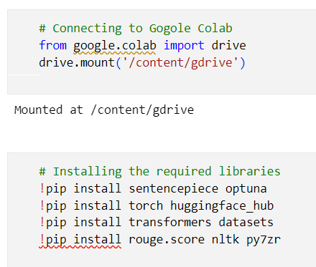

Figure 51: Handling library imports for generalized model

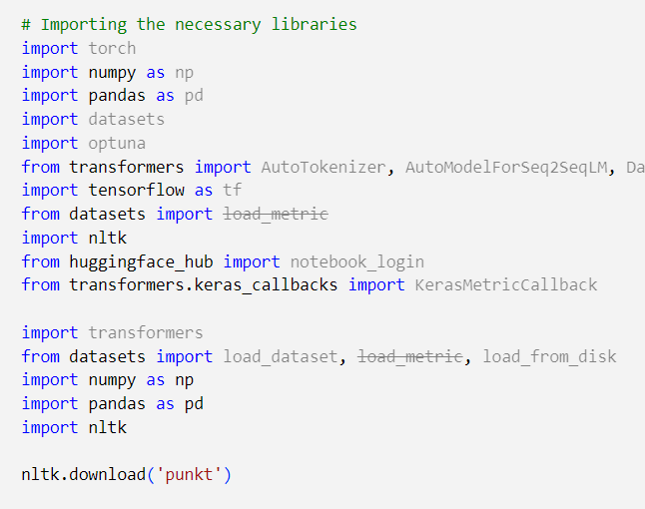

Figure 52: Variable initialization

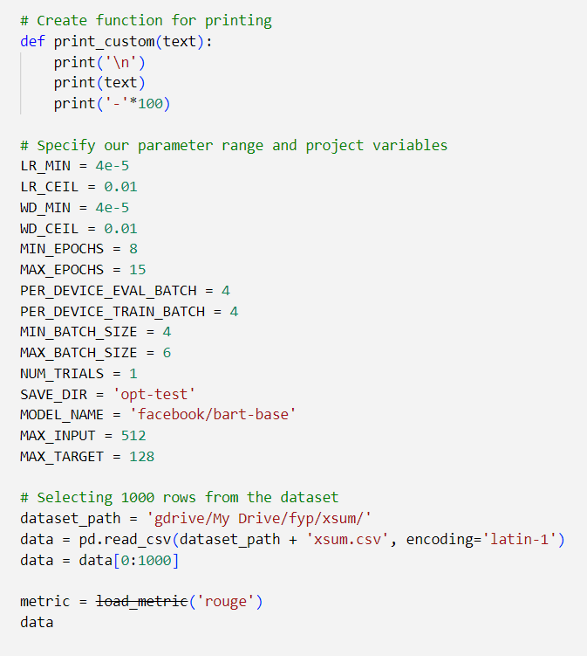

Figure 53: Handle preprocess data and train test split

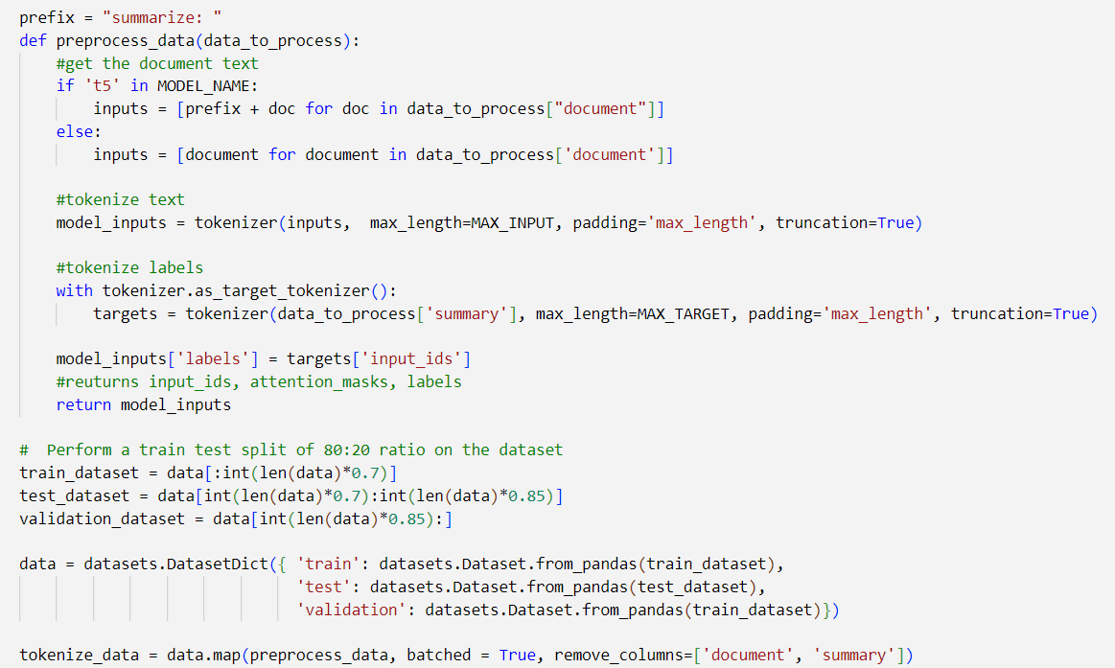

Figure 54: Creating rouge function for evaluation

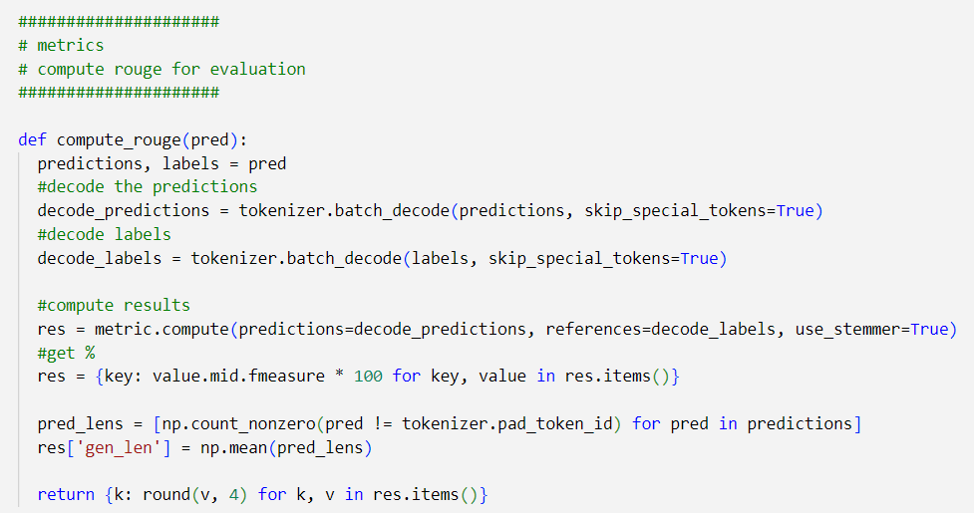

Figure 55: Model parameter & training parameter tuning

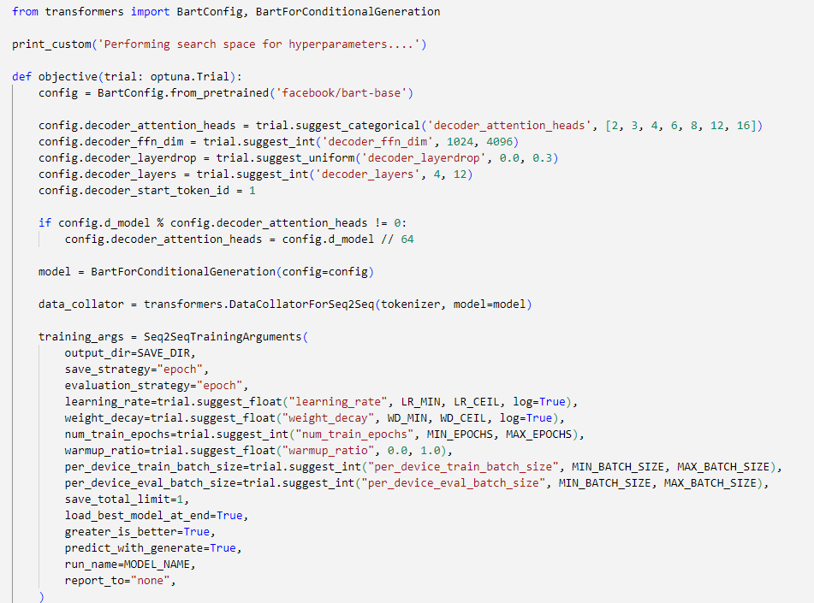

# **E.8. User interface**

Figure 56: GUI – homepage (after signup) (self-composed)



Figure 57: GUI – review history page (self-composed)



Figure 58: GUI – user profile (self-composed)



Figure 59: GUI – model retraining modal (self-composed)



Figure 60: GUI – homepage (before signup) (self-composed)



# **APPENDIX F – TESTING**

# **F.1. Functional Testing**

Table 60: Functional testing

|  |  |  |  |  |  |
| --- | --- | --- | --- | --- | --- |
| **Test case** | **FR ID** | **User Action** | **Expected Result** | **Actual Result** | **Result Status** |
| 1 | FR1 | Users, both general and specific to the domain, can input review text to produce a summary. | Users can input review text in a provided field and generate a summary by clicking a button. | Users can input review text in a provided field and generate a summary by clicking a button. | Passed |
| 2 | FR10, FR11 | Users will click "signup" to create an account, then go to their profile to update it. | After signing up, domain users will see their personal profile and can access their pages. | After signing up, domain users will see their personal profile and can access their pages. | Passed |
| 3 | FR2 | If there is enough data in the database, domain users can click the "retrain model" button to initiate model retraining. | Users will receive a prompt to confirm model retraining, and email notifications will be sent to them to update them on the progress. | Users will receive a prompt to confirm model retraining, and email notifications will be sent to them to update them on the progress. | Passed |
| 4 | FR12 | User will be able to trigger model retraining during off peak hours. | Model retraining happens | Model retraining happens | Passed |
| 5 | FR3,  FR4,  FR5,  FR15,  FR17 | None | The system will find the new best set of (model architecture + model training) hyperparameters by fetching the domain user data/groups and perform necessary preprocessing and trigger model retraining. | The system will find the new best set of (model architecture + model training) hyperparameters by fetching the domain user data/groups and perform necessary preprocessing and trigger model retraining. | Passed |
| 6 | FR6 | None | The summary output will be displayed on the UI | The summary output will be displayed on the UI | Passed |
| 7 | FR7 | None | The system uses the latest retrained model for summary generation | The system uses the latest retrained model for summary generation | Passed |
| 8 | FR13 | Users can input review text to generate a summary and receive the sentiment and sentiment score of the review. | Displays the summary text along with the sentiment score and the sentiment. | Displays the summary text along with the sentiment score and the sentiment. | Passed |
| 9 | FR8 | None | The system encrypts the data and stores it in the database for model retraining purposes | The system encrypts the data and stores it in the database for model retraining purposes | Passed |
| 10 | FR16 | Domain user clicks on “delete” review from the review list | The review gets deleted from the database and is updated on the GUI | The review gets deleted from the database and is updated on the GUI | Passed |
| 11 | FR9 | When domain user submits a review for summarization. | The review and result is encrypted and stored into the database | The review and result is encrypted and stored into the database | Passed |
| The percentage of functional testing that have passed= $\frac{11}{11}*100=100\%$ | | | | | |

# **F.2. Non-functional testing**

In order to evaluate whether the system satisfies the non-functional requirements and design objectives, the writer utilized testing methodologies such as performance testing, GUI testing, maintainability testing, and a limited number of test cases.

**Performance testing**

At present, the author has configured the system to operate in a local environment, and the system resource manager graph below depicts the utilization of resources when the application is deployed and operational in this environment.

Figure 61: System resource manager graph (self-composed)



**GUI testing**

During the requirement gathering phase, it was established that developing a straightforward and efficient GUI was crucial. To assess its performance and accessibility, the GUI was evaluated using Google Lighthouse. The results of this evaluation are illustrated in the diagram below.

|  |  |
| --- | --- |
| Figure 62: Lighthouse Landing Page | Figure 63: Lighthouse Records Page |
| Figure 64: Lighthouse User Profile Page |  |

**Maintainability testing**

Ensuring maintainability is essential to enable smooth future research on the system, particularly the developed algorithm. To achieve this, **CodeFactor** and **CodeQL** were employed to verify that the repositories are well-documented and maintained, and that there are no vulnerabilities present.



Figure 65: CodeFactor - gensum repository



Figure 66: CodeQL - gensum repository

**Test cases**

Table 61: Non-functional requirement testing

|  |  |  |  |
| --- | --- | --- | --- |
| **Non-functional requirements** | | |  |
| **Test case** | **ID** | **Result** | **Status** |
| 1 | NFR1 | Created a minimalist UI design making it user friendly to all type of users. | Passed |
| 2 | NFR5 | Meaningful error messages are displayed on the GUI, if anything faulty happens. | Passed |
| 3 | NFR2 | The summary generation on the GUI takes an average of 5000ms | Passed |
| 4 | NFR3 | CodeQL and CodeFactor is used to maintain the coding standards up to the best quality. | Passed |
| 5 | NFR4 | The idea of model generalization with respect on the domain users works as expected. A domain specific model is created whenever a new domain user signup into the application. | Passed |
| 6 | NFR6 | Data encryption is applied for the data which are domain specific and stored in the database, to ensure that the meaning of the data is not retrained even if the data is lost. | Passed |
| The percentage of non-functional testing that have passed= $\frac{6}{6}*100=100\%$ | | | |

# **APPENDIX G – EVALUATION**

# **G.1. Expert evaluators**

Table 62: Details of the expert evaluator(s) selected.

|  |  |  |
| --- | --- | --- |
| **ID** | **Affiliation** | **Expertise related to the research** |
| EV1 | PhD Research Student NLP | NLP |
| EV2 | NLP Researcher | NLP |
| EV3 | Software Architect & ML Researchers | ML & Algorithms |
| EV4 | Software Engineer | ML & Neural Networks |
| EV5 | Lecturer | NLP |

# **G.2. Evaluation of functional requirements**

Table 63: Evaluation of the implementation of functional requirements

|  |  |  |  |  |  |
| --- | --- | --- | --- | --- | --- |
| **ID** | **FRID** | **Description** | **Priority** | **Use case** | **Evaluation** |
| EV1 | FR1 | Both general and domain-specific users can input review text from the GUI for summary generation | M | UC:01 | Implemented |
| EV2 | FR2 | Retrain system with new data for specific domains after obtaining user consent via GUI. | M | UC:03 | Implemented |
| EV3 | FR3 | The system must be able to find the new set of best hyperparameters with the usage of the new data. | M | UC:04 | Implemented |
| EV4 | FR4 | The system must be able to able to retrain the model with the new best hyperparameters and create the model | M | UC:05 | Implemented |
| EV5 | FR5 | The system must be able to pull the new data from the database to recreate the new dataset for retraining | M | UC:06 | Implemented |
| EV6 | FR6 | The system must be able to process the review text and display the summary output on the GUI | M | UC:07 | Implemented |
| EV7 | FR7 | The system must be able to use the latest trained model to generate the summary for the review text | M | UC:08 | Implemented |
| EV8 | FR8 | User review and generated summary should be stored in the database for retraining | M | UC:09 | Implemented |
| EV9 | FR9 | The system should encrypt the data when saving into the database (both the review and summary) | S | UC:09 | Implemented |
| EV10 | FR10 | Only domain-specific users can create an account after providing required details. | S | UC:02 | Implemented |
| EV11 | FR11 | The system could allow the ability to update the account details of the domain user after creating the account | C | UC:02 | Implemented |
| EV12 | FR12 | The system could be able to perform model retraining automatically during off peak hours every day. | C | UC:03 | Implemented |
| EV13 | FR13 | The system could also find the sentiment of the generated summary if its positive or negative and return the result | C | UC:08 | Implemented |
| EV14 | FR14 | The system could make use of a hybrid model for the text summarization. | C | UC:08 | Not-Implemented |
| EV15 | FR15 | Combine data from common domain groups for dataset creation only with approved consent. | C | UC:06 | Implemented |
| EV16 | FR16 | The system could allow the domain users to delete the reviews from the database. | C | UC:10 | Implemented |
| EV17 | FR17 | The system could automate and update the model architecture to increase performance | C | UC:04 | Implemented |
| The percentage of functional requirements that have been fulfilled = $\frac{16}{17}*100=94.11\%$ | | | | | |

# **G.3. Evaluation of non-functional requirements**

Table 64: Evaluation of the implementation of non-functional requirements

|  |  |  |  |  |
| --- | --- | --- | --- | --- |
| **ID** | **Specification** | **Description** | **Priority** | **Evaluation** |
| NFR1 | Usability | The system needs to be simple enough for non-technical individuals to utilize without much effort. | M | Implemented |
| NFR2 | Performance | Summary generation should be done within 3000ms | M | Implemented |
| NFR3 | Maintainability | Following coding standards and best practices | M | Implemented |
| NFR4 | Generalization | Application can be used by any domain users and model adapts to the domain. | M | Implemented |
| NFR5 | Usability | Meaningful error messages should be displayed if anything goes wrong | C | Implemented |
| NFR6 | Security | The system should protect against data corruption by attackers, and testing can ensure this. | C | Implemented |
| NFR7 | Scalability | The prototype must support many concurrent user-requests from multiple businesses under a single domain. | C | Halfway -Implemented (Database is set to be scaled) |
| The percentage of non-functional requirements that have been fulfilled = $\frac{6.5}{7}*100=92.9\%$ | | | | |

Table 65: Evaluation of the achievement of design goals

|  |  |  |
| --- | --- | --- |
| **ID** | **Goal** | **Evaluation** |
| DG1 | Performance | Achieved |
| DG2 | Correctness | Achieved |
| DG3 | Usability | Achieved |
| DG4 | Adaptability | Achieved |
| DG5 | Scalability | Halfway achieved (database) |
| The percentage of achievement of design objectives. $\frac{3.5}{4}*100=87.5\%$ | | |

# **APPENDIX H – CONCLUSION**

# **H.1. Status of research objectives**

Table 66: Status of research objectives

|  |  |  |
| --- | --- | --- |
| **Objective** | **Description** | **Status** |
| Problem Identification | Comprehend and document the identified issue.  **RO1:** Perform research in a domain of interest and identify a sufficiently comprehensive problem that needs to be addressed.  **RO2**: Thoroughly explore and analyze potential solutions for addressing the problem.  **RO3**: Explore methods for developing an adaptive and generalized approach.  **RO4**: Create a schedule, determine associated deliverables, and develop a Gantt chart for the project. | Completed |
| Literature Review | Complete a thorough critical review of earlier related work.  **RO1:** Make a preliminary investigation on existing abstractive text summarization using deep learning approaches.  **RO2:** Make a preliminary investigation on why transformers architecture was the chosen deep learning choice for this research.  **RO3:** Analyze the top tier transformer architectures widely used.  **RO4:** Analyzing how the models can be fine-tuned via hyperparameter optimization & perform model customization.  **RO5:** Analyzing the different approaches used for model evaluation.  **RO6:** Analyze how the model can be generalized for every other domain. | Completed |
| Methodology Selection and SLEP Framework | This defines the outline structure for the requirement analysis and the design process followed by the social legal ethical and professional issues.  **RO1**: Analyzing the Research Methodology approaches.  **RO2**: Analyzing the Development Methodology approaches.  **RO3**: Analyzing the Project Management Methodology approaches.  **RO4**: Analyzing the Solution Methodology approaches.  **RO5**: Analyzing the Social, Legal Ethical and Professional Issues which could develop during the phase of the project. | Completed |
| Requirement Elicitation | The process of defining the project's requirements involves the identification and application of appropriate methods and tools aimed at resolving anticipated research limitations and challenges, based on existing relevant research.  **RO1:** Gathering information related to the expected metadata required for the dataset to contain for the model training.  **RO2:** Gathering the requirements of transformer architectures for fine-tuning and understand the end to end user expectations.  **RO3:** Getting insights from domain experts to build a suitable system.  **RO4:** Gathering the requirements for handling generalization. | Completed |
| Design | Considering the following when developing the suggested system:  **RO1:** Design a component to preprocess the dataset for the respective model inputs.  **RO2:** Design a component to store the top tier transformer models with their respective metadata, to use throughout.  **RO3:** Design a hyperparameter tuning component that can improve accuracy of the transformer model & customize model architecture.  **RO4**: Design high-level architecture for the system. | Completed |
| Implementation | Setting up a mechanism capable of addressing the gaps that were intended to be covered.  **RO1:** To develop data preprocessing component.  **RO2**: To develop a component that handles and stores the top tier transformer architectures for fine-tuning.  **RO3**: To develop the automated model customization & hyperparameter search component that handles all the top tier architectures assigned.  **RO4**: To develop a component for the model evaluations for the measured hyperparameters | Completed |
| Evaluation | Testing and evaluating the developed system (including the data science models with the suitable metrices)  **RO1**: Performing unit test, integration and performance testing along with a test plan created.  **RO2**: Evaluating all the transformer architectures used for fine-tune experimentations, using recommended scores such as (ROUGE or BLEU SCORE). | Completed |
| Documentation | Keeping track of and documenting the study project's ongoing progress and any challenges encountered. | Completed |
| Publication | Ensure that the documentation, reports, and papers are well-structured and include a critical analysis of the research.  **RO1**: To publish a review paper on the related work done.  **RO2:** To publish a research paper on the related work done.  **RO3**: To publish the code implementation repository as public to be access by future research investigations, along with the models and datasets | Completed |

# **H.2. Achievement of learning outcomes**

Table 67: Achievement of learning outcomes

|  |  |
| --- | --- |
| **Description** | **LO(s)** |
| The project was divided into smaller problems, and each problem was further broken down into manageable parts. Each part was addressed separately by using relevant techniques obtained from analyzing literature and project requirements. | LO1 |
| The project plan was designed by identifying the components and setting them as milestones to be accomplished within a specific timeframe, ensuring the project's timely completion. | LO2 |
| The author collected and analyzed project requirements from two groups: academic researchers and end-users, which provided valuable insights for developing the system and determining which features to prioritize. | LO3 |
| The author critically reviewed the literature to comprehend the concepts pertinent to the domain. | LO4 |
| Upon obtaining the requirements, insights, and knowledge, the author proceeded to address the two subproblems incrementally, acquiring new skills where necessary. The supervisor provided regular guidance to ensure that the project was progressing as planned, with milestone deliverables being produced accordingly. Any SLEP considerations were considered and documented as well. | LO5,  LO6,  LO7 |
| The author documented the progress of the research by presenting each chapter to the supervisor as a milestone and incorporating feedback from both the supervisor and module leader. Prior to completing the dissertation, two document artifacts - the project proposal and PSDP - were submitted. Additionally, the author presented papers at conferences to validate their proposed solution. | LO8 |

# **H.3. Project plan**

Figure 67: Gantt chart: initial plan (self-composed)



Figure 68: Gantt Chart: final plan (self-composed)



# **APPENDIX I – CONCEPT MAP**

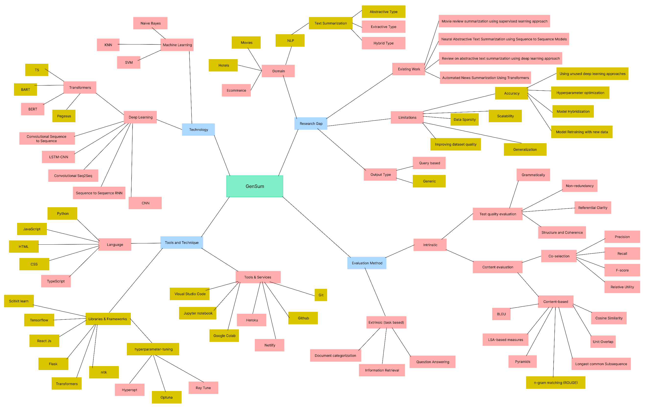

*An enhanced version of the concept map can be found* [*here*](https://drive.google.com/file/d/1jo4h8m0JhpvE6MtpAXmAGfVivWjgJrGr/view?usp=share_link)*.*

# **APPENDIX J – REVIEW PAPER**

















# **APPENDIX K – RESEARCH PAPER**













# **APPENDIX L – PROOF OF SUBMISSION**

Figure 69: Research & Review Paper Submission

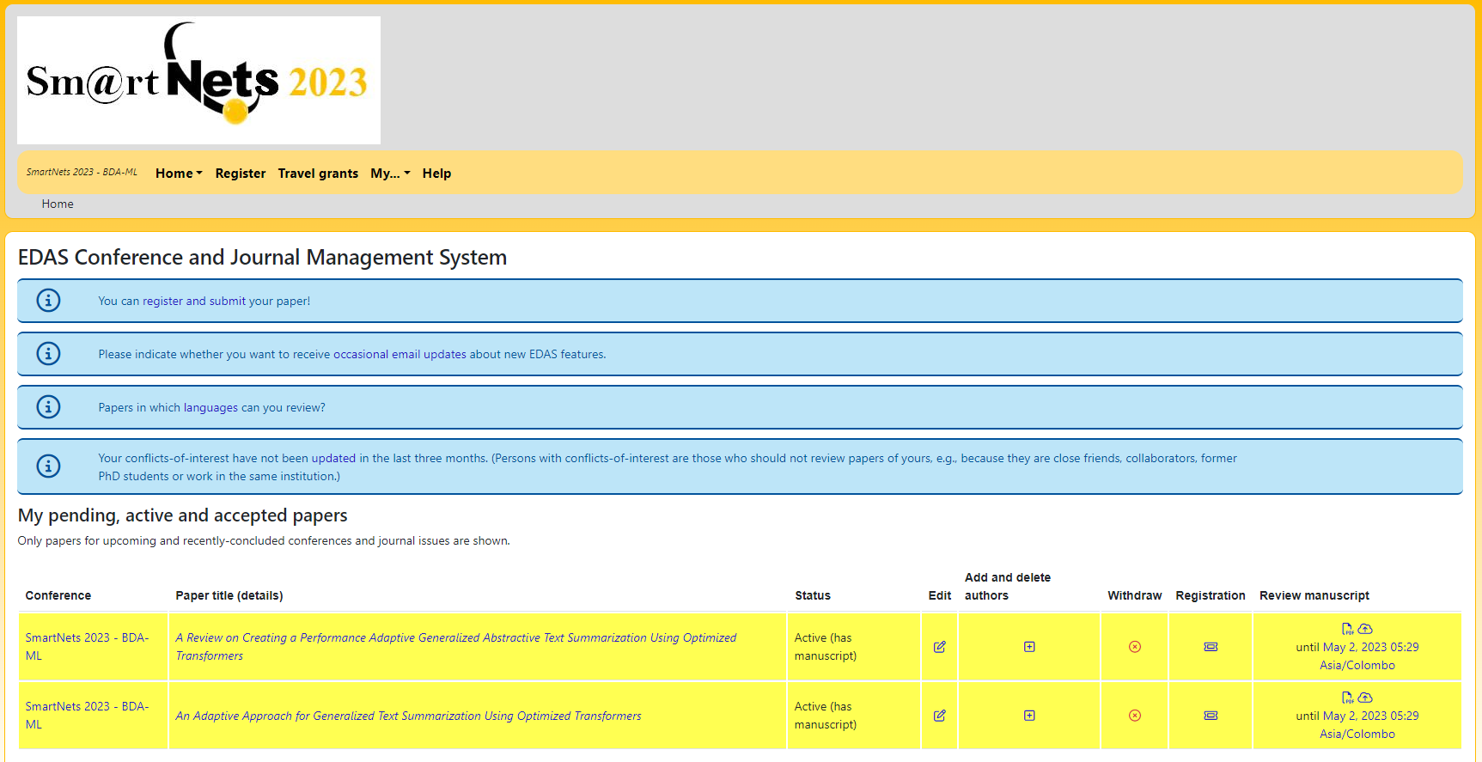

The above figure shows the proof of the review and research paper submission at SmartNETs 2023 under EDAS Conference and Journal Management System.